Berner & Mattner is Preferred Supplier of MBDA Germany

Software development for complex defence projects

Munich, December 16, 2011 - MBDA Germany has nominated Berner & Mattner, the specialist for specification, development and testing of complex electronic systems, as "Preferred Supplier 2011/2012". This award is a sign of confidence in Berner & Mattner by the missile manufacturer. The company has been cooperating with Berner & Mattner in the transatlantic air defence system project MEADS (Medium Extended Air Defense System) since 2004.
"The cooperative partnership with Berner & Mattner is characterized not only by high technical expertise, but also by the highest quality of delivery, flexibility and short reaction times," says Rüdiger Bodier, Head of Purchasing and Materials Management and a member of the board of MBDA Germany, on the occasion of presenting Hans Berner, founder and CEO of Berner & Mattner, with the award. "We are grateful for the excellent performance of our partner and underline this by admitting Berner & Mattner to our circle of "preferred suppliers" today.
Experienced supplier in a demanding industry
The award has been presented for "Software Development Engineering" and "System Engineering" on behalf of the LFK Lenkflugkörpersysteme, which constitutes the German branch of the European defense group MBDA together with its subsidiaries. Criteria of the coveted award given to only four other suppliers are business conduct, logistics, service, quality and technology.
Berner & Mattner is a service provider for model-based development and testing for various industries, especially in the field of embedded systems. The successful work for MBDA Germany has thus been promoted by the long-standing experience of Berner & Mattner in the implementation of international projects in the defence industry and the associated understanding of their specific requirements.
Available images
The following images are available in a printable format for download at:
www.htcm.de/kk/bernermattner/

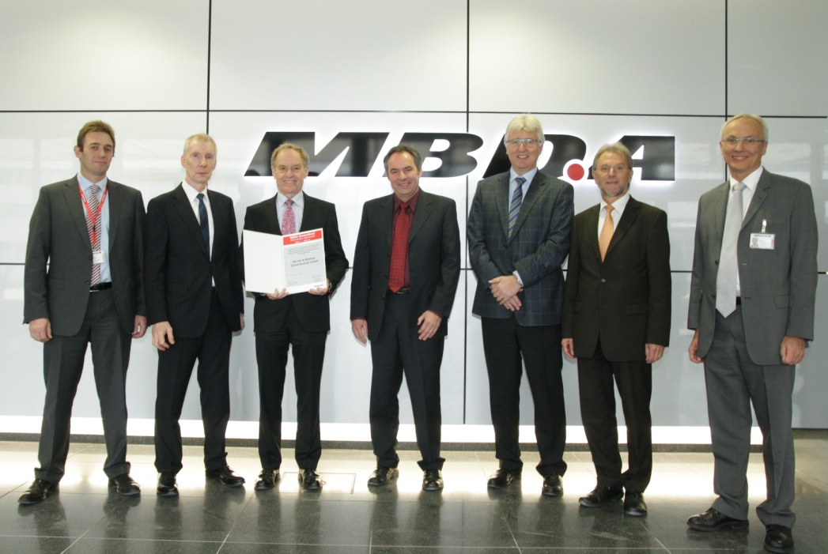
Image source: MBDA

MBDA Germany awarded Berner & Mattner with the title "Preferred Supplier 2011/2012". The presentation of the award took place at the office of MBDA in Schrobenhausen.
Left to right: Anthony Garrett, Head of Project Purchasing (MBDA) and Rüdiger Bodier, Head of Purchasing and Materials Management (MBDA) presenting Hans Berner, CEO of Berner & Mattner, with the certificate, in the presence of Günther Kohler, Senior Project Manager (Berner & Mattner), Christian Hock, Head of Industry Division (Berner & Mattner), Joachim Droth, Subcontractor Manager (MBDA) and Dr. Walter Stammler, Head of Development and Production (MBDA).

About MBDA
MBDA Germany is the leading missile systems company in Germany and develops, produces and manages anti-aircraft and air defense systems, missile systems for aircraft weapons, the arming of helicopters and ships as well as for the so-called "Battlefield Engagement". MBDA Germany is part of the European MBDA group and employs approx. 1,300 employees at locations in Schrobenhausen, Unterschleissheim, Ulm and Aschau.
With industrial facilities in four European countries and the USA, MBDA achieved an annual turnover of approx. € 2,800 million with an order backlog of approx. € 10,800 million. With more than 90 customers worldwide, MBDA is a world leader in the field of missiles and missile systems. Overall, MBDA offers a range of 45 missile systems and countermeasure products that are already in operational service. More than 15 others are in development.

About Berner & Mattner Systemtechnik GmbH, Munich
Berner and Mattner Systemtechnik GmbH is specialized in custom-made solutions for the specification, development and testing of complex electronic systems. Its competence spectrum ranges from consulting, conception, software and systems development to the setup and operation of entire test and integration systems.
On the basis of its products and services, Berner & Mattner provides customized software and engineering solutions for the automotive, aerospace, industrial automation, transportation, and defence industries. By means of its integrated model-based approach, Berner and Mattner optimizes its customers’ efficiency and quality in software and systems development. This is why well- known companies such as Audi, BMW, Daimler, Deutsche Bahn, EADS Germany and Siemens have been placing their trust in Berner and Mattner for many years. The company with headquarters in Munich was founded in 1979, currently employs 320 people at 7 sites in Germany and Austria and is a member of the international Assystem Group. Further information on Berner & Mattner: www.berner-mattner.com.

(without company profil 1.900 characters / with profil 3.910 characters)
Press Contact:
Berner & Mattner  Systemtechnik GmbH  Erwin-von-Kreibig-Str.3  D-80807 München  Tel. +49 (0)89 60 80 90-0  Fax +49 (0)89 609 81-82  www.berner-mattner.com | Martina Heinze  Marketing Communications & PR  Tel. +49 (0)89 60 80 90-166  Fax +49 (0)89 60 80 90-299  E-Mail:  Martina.Heinze@berner-mattner.com
HighTech communications GmbH  Grasserstr. 1c  80339 München  Tel. +49 (0)89 50 07 78-0  Fax +49 (0)89 50 07 78-78  www.htcm.de | Brigitte Basilio  E-Mail: b.basilio@htcm.de  Tel. +49 (0)89 50 07 78-20

