Berner & Mattner: Dr. Klaus Eder becomes CEO

Change in Management

Munich, January 18, 2012 – Berner & Mattner Systemtechnik GmbH has reorganized its management: Dr. Klaus Eder has taken the chair of the management board, assuming the function of Chief Executive Officer (CEO). The company’s founder and previous CEO, Hans Berner, will be focusing on the establishment of the Assystem Group in Germany. Dr. Jan-Oliver Wenzel remains Chief Financial Officer (CFO) of the company specializing in the specification, development and testing of complex electronic systems. Berner & Mattner has been a subsidiary of the Assystem Group since the beginning of 2011.
Berner & Mattner became a member of the international Assystem Group, which employs about 10,000 people around the world, by selling its company shares at the beginning of 2011. Since then the company’s founder Hans Berner has been supporting the integration and establishment of Assystem in Germany. In order to be able to fully concentrate on this task he turned over the chair of the management board to Dr. Klaus Eder at the beginning of 2012. Dr. Eder will additionally remain responsible for sales, marketing, product development and the entire service portfolio. His task is to further extend Berner & Mattner’s market shares - both in already well-developed markets such as automotive and transportation and in additional branches in the field of Industrial Embedded Systems. Furthermore, he will be continuing the company’s course of expansion of recent years.
The 47-year-old computer scientist Dr. Klaus Eder joined the company in 2001 as an authorized representative and has been general manager of Berner & Mattner since 2007. Prior to this, he was a division manager at a Munich-based company with responsibility for products and services in the automation and optimization of production processes. Dr. Eder has numerous years of experience in managing software development projects and business processes.
“Our intention for reorganizing the main focuses in our management team of three was to organize the management of Berner & Mattner effectively and with good prospects for the future as well as to further encourage the establishment of Assystem in Germany“, says Dr. Klaus Eder, CEO of Berner & Mattner. “By being part of this internationally successful company, we are now able to provide our customers with a complete and highly extended service portfolio, consisting of software, electronics, mechatronics and mechanics, and we also have access to the necessary resources, e. g. offshoring. We are thus able to assume the sole responsibility for larger and increasingly international development projects.“

Available images
The following images can be downloaded from our website in a print version:
www.htcm.de/kk/bernermattner/
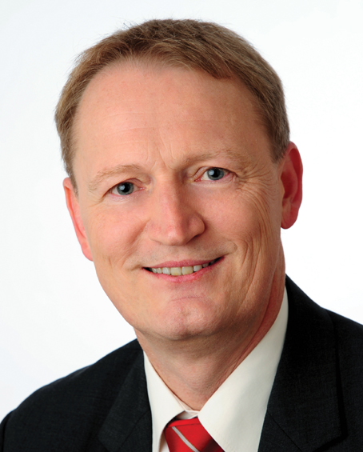
Image source: Berner & Mattner

Dr. Klaus Eder, CEO of Berner & Mattner Systemtechnik GmbH

About Berner & Mattner
Berner and Mattner Systemtechnik GmbH is specialized in custom-made solutions for the specification, development and testing of complex electronic systems. Its competence spectrum ranges from consulting, conception, software and systems development to the setup and operation of entire test and integration systems.
On the basis of its products and services, Berner & Mattner provides customized software and engineering solutions for the automotive, aerospace, industrial automation, transportation, and defence industries. By means of its integrated model-based approach, Berner and Mattner optimizes its customers’ efficiency and quality in software and systems development. This is why well-known companies such as Audi, BMW, Daimler, Deutsche Bahn, EADS Germany and Siemens have been placing their trust in Berner and Mattner for many years. The company with headquarters in Munich was founded in 1979, currently employs 370 people at 7 sites in Germany and Austria and is a member of the international Assystem Group. Further information on Berner & Mattner: www.berner-mattner.com.

About Assystem
Assystem is an international Engineering and Innovation Consultancy. As a key participant in the industry for more than 40 years, Assystem supports its customers in developing their products and managing their capital expenditure throughout the product life cycle. Assystem employs around 9,500 people worldwide and reported €636 million in revenue in 2010. The Company is listed on NYSE Euronext Paris – Compartment B – Code ISIN: FR0000074148 – ASY. For more information: www.assystem.com
In Germany, Assystem employs more than 1,100 people at the companies Assystem, Berner & Mattner Systemtechnik and SILVER ATENA Electronic Systems Engineering.

(without company profile 2,682 characters / with company profile 4,453)

Press contact:
Berner & Mattner  Systemtechnik GmbH  Erwin-von-Kreibig-Str.3  D-80807 Munich  Phone +49 (0)89 60 80 90-0  Fax +49 (0)89 609 81-82  www.berner-mattner.com | Martina Heinze  Marketing & Communications  Phone +49 (0)89 60 80 90-166  Fax +49 (0)89 60 80 90-299  E-Mail:  Martina.Heinze@berner-mattner.com
HighTech communications GmbH  Grasserstr. 1c  D-80339 Munich  Phone +49 (0)89 50 07 78-0  Fax +49 (0)89 50 07 78-78  www.htcm.de | Brigitte Basilio  E-Mail: b.basilio@htcm.de  Phone +49 (0)89 50 07 78-20

