PRESS RELEASE

IQD Signs new global distributor Digi-Key Electronics
Waldenburg (Germany), 8 June 2018 – IQD Frequency Products are pleased to announce that they have signed a global distribution agreement with Digi-Key Electronics, one of the world’s leading distributors of electronic components. Through this agreement, Digi-Key will distribute IQD’s frequency products worldwide. The IQD product line, available for immediate shipment from Digi-Key, comprises of quartz crystals, clocks oscillators, VCTCXOs, TCXOs, OCXOs, GPS Disciplined OCXOs, and Rubidium oscillators.
“In today’s world where design engineers need product immediately for their designs, the agreement with Digi-Key enables IQD’s products to be available from stock at what we know is most design engineers’ first port of call,” said Maria Shoteh, Vice President Sales at IQD Frequency Products Inc. “Digi-Key will be stocking a wide range of our products for communication, consumer, industrial, medical applications, and also our range of TS16949 automotive products.”
"We are excited to expand our partnership with Würth Elektronik eiSos and offer their IQD Frequency Products line to our global customer base, as the IQD brand is highly recognized and regarded amongst the global design community,” said David Stein, VP, Global Supply Management at Digi-Key. “We are now better able to assist the engineering public with global exposure on the Würth Elektronik eiSos product line that includes inductors and power magnetics, in addition to those looking for oscillators and other frequency control products to use in their designs and applications.”
Backed by over 40 years’ experience in the manufacture of frequency products, IQD is a recognized market leader in the frequency control market and part of the Würth Elektronik eiSos group, one of the leading European manufacturers of passive components.

Available images
The following images can be downloaded from the Internet in printable quality: http://www.htcm.de/kk/wuerth

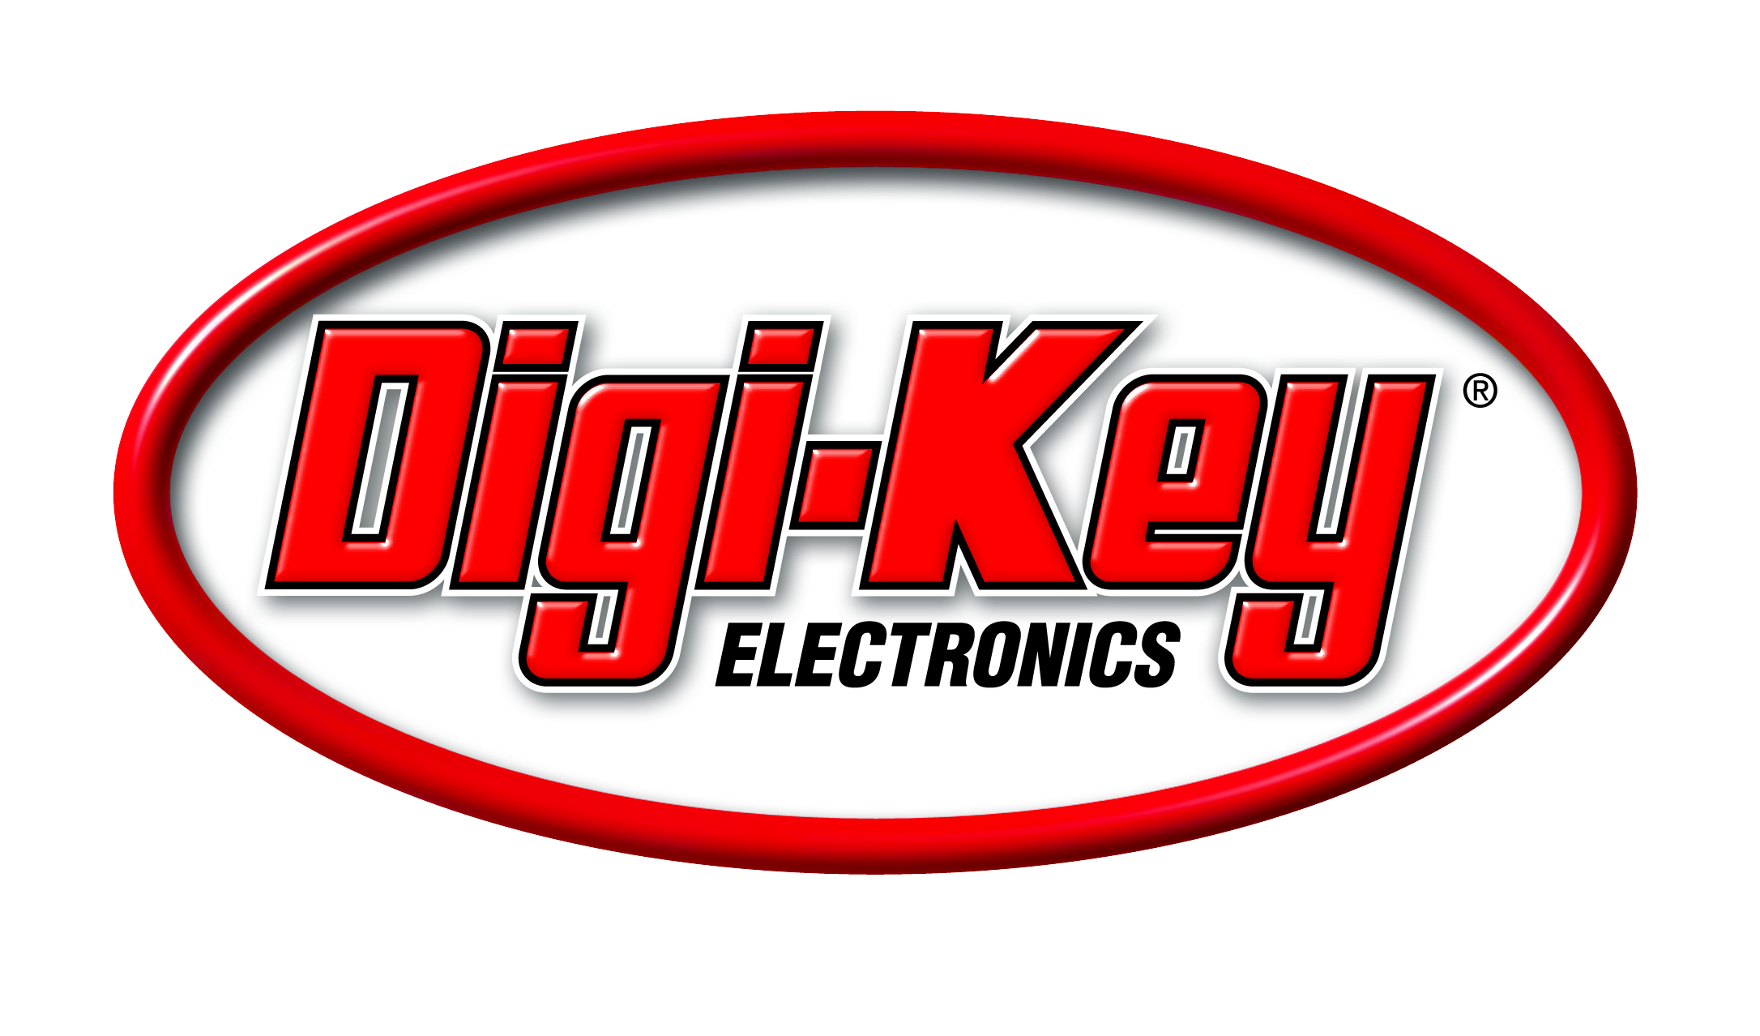
Image source: Digi-Key
Logo Digi-Key

About Digi-Key Electronics
Digi-Key Electronics, based in Thief River Falls, Minn., is a global, full-service distributor of both prototype/design and production quantities of electronic components, offering more than 6.8 million products from over 750 quality name-brand manufacturers. With over 1.4 million products in stock and an impressive selection of online resources, Digi-Key is committed to stocking the broadest range of electronic components in the industry and providing the best service possible to its customers. Additional information and access to Digi-Key’s broad product offering is available at www.digikey.com.

About IQD
Backed by over 40 years’ experience in the manufacture of frequency products, IQD is a recognised market leader in the frequency control market and part of the Würth Elektronik eiSos group, one of the leading European manufacturers of passive components. With active customers in over 80 countries, IQD offers one of the most comprehensive frequency product ranges available, from low cost commercial grade product to that used in high reliability industrial, automotive and military grade applications including: Quartz Crystals, Clock Oscillators, AEC-Q200/TS16949 Crystals & Oscillators, VCXOs, TCXOs, OCXOs, GPS Disciplined OCXOs, and Rubidium Oscillators.
Manufacturing capacity totals over 40 million units per month covering quantities from one off specials to multi-million unit orders. In addition, IQD offers customers a range of engineering support services including: application support, custom product design, sample development, electrical testing & screening, frequency/temperature testing, accelerated ageing, circuit characterisation and MTIE/TDEV testing. IQD’s products are specified by leading manufacturers in the aerospace, automotive, communications, computing, consumer, industrial, medical and military industries throughout the world. The full range of products is available direct through sales offices or via an extensive worldwide distribution network.
Further info at www.iqdfrequencyproducts.com

About the Würth Elektronik eiSos Group
Würth Elektronik eiSos GmbH & Co. KG (Focus: standard components), Würth Elektronik iBE GmbH (Focus: customized passive components for the automotive industry), Wurth Electronics Midcom Inc. (Focus: transformers and custom magnetics), Würth Elektronik Stelvio Kontek S.p.A. (Focus: customized plug connectors), AMBER wireless GmbH (Focus: wireless data transmission solutions) and IQD Frequency Products Ltd (Focus: frequency-control components) form the Würth Elektronik eiSos Group. The group of companies with 6,700 employees generated sales of approx. € 653 million in 2017. The Würth Elektronik eiSos Group is one of the biggest European manufacturers of passive components and operates in 50 countries.
Through its technology partnership with the Audi Sport ABT Schaeffler Formula E Team and its support for the Formula E racing series, the Group demonstrates its innovative strength in eMobility (www.we-speed-up-the-future.com). Other global growth markets, such as Energy Harvesting, Internet of Things and Wireless Communication, are addressed with innovative products.
The Würth Elektronik eiSos Group is part of the Würth Group, the world market leader for assembly and fastening technology.
Würth Elektronik: more than you expect!
Further info at www.we-online.com

More information:  IQD Frequency Products Ltd  Rebecca Long  Station Road  Crewkerne  Somerset  TA18 8AR  United Kingdom  Phone: +44 (0)1460 270270  E-mail: rebecca.long@iqdfrequencyproducts.com  www.we-online.com  www.iqdfrequencyproducts.com | Press contact:  HighTech communications GmbH  Brigitte Basilio  Brunhamstrasse 21  81249 Munich  Germany  Phone: +49 89 500778-20  Telefax: +49 89 500778-77  E-mail:  b.basilio@htcm.de  www.htcm.de

