PRESS RELEASE
OPEN MIND successful at IMTS
hyperMILL® 2014 attracts attention in Chicago
Wessling (Germany), 1 October 2014 – CAM/CAD specialist OPEN MIND received a number of detailed inquiries and enjoyed a great deal of positive feedback on presentations held at its exhibition booth at the International Manufacturing Technology Show in Chicago. Over the six days at a trade show, over 40% more interested parties took advantage of the opportunity to view the hyperMILL® CAM solutions than two years ago.
Over 114,000 visitors attended the event, and the Association for Manufacturing Technology (AMT), the organiser of IMTS, announced that it was one of the most successful trade fairs in recent years. OPEN MIND confirms this success. “This year’s IMTS was our most successful one in the past ten years. We received a lot of detailed inquiries. Many visitors asked about how it’s possible to increase productivity using hyperMILL®,” says Alan Levine, Managing Director of OPEN MIND USA. The strong partnerships with different machine and tool manufacturers also paid off. Many visitors stopped by at the OPEN MIND booth after viewing live processing demonstrations on a CNC machine. At Hermle, a woman’s high heel shoe was milled from solid stock on a C32U machining centre. This shoe proved to be a special attraction at the OPEN MIND booth. Like at many other global trade fairs, a motorcross helmet attracted the attention of visitors. And OPEN MIND also displayed the recently developed Puzzle Ball.
The positive atmosphere on the market is reflected in the inquiries and demonstrations of the new features of the CAM/CAD hyperMILL® solution. The extensions in hyperCAD®-S were particularly interesting. The ‘Deformation’ module now offers the option to deform geometries in a targeted manner. This powerful tool allows the modification of component areas, which is otherwise only possible with elaborate modelling techniques.

Available images
The following images are available for download in printable format at:
http://www.htcm.de/kk/openmind
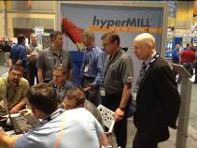  hyperMILL® demo at IMTS | 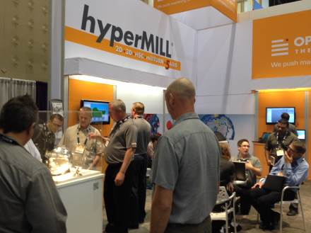  Open Mind successful at IMTS
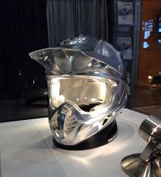  Motorcross helmet: hyperMILL® 5axis machining in top quality | 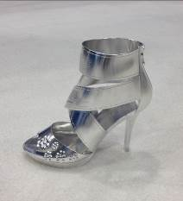  A high heel shoe milled from solid stock
Image source (4): OPEN MIND

About OPEN MIND Technologies AG
OPEN MIND Technologies AG is a leading developer of CAM/CAD software and postprocessors for designing and manufacturing complex moulds and parts. OPEN MIND is one of the world’s five largest providers of CAM solutions according to the NC Market Analysis Report 2014 compiled by the CIMdata market research company.
OPEN MIND offers an extensive selection of products ranging from 2D feature-oriented solutions for milling standard parts through to software for 5axis simultaneous machining.
OPEN MIND Technologies AG is represented in all key markets in Asia, Europe and America with their hyperMILL® software, which is used in the automotive, tool and mould manufacturing, mechanical engineering, medical and aerospace, and watch and jewellery industries.
OPEN MIND Technologies AG is a Mensch und Maschine company (www.mum.de).

Additional information is available upon request or from our website at www.openmind-tech.com.

OPEN MIND Technologies USA, Inc.
1492 Highland Avenue, Unit 3
Needham MA 02492
USA
Phone: +1 339 225 4557 office
Phone: +1 888 516 1232 x0 toll-free
Fax: +1 270 912 5822
E-mail: Info.Americas@openmind-tech.com

OPEN MIND Technologies UK Ltd., Oxford
Units 1 and 2
Bicester Business Park
Telford Road
Bicester
Oxfordshire OX26 4LN
England
Phone: +44 1869 290 003
Fax: +44 1869 369 429
E-mail: Info.UK@openmind-tech.com

Head office:
OPEN MIND Technologies AG, Argelsrieder Feld 5, 82234 Wessling, Germany
Phone: +49 8153 933-500, Fax: +49 8153 933-501
E-mail: Info@openmind-tech.com, website: www.openmind-tech.com

Press contact:
HighTech communications GmbH
Brigitte Basilio
Grasserstrasse 1c
80339 Munich, Germany
Phone: +49 89 500778-20
Fax: +49 89 500778-78
E-mail: b.basilio@htcm.de
Website: www.htcm.de

