Press Release

Markt Indersdorf, 12 November 2015

Sumitomo (SHI) Cyclo Drive Germany GmbH at SPS IPC Drives 2015
Maximum torque in minimum space
Stand 3-251
Sumitomo (SHI) Cyclo Drive Germany GmbH is displaying their wide ranging portfolio of gearboxes at SPS IPC Drives (November 24-26, 2015), above all the precision gearboxes in the Fine Cyclo series. The highlight of the presentation at Stand 3-251 at the Nuremberg trade fair is a highly compact, precision gearbox with a hollow shaft: The new FC Drive C25. It is the result of the co-operation with the Swedish company HDD Servo Motors AB. The combination of the cycloid principle of the Fine Cyclo gearboxes with the patented Stritorque® technology of the HDD motors results in a drive which is half as long as conventional rotary drives with comparable performance. The FC Drive is being presented for the first time at Europe’s leading specialist trade fair for electric automation. The new standard for compactness and torque density will be available on the market in 2016.
“The collaboration between Sumitomo and HDD not only brings together the core competences of two companies, but allows our products to be combined to create a unique new drive. The Ultra Compact servo motors from HDD combined with the high precision and tilt-resistant gearboxes from Sumitomo are a recipe for success”, says Gustav Alberius, CEO of HDD Servo Motors AB.
“We have already supplied FC Drives to selected customers and have received extremely positive feedback”, reports Florian Butzmann, Director Sales & Marketing EMEA at Sumitomo (SHI) Cyclo Drive Germany GmbH. “The uncomplicated mechanical integration and high level of flexibility in combination with virtually any power electronic is highly valued by our customers.”
The most important technical data for the precision drive is already available. The unit reaches an acceleration torque of 1040 Nm with a length of just 174 mm (depending on the feedback system) and a diameter of 189 mm. Together with its Ultra Compact design, the drive features an extremely generous hollow shaft bore of 45 mm which allows cables and media to be fed through it.
Sumitomo (SHI) Cyclo Drive Germany GmbH and HDD would like to appeal to a number of different industries with the new product, especially machine tool and robot manufacturers.
With the FC Drive C25, Sumitomo (SHI) Cyclo Drive Germany GmbH and HDD become technology leaders in compactness and torque density. Other joint product releases are already being planned.

Graphic materials available
The following picture material is available on the internet for downloading and printing:
http://www.htcm.de/kk/sumitomo

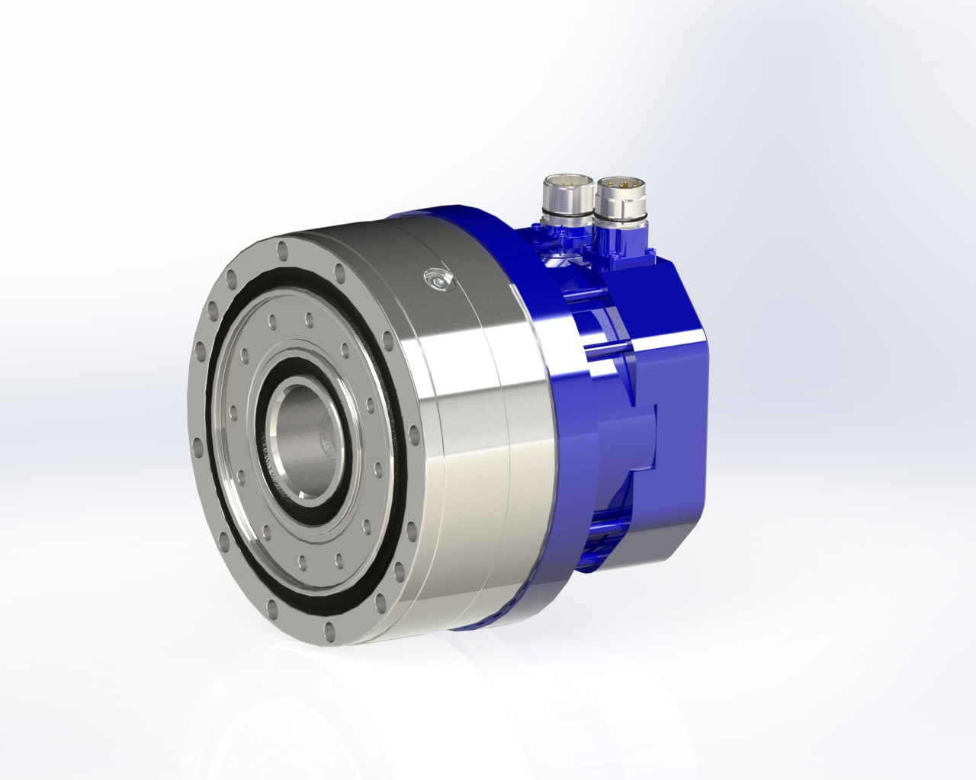
Source: Sumitomo (SHI) Cyclo Drive Germany GmbH/HDD Servo Motors AB
Highly compact, precision gearbox with a hollow shaft: The new FC Drive C25.

  Source:  HDD Servo Motors AB  Gustav Alberius, CEO of HDD Servo Motors AB |   Source: Sumitomo (SHI) Cyclo Drive Germany GmbH  Florian Butzmann, Director Sales & Marketing EMEA at Sumitomo (SHI) Cyclo Drive Germany GmbH

About HDD Servo Motors AB:
HDD Servo Motors AB has developed and produced Ultra Compact electric motors for more than 20 years. The patented Stritorque® technology results in motors with less than half the size compared to motors with equivalent performance. The motors are used in the Aerospace industry, the Machine Tool industry, the Manufacturing industry, the Military industry and among the customers are Siemens, Husqvarna, Sumitomo, TetraPak and Saab Defense.
About Sumitomo (SHI) Cyclo Drive Germany GmbH:
Sumitomo (SHI) Cyclo Drive Germany is a subsidiary of Sumitomo Heavy Industries within the Power Transmission Control business segment, as is their sister company Hansen Industrial Transmissions. In 2014 Sumitomo Heavy Industries achieved total revenues of almost 6 billion US dollars. Under the umbrella brand of SUMITOMO DRIVE TECHNOLOGIES, Sumitomo Heavy Industries is the market leader for drive technology in Japan and continues to expand its global presence and market share. Thus, Sumitomo (SHI) Cyclo Drive Germany GmbH has sales, service and production facilities in many European countries and subsidiaries in France, Italy, Spain, Scandinavia, Great Britain and Turkey.
Further information at: www.sumitomodrive.com
Sumitomo (SHI) Cyclo Drive Germany GmbH  Christiane Loichinger  Cyclostrasse 92  85229 Markt Indersdorf  Germany  Tel.: +49 8136 66-168  Fax: +49 8136 5771  E-Mail: cloichinger@sce-cyclo.com  Website: www.sumitomodrive.com | Press contact:  HighTech communications GmbH  Brigitte Basilio  Grasserstrasse 1c  80339 Munich  Germany  Tel.: +49 89 500778-20  Fax: +49 89 500778-77  E-Mail: b.basilio@htcm.de  Website: www.htcm.de
HDD Servo Motors AB
Rolf Ohlsson, Sales and Marketing Manager
Stallarholmsvägen 40
SE-124 59 Bandhagen
Sweden
Tel.: +46 8 86 87 80
Fax.: +46 8 99 51 53
E-Mail: sales@hdd.se
Website: www.hdd.se

