PRESS RELEASE

Swissbit Memory-Solutions for IIoT at embedded world
Secure storage products for decentralized intelligence
Bronschhofen, Schwitzerland. March 13, 2017 – Swissbit, a leading manufacturer of flash memory solutions, will be exhibiting at embedded world 2017 (Nuremberg, 14-16 March 2017, Hall 1, booth 1-534) as an expert partner for Industrial Internet of Things (IIoT) projects. Developers and manufacturers can choose from a broad range of optimized industrial flash memory products for applications relating to cyber physical systems, M2M communication, decentralized sensors, edge computing and smart factory environments. In addition, Swissbit is showing its manufacturing expertise with special knowledge of complex integrated systems with system-in-package manufacturing capacities (SiP) and a deep understanding of processing TSOP, BGA and bare die components.
"The 'things' in the Internet of Things (IoT), especially in the Industrial Internet of Things (IIoT), are 'smart' and comprise of sensors and devices each equipped with their own decentralized intelligence. Consequently, the IIoT needs robust and durable memory for booting or data collection. At the same time, there is also a need to protect data and communication," explains Ulrich Brandt, Director of Marketing at Swissbit. "We offer suitable solutions as well as the manufacturing capacities for integrated multifunctional SiPs beyond the usual standards."
Data rates, endurance, security
Swissbit S-45 and S-45u are MLC SD and microSD cards, which are perfect for data logging applications thanks to their durabit™ firmware with high writing speeds. An even higher data rate and endurance can be achieved with the SLC versions of the card: S-450 and S-450u. These are ideal for video applications requiring a local recording due to redundancy or bandwidth availability. The security-versions of these products ensure highest data protection through encryption, and allow applications that safeguard data security and privacy laws. The Swissbit product portfolio of secure memory products also includes cards with a secure element, which ensure counterfeit-proof identification of network components in M2M communication.
Security features also ensure that an in-field firmware update is secured against the threat of malware. Feature upgrades in particular, or plugging security gaps, which in a decentralized network can only be managed remotely, have to be protected against unauthorized manipulation.

In the highly competitive IIoT market, protection against copying, reverse engineering or the activation of locked options is of utmost importance, to justify investments. Flexible administration for access control offered by the Swissbit-security-functions are the ideal solution.
Boot media
U-45 and U-450 are Swissbit’s robust embedded USB 2.0 boot media solutions for NetCom systems or data loggers. They combine the common USB-interface found in IIoT systems with a robust form factor. For higher data rates and faster booting, Swissbit U-500, an embedded USB 3.1 flash drive based on SLC-technology, is available.

Available images
The following images are available for download in printable format at: http://www.htcm.de/kk/swissbit
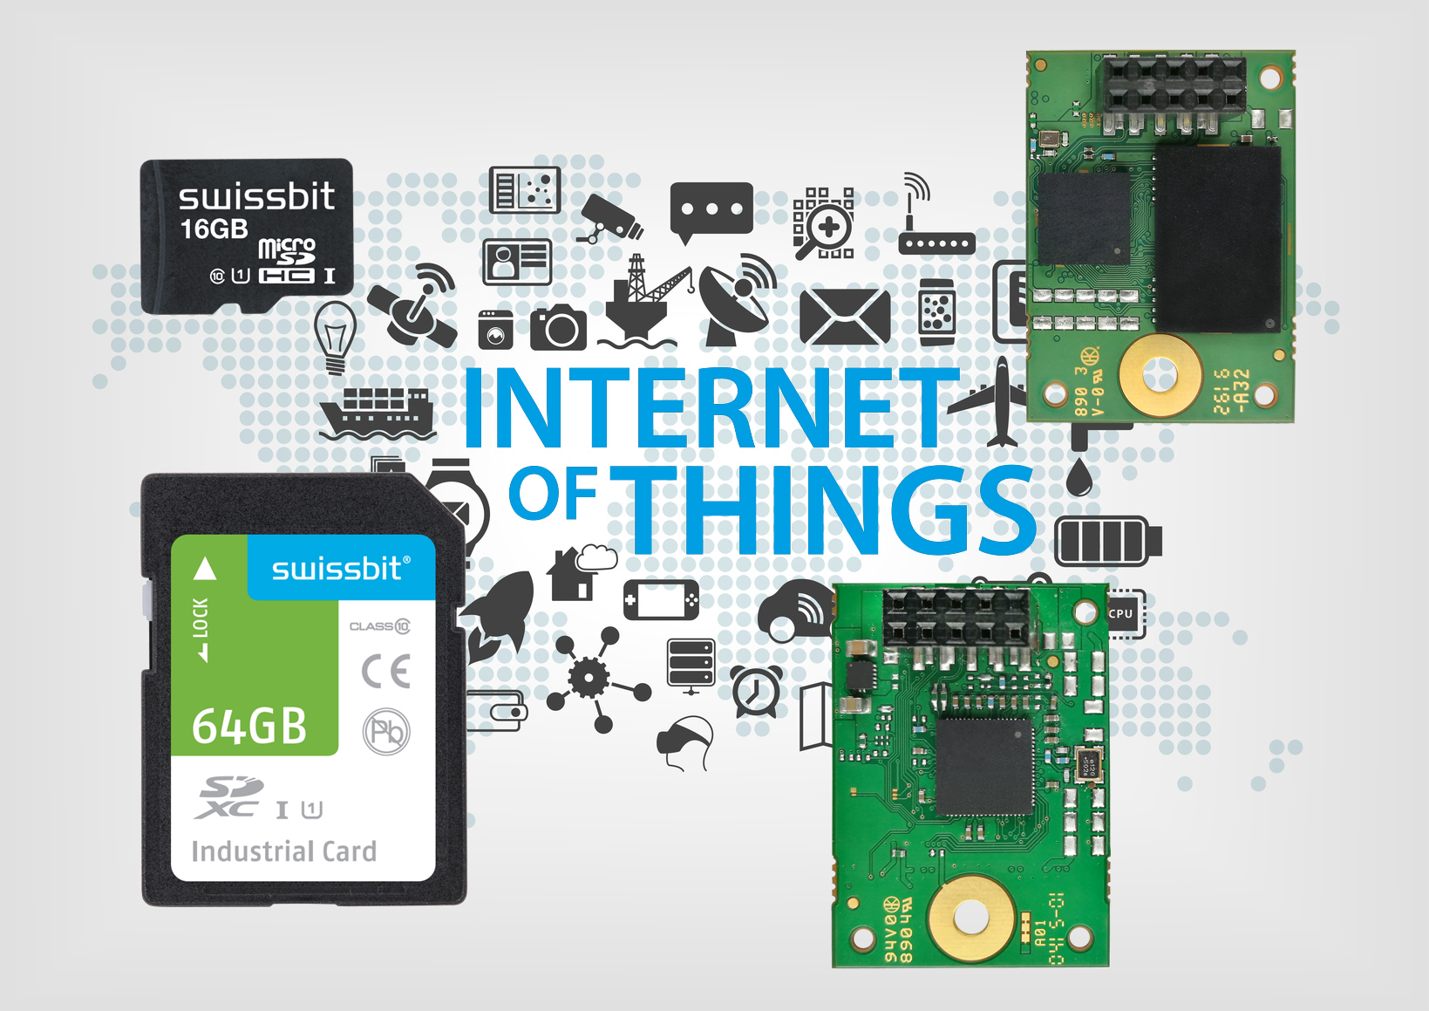
Image Source: Swissbit
Swissbit offers memory solutions for IIoT applications.

About Swissbit AG
Swissbit is the largest independent manufacturer of embedded memory and flash storage solutions in Europe. The company was founded in 2001 through a management buy-out of Siemens AG, and has offices in Switzerland, Germany, US, Japan and Taiwan. Its main manufacturing plant in Berlin produces industrial strength flash memory products and memory cards with dedicated features for demanding applications. The Swissbit flash range includes SSDs with SATA interface as mSATA, Slim SATA, CFast™, M.2 and 2.5”, CompactFlash, USB flash drives, SD and micro SD memory cards. Swissbit offers products with long-term availability, high reliability and durability and custom optimization for demanding applications in the industrial, automotive and telecommunications sectors. With its secure storage solutions, Swissbit addresses the increasing security requirements demanded by industrial, government, defense, medical, telecommunications, machine-to-machine communication and finance industry segments. All Swissbit products meet the highest quality standards and the RoHS and REACH directives.
For further information, please visit www.swissbit.com

Further Information:  Swissbit AG  Silke Lüers  Industriestrasse 4  9552 Bronschhofen  Switzerland  Tel: +41 71 913 03 39  Email: silke.lueers@swissbit.com  www.swissbit.com | Media Contact:  HighTech communications GmbH  Brigitte Basilio  Grasserstrasse 1c  80339 Munich  Germany  Phone: +49 89 500778-20  Fax: +49 89 500778-77  E-mail: b.basilio@htcm.de  www.htcm.de

