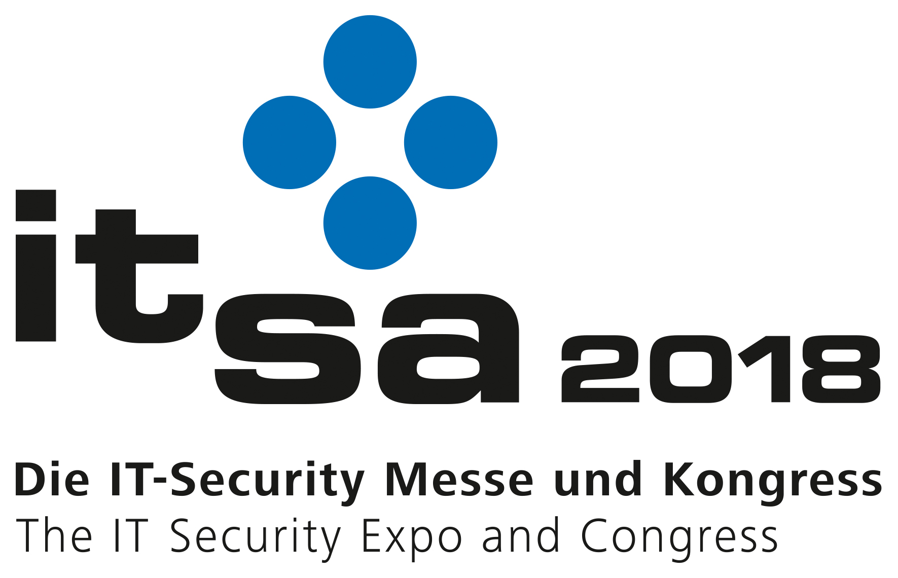
PRESS RELEASE

Swissbit to exhibit at it-sa 2018
Security solutions based on industrial-grade flash memory
9–11 October 2018
Hall 10.1, Booth 10.1-205
Bronschhofen, Switzerland. October 5, 2018 – Swissbit AG, a leading manufacturer of industrial-grade flash memory solutions, will be exhibiting at it-sa in Nuremberg, Germany from 09th to 11th October 2018. The company will be showcasing its latest security products and their possible applications on booth 10.1-205 in Hall 10.1. With the USB-stick PU-50n DP and the microSD Memory Card PS-45u DP, Swissbit will demonstrate the concept of a net-policy-server to control and manage flash memory devices as authentication tokens and secure IIoT boot devices.
The USB-stick PU-50n DP will be presented at the show. The USB 3.1 mass storage device in a rugged metal housing is available with MLC and pSLC-NAND options. It has an internal AES 256-bit encryption and password protection offers a configurable repeat counter. Different separate partitions can be defined, for example, as ROM or WORM memory. Comparable with the Swissbit memory cards, which are used in police bodycams, any read and write permissions can be defined.
"Secure firmware updates, GDPR compliant company data protection, secure storage of audit trails – we are looking forward to show our booth-visitors at it-sa diverse application scenarios," commented Hubertus Grobbel, Head of BU Security, Swissbit AG. He continued explaining the underlying concept: "Flash memory cards and USBs are common, be it as data media in embedded systems – for example in industrial automation – or in IT as mobile information transfer media. At the same time, we need to address the increasing security and data protection requirements, for example for IIoT communication. Here, we offer approaches based on proven memory products with built-in security and data protection features."
Example: Connecting secure memory with the IP address
At it-sa, Swissbit will, with its security solutions, demonstrate the concept of a net-policy-server for control and management of memory in the field. The company will show how two factor authentications can be bound to one IP address. It is possible, for example, that a boot loader only functions within a defined network. This way, there is no security risk, in case of unauthorized removal of hardware from a manufacturing facility. Whilst, inserting non-authorized hardware is made extremely difficult thanks to the level of trust among the devices themselves. The microSD Memory Card PS-45u DP is also equipped with an integrated data protection feature with AES 256-encryption. On Swissbit’s it-sa booth, secure booting of a RaspBerry Pi will be shown. Here, an administrator can differentiate between many policies determining the approval of access to the memory. The memory can only be used with the right device, by the right person, within the right network and with a specific license token or the right boot software.

Available images
The following images are available for download in printable format at: http://www.htcm.de/kk/swissbit
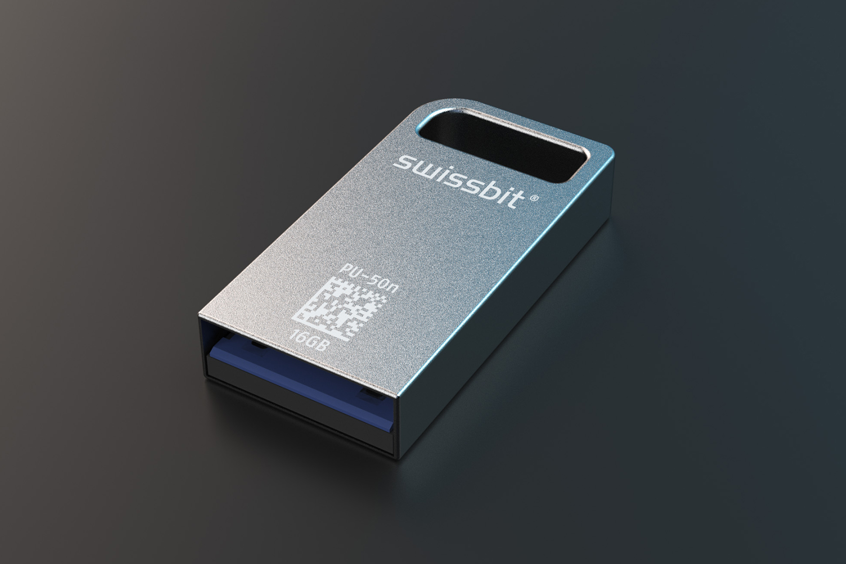Image Source: Swissbit
Industrial-grade USB stick with integrated data protection features: PU-50n DP

About Swissbit AG
Swissbit is the largest independent manufacturer of embedded memory and flash storage solutions in Europe. The company was founded in 2001 through a management buy-out of Siemens AG, and has offices in Switzerland, Germany, US, Japan and Taiwan. Its main manufacturing plant in Berlin produces industrial strength flash memory products and memory cards with dedicated features for demanding applications. The Swissbit flash range includes SSDs with SATA interface as mSATA, Slim SATA, CFast™, M.2 and 2.5”, CompactFlash, USB flash drives, SD and micro SD memory cards. Swissbit offers products with long-term availability, high reliability and durability and custom optimization for demanding applications in the industrial, automotive and NetCom sectors. With its secure storage solutions, Swissbit addresses the increasing security requirements demanded by industrial, government, defense, medical, NetCom, machine-to-machine communication and finance industry segments. All Swissbit products meet the highest quality standards and the RoHS and REACH directives.
For further information, please visit www.swissbit.com

Contact:  Swissbit AG  Silke Lüers  Industriestrasse 4  9552 Bronschhofen  Switzerland  Tel: +41 71 913 03 39  Email: silke.lueers@swissbit.com  www.swissbit.com | Press Agency:  HighTech communications GmbH  Brigitte Basilio  Brunhamstrasse 21  81249 Munich  Germany  Tel: +49 89 500778-20  Fax: +49 89 500778-77  Email: b.basilio@htcm.de  www.htcm.de

