PRESS RELEASE

Swissbit launches innovative Product Finder web-tool
Product recommendations from memory solutions experts
Bronschhofen, Switzerland. March 26, 2019 - Swissbit AG, a leading manufacturer of industrial-grade flash memory solutions, has launched a new website that features an innovative Product Finder web-tool (https://www.swissbit.com/service/product-finder/). The useful and intuitive search app uses sophisticated and advanced algorithms to identify and recommend the best memory products for a customers’ unique needs. The new concept is based on typical and common use cases that exemplify the way in which particular storage products work with various applications. Use cases differ in the percentage of writes vs. reads and most importantly block size and either sequential or random sequence.
Swissbit has defined a selection of 6 typical use cases, for example “small data logging” or “Boot OS”, ensuring that users can easily select the right scenario that reflects their needs. Product searches without a particular application in mind are also possible without an initial use-case-selection.
Swissbit’s previous product finder or those offered by other suppliers, filter products by “features” or “segments”, which does not take into account the circumstantial endurance of a product for a given application. Swissbit’s latest product finder in contrast now also considers exact endurance requirements, related costs and expected conditions of the chosen use case. Each resulting Swissbit product-recommendation is highlighted and ranked in order of relevance & suitability: three stars for Swissbit’s highest product-recommendation for the application, one star for product recommendations that may be a suitable solution depending on circumstance.
The Product Finder tool allows further selection of up to 14 individual filters for capacity, technology, performance, endurance, production status, interface, form factor and product series to narrow down and fine-tune the recommendation even further. Existing customers can enter a complete or partial Swissbit part number to identify products, download fact sheets and check online availability. With a direct live link to Swissbit’s webshop partners, actual product availability is displayed and updated in real-time while the filter shows its results, to ensure online availability for the order selection process.
Additional features such as product comparison, pdf and excel file-export as well as filter-setting sharing with others or information requests for Swissbit, complement the comprehensive functionality of the Swissbit tool.
The new tool follows Swissbit’s best customer service approach and offers customers an easy and convenient solution to identify and quickly order the best products and samples for their particular applications.
The product finder can be accessed here: https://www.swissbit.com/service/product-finder/

Available images
The following images are available for download in printable format at: http://www.htcm.de/kk/swissbit
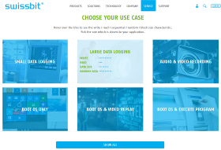  Image Source: Swissbit  Swissbit Product Finder use case entry | 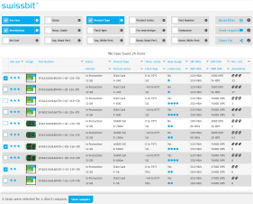  Image Source: Swissbit  Swissbit Product Finder results

About Swissbit AG
Swissbit is the largest independent manufacturer of embedded memory and flash storage solutions in Europe. The company was founded in 2001 through a management buy-out of Siemens AG, and has offices in Switzerland, Germany, US, Japan and Taiwan. Its main manufacturing plant in Berlin produces industrial strength flash memory products and memory cards with dedicated features for demanding applications. The Swissbit flash range includes SSDs with SATA interface as mSATA, Slim SATA, CFast™, M.2 and 2.5”, CompactFlash, USB flash drives, SD and micro SD memory cards. Swissbit offers products with long-term availability, high reliability and durability and custom optimization for demanding applications in the industrial, automotive and NetCom sectors. With its secure storage solutions, Swissbit addresses the increasing security requirements demanded by industrial, government, defense, medical, NetCom, machine-to-machine communication and finance industry segments. All Swissbit products meet the highest quality standards and the RoHS and REACH directives.
For further information, please visit www.swissbit.com

Contact:  Swissbit AG  Silke Lüers  Industriestrasse 4  9552 Bronschhofen  Switzerland  Tel: +41 71 913 03 39  Email: silke.lueers@swissbit.com  www.swissbit.com | Press Agency:  HighTech communications GmbH  Brigitte Basilio  Brunhamstrasse 21  81249 Munich  Germany  Tel: +49 89 500778-20  Fax: +49 89 500778-77  Email: b.basilio@htcm.de  www.htcm.de

