PRESS RELEASE

Pluggable: Swissbit TSE for fiscal compliance
Easy-to-install TSE solution makes cash registers tamper-proof
Bronschhofen, Switzerland. June 4, 2019 – Swissbit AG, specialist provider of data-storage, -protection and -processing solutions for industrial applications, is pleased to announce the introduction of its TSE solution for tamper-proof recording of POS (Point of sale) data. The launch is in response to new statutory regulations imposed by German tax authorities. By January 1. 2020, all new electronic and existing PC-based POS systems in Germany must be equipped with a certified technical security device (TSE). All other existing POS systems will need to be retrofitted accordingly by the end of 2022. Swissbit has developed a pluggable TSE solution that is extremely easy to install. The Swissbit TSE is connected to the USB-, SD- or microSD-port which allows easy system integration for both manufactures of traditional POS systems as well as POS software providers for PCs or tablets. For existing POS systems it is also a very cost-effective retrofit-solution. For networked POS systems, Swissbit also offers a LAN-TSE option with multiple Swissbit TSE’s that ensures fiscal compliance across a complete POS system without the need for hardware upgrades of each individual cash register.
Time is running out. By the end of 2019, manufacturers of electronic and PC-based POS systems in Germany must install certified TSE solutions into their systems to be legally compliant and ensure their systems are tamper-proof. Equally, by the end of 2022 at the latest, all existing POS systems used by the retail, trade and catering sectors, must be retrofitted in accordance with the requirements imposed by the tax authorities.
Swissbit is all set for the timely implementation of fiscally compliant solutions
It’s not an easy feat, but with the Swissbit TSE, manufacturers of cash registers now have a solution that can simply be plugged into any POS system via the USB-, SD- or microSD-port, making it very easy to integrate and retrofit. Swissbit is already going through the certification process at the German Federal Office for Information Security (BSI) for three of its TSE product variants and is closely cooperating with the authorities to deliver a certified TSE in accordance with TR-03153 that ensures a legally and fiscally compliant solution in Germany.
Samples of the Swissbit TSEs were already provided to customers at the end of last year and have officially been part of the DFKA (German Association for Cash and Billing System Technology) field test program since April 2019 with successful results. By doing so, Swissbit supports all POS manufacturers who are serious about achieving legal compliance in application and process.
Future-proof Swissbit TSE solution: scalable and easy to integrate
Cash register manufacturers can easily integrate the Swissbit TSE solution into their systems. In addition to the TSE, Swissbit also provides an SDK (Software Development Kit), drivers and support for Windows, Linux, Android and embedded systems. Swissbit’s TSE is connected via the USB-, SD- or microSD-port. In addition, the solution is future-proof, cost-effective and easily scalable, as it can be used both as a stand-alone and as a LAN solution with multiple parallel TSEs that connect different devices such as PCs and tablets without the need for any further installation at the POS system level.
"We fully understand the complex challenges faced by cash register manufacturers to provide legally compliant cash register systems and we follow the strict certification requirements of the German Federal Office for Information Security (BSI). The Swissbit TSE is 'pluggable' and therefore offers a unique flexible and easy-to-integrate fiscal solution. Development and production are done in-house and can be completely controlled and flexibly adapted to our customers' requirements," said Hubertus Grobbel, Head of Security Products at Swissbit AG. "During the development, we closely aligned ourselves with the entire cash register eco system. Our customers are busy integrating the Swissbit TSE to allow them to offer a legally compliant fiscal solution on time."
Field-tested fiscal solution already used throughout the European Union
Swissbit is an established specialist with over 20 years’ experience in demanding industrial-grade storage and security solutions. In addition, Swissbit is well known for its high quality and security standards. The company maintains its own development and manufacturing site for memory products in Berlin, Germany and is therefore also able to offer a flexible and demand-oriented service for customized products. For over three years, Swissbit has been providing proven fiscal solutions in fiscal countries such as France and others.

Available images
The following images are available for download in printable format at: http://www.htcm.de/kk/swissbit
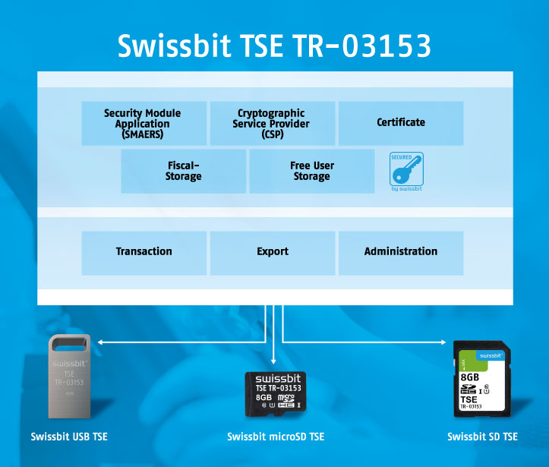  Image Source: Swissbit  Swissbit’s TSE is pluggable and easy to integrate. Existing POS systems can be easily retrofitted. | 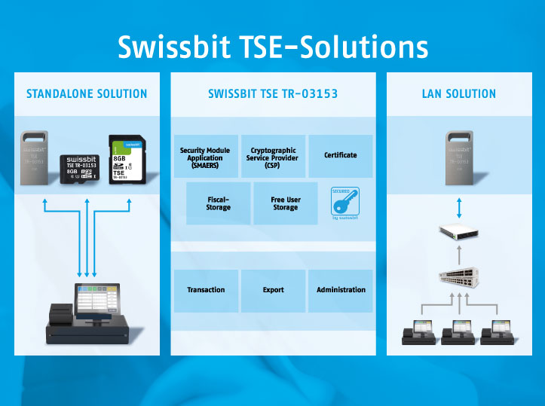  Image Source: Swissbit  The TSE from Swissbit is available as a standalone-device solution as well as a LAN solution with multiple parallel TSEs that connect different devices.

About Swissbit
Swissbit AG is the largest independent manufacturer of storage and security solutions for demanding industrial and IoT applications in Europe. Swissbit combines its unique competences in embedded memory and flash storage products with cutting-edge security technology and its expertise in advanced packaging to store, protect and process data reliably in industrial, NetCom, automotive, medical and finance sectors. The company manufactures industrial strength flash storage and security products “Made in Germany” with long-term availability, high reliability and durability as well as custom optimization. Swissbit’s flash range includes SSDs with PCIe and SATA interface such as mSATA, Slim SATA, CFast™, M.2 and 2.5” as well as CompactFlash, USB flash drives, SD, micro SD memory cards and managed NAND BGAs. Security products are available in various application specific editions as USB flash drives, SD, and micro SD memory cards. Swissbit was founded in 2001 through a management buy-out of Siemens AG, and has offices in Switzerland, Germany, USA, Japan and Taiwan.
For further information, please visit www.swissbit.com

Contact:  Swissbit AG  Zeljko Angelkoski  Industriestrasse 4  9552 Bronschhofen  Switzerland  Tel: +49 172 6325706  Email: zeljko.angelkoski@swissbit.com  www.swissbit.com | Press Agency:  HighTech communications GmbH  Brigitte Basilio  Brunhamstrasse 21  81249 Munich  Germany  Tel: +49 89 500778-20  Fax: +49 89 500778-77  Email: b.basilio@htcm.de  www.htcm.de

