PRESS RELEASE

Swissbit’s TSE solution for fiscalization granted "preliminary release" status by the German Federal Office for Information Security (BSI)
POS system manufacturers ready to provide legally compliant solutions
Bronschhofen (Switzerland), 20 December 2019 – Swissbit AG, a specialist provider of storage and security solutions for industrial applications and the Internet of Things (IoT), is pleased to announce that all three Swissbit TSE module versions (BSI TR-03153-standard Technical Security Devices), have been granted "preliminary release" status by the German Federal Office for Information Security (BSI). This successfully completes a key milestone in the certification process. As of today, the cost-effective and easily retrofittable solution for tamper-proof recording of fiscal data is available through distributors Gastro-MIS, Jarltech and Partner Tech as well as POS-device providers. Manufacturers of POS systems and indeed taxpayers are thus assured of a legally compliant solution that conforms with the regulations for tamper-proof recording of POS data which will come into effect in Germany from 1 January 2020.
Swissbit’s technical security device (license number BSI-K-TR-0362) is available for the most common interfaces as a USB stick, an SD card and a microSD card. This makes the integration of microSD TSE, SD TSE and USB TSE in POS systems particularly easy - especially for retrofitting existing systems. Durable, industrial-grade flash memory (signature certified to TR-03145) and certified security modules SMAERS and CSP protect recorded POS or cash register data from the risk of tampering. In addition to the secure fiscal memory device which stores all automatically signed transactions, Swissbit’s TSE solution offers additional user memory capacity which is freely available to cash register manufacturers. Fiscal data is exported securely for review via an intuitive digital interface. Swissbit’s TSE can be equipped to stand-alone devices without a network connection or as a LAN solution to connect different PCs and tablets without the need for on-site installation. Entire locations can thus be easily refitted without having to change or interfere with the hardware of individual cash registers.
Cost-effective and easy to integrate
“From January 1, 2020, cash registers that cannot be equipped with a certified TSE by September 30, 2020, at the latest, will no longer be permitted. In addition, all cash registers already in operation, must be retrofitted no later than the end of 2022 - with our fiscalization solution, manufacturers now have no problem meeting these deadlines,” said Hubertus Grobbel, Vice President Security Solutions at Swissbit AG. “Our solution is cost-effective, and the technology has proven successful in France and Slovakia, for example, for over three years already.”

Available images
The following images are available for download in printable format at: http://www.htcm.de/kk/swissbit
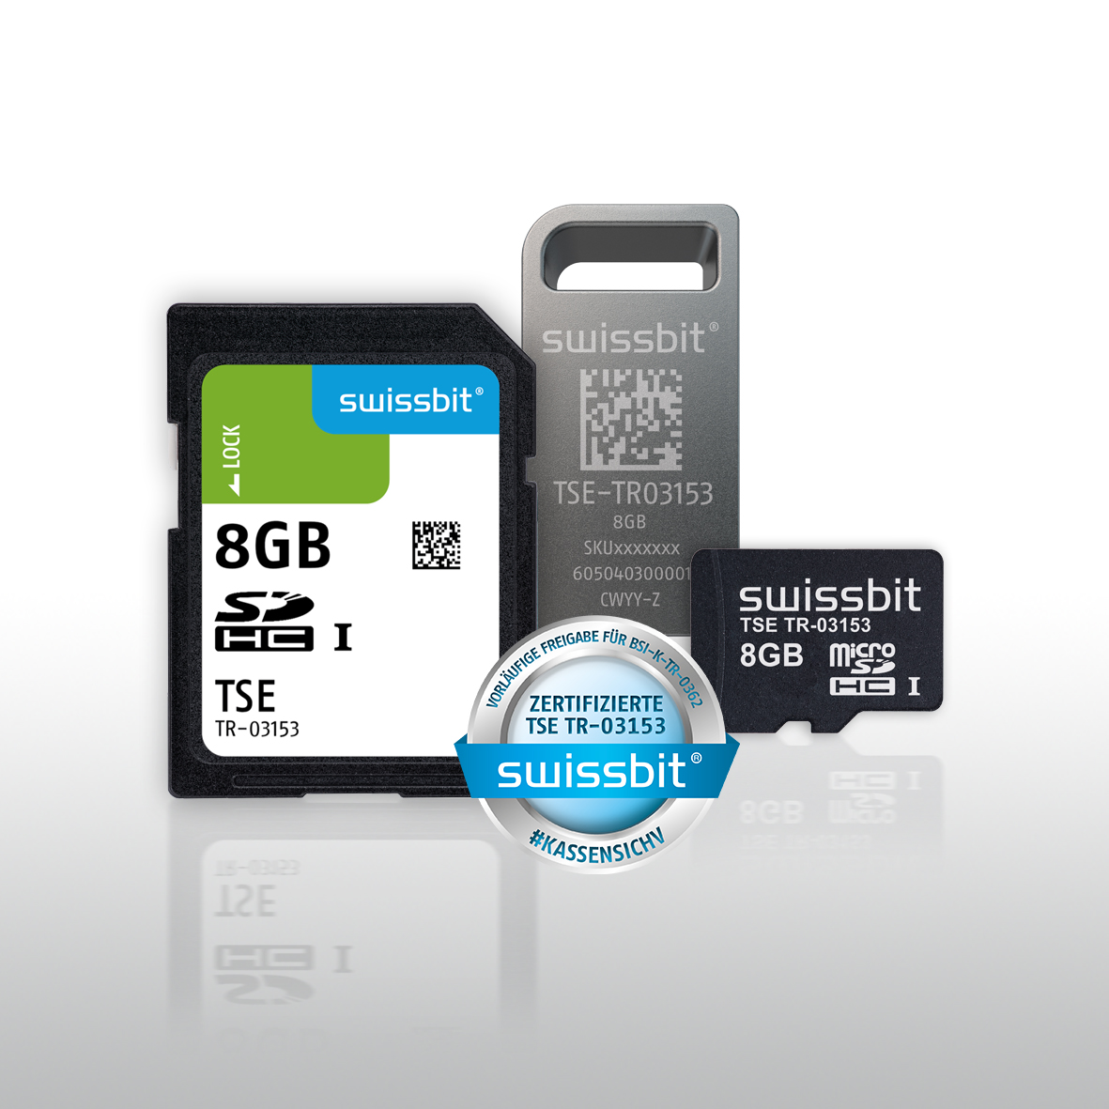Image Source: Swissbit
The certified Swissbit-TSE is available as microSD, SD and USB - without the need for any adapter for maximum reliability.

About Swissbit
Swissbit AG is the only independent manufacturer of storage and security solutions for demanding applications in the Internet of Things (IoT) in Europe. Swissbit combines its unique competences in storage and security products with its expertise in advanced packaging to store and protect data reliably in industrial, NetCom, automotive, medical and finance applications. The company develops and manufactures industrial-grade storage and security products “Made in Germany” with long-term availability, high reliability and custom optimization.
Swissbit’s storage range includes SSDs with PCIe and SATA interface such as mSATA, Slim SATA, CFast™, M.2 and 2.5” as well as CompactFlash, USB flash drives, SD, micro SD memory cards and managed NAND BGAs. Security products are available in various application specific editions as USB flash drives, SD, and micro SD memory cards. Swissbit was founded in 2001 through a management buy-out of Siemens AG, and has offices in Switzerland, Germany, USA, Japan and Taiwan.
For further information, please visit www.swissbit.com

Contact:  Swissbit AG  Zeljko Angelkoski  Industriestrasse 4  9552 Bronschhofen  Switzerland  Tel: +49 172 6325706  Email: zeljko.angelkoski@swissbit.com  www.swissbit.com | Press Agency:  HighTech communications GmbH  Brigitte Basilio  Brunhamstrasse 21  81249 Munich  Germany  Tel: +49 89 500778-20  Fax: +49 89 500778-77  Email: b.basilio@htcm.de  www.htcm.de

