PRESS RELEASE

Swissbit introduces industrial grade USB flash drive ‘U-50n’
USB 3.1 flash drive key for industrial applications
Bronschhofen, Switzerland. June 27, 2019 – Swissbit announces the introduction of its U-50n (Nano) - a small and robust USB 3.1 flash drive with capacities from 8 to 64GB intended for IoT and industrial applications which need more than just a USB drive.
The new U-50n offers all the features required by demanding applications. The specified operational temperature ranges from -40 to 85°C, metal housing provides mechanical stability, the 30µ” gold connector withstands frequent insertions and the molded COB (Chip On Board) package makes the device shock- and vibration-proof. Manufactured and tested in Swissbit´s own production site in Berlin, Germany, the Nano is a prime example of the company’s advanced packaging capabilities.
Fast and durable
The U-50n features sophisticated page-based firmware which accelerates random write operation while significantly reducing write amplification. The performance for sequential read/write access is 135/65 MB/s while the random operation excels with 2500/700 IOPS. Especially applications with high random write data rates typical for data logging use cases benefit from the for USB flash drives unprecedented endurance level.
While most USB 3.1 consumer drives are optimized for high sequential speed, the U-50n is tuned for industrial usage. Swissbit’s data care management runs in the background and constantly monitors the health of the data, refreshes weak pages, and ensures protection against sudden power losses. The U-50n is based on 15nm MLC NAND flash. Its durability and frozen BOM (Bill Of Material) makes the Nano attractive for long-term usage.
Applications with even higher performance requirements and durability are best served with the pSLC version U-56n that offers close to double the performance specifications and a seven-fold endurance-increase, which surpasses the values of most SLC flash drives available on the market.
Both variations are supported by Swissbit’s Lifetime Monitor which displays highly detailed device status information including flash utilization and WAF.
USB key with optional security features
As a specialist in combining storage and security, the PU-50n DP is Swissbit’s highly protected version of the U-50n. This device has integrated hardware encryption and access protection which by far surpasses the software solutions used by consumer devices. Equal to a credit card, the PU-50n has a retry counter which completely blocks access when a specified number of illegal password attempts has been exceeded. The PU-50n is a GDPR (EU-General Data Protection Regulation) compliant portable storage solution as well as a license and configuration token for industrial automation.
“I´m proud to announce the introduction of our U-50n which is a shining example of our impressive manufacturing capabilities and demonstrates our firmware expertise. And with the PU-50n we have created an exciting combination of reliable storage and security which is the direction Swissbit is heading” says Silvio Muschter, CEO of Swissbit.

Available images
The following images are available for download in printable format at: http://www.htcm.de/kk/swissbit
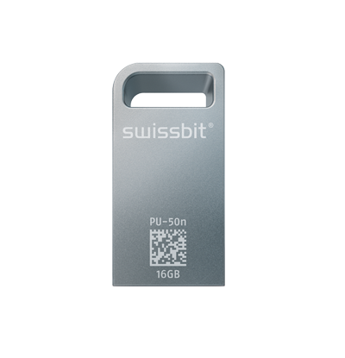
Image Source: Swissbit
Swissbit PU-50n Nano, small, reliable, durable and secure

About Swissbit
Swissbit AG is the largest independent manufacturer of storage and security solutions for demanding industrial and IoT applications in Europe. Swissbit combines its unique competences in embedded memory and flash storage products with cutting-edge security technology and its expertise in advanced packaging to store, protect and process data reliably in industrial, NetCom, automotive, medical and finance sectors. The company manufactures industrial strength flash storage and security products “Made in Germany” with long-term availability, high reliability and durability as well as custom optimization. Swissbit’s flash range includes SSDs with PCIe and SATA interface such as mSATA, Slim SATA, CFast™, M.2 and 2.5” as well as CompactFlash, USB flash drives, SD, micro SD memory cards and managed NAND BGAs. Security products are available in various application specific editions as USB flash drives, SD, and micro SD memory cards. Swissbit was founded in 2001 through a management buy-out of Siemens AG, and has offices in Switzerland, Germany, USA, Japan and Taiwan.
For further information, please visit www.swissbit.com

Contact:  Swissbit AG  Zeljko Angelkoski  Industriestrasse 4  9552 Bronschhofen  Switzerland  Tel: +49 172 6325706  Email: zeljko.angelkoski@swissbit.com  www.swissbit.com | Press Agency:  HighTech communications GmbH  Brigitte Basilio  Brunhamstrasse 21  81249 Munich  Germany  Tel: +49 89 500778-20  Fax: +49 89 500778-77  Email: b.basilio@htcm.de  www.htcm.de

