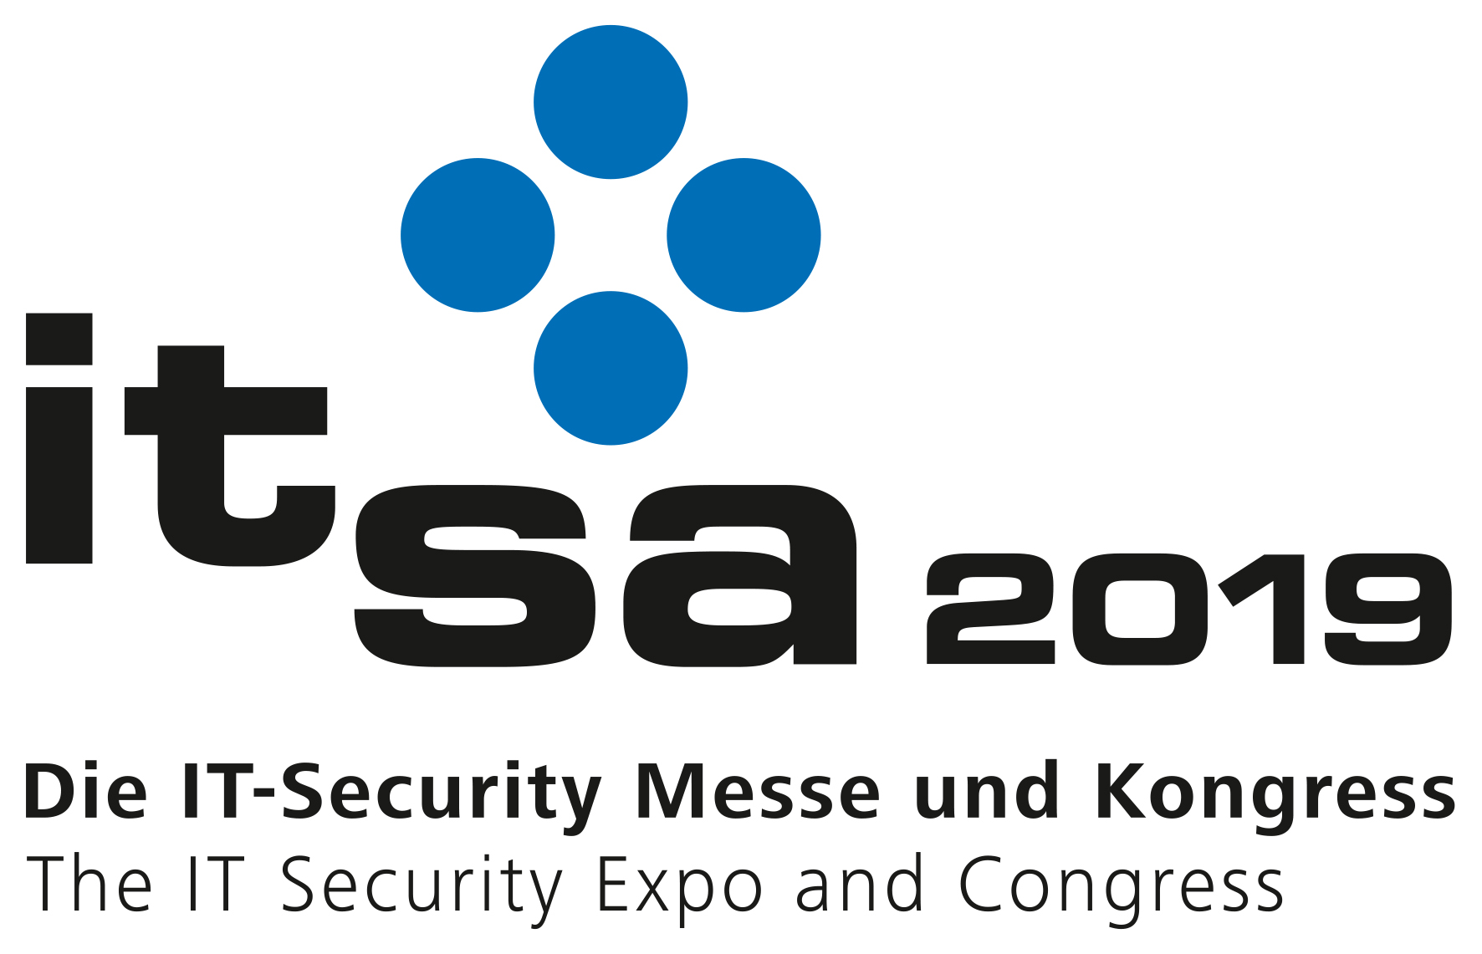
PRESS RELEASE
October 8–10 2019
Hall 10.0, Booth 409
Swissbit at it-sa 2019
Hardware-based security solutions to protect data and devices
Bronschhofen, Switzerland. September 25, 2019 – At it-sa, Swissbit AG will present innovative and industrial hardware-based security solutions to protect data and devices for Internet of Things (IoT) applications. Visit booth #409 in hall 10.0, where Swissbit will be co-exhibiting together with the Cyber-Sicherheitsrat Deutschland e.V., and where you will be able to discover these easy-to-integrate and retrofittable products. The latest application examples from the exhibition program are Swissbit’s fiscal memory solutions (TSE) for cash register manufacturers to provide tamper-proof cash-register recordings in Germany. A further highlight is the USB 3.1 stick, PU-50n DP with hardware encryption and access protection. At it-sa, Swissbit will be promoting its unique services for modular security products from its own advanced packaging production plant in Berlin. This includes customized shapes and sizes and the integration of various different components and functions into one robust module.
“The Internet of Things drastically increases demand for security solutions. Previously, only IT networks needed to be protected from attacks, today everything from industrial manufacturing plants, networked cars through to medical technologies needs to be secured. Our modular security products are based on standard interfaces and offer system manufacturers a range of hardware-based Cyber Security solutions for the protection of data and devices”, said Hubertus Grobbel, VP Security Solutions at Swissbit AG.
Unique hardware security for the protection of data and devices
Swissbit offers easy-to-integrate and retrofittable hardware-based security products enabling manufacturers to offer systems with secured devices, secure data storage and secure data communication. Swissbit security products “Made in Germany” cover many applications including secure boot and safeguarding M2M communication as well as legally compliant and tamper-proof data storage in bodycams or cash register systems. There are many scenarios where the need to store data and protect access and communication can be achieved in a single step.
Swissbit’s security products are extremely robust and durable, which makes them ideal for challenging applications with long lifetime and maintenance cycles. Thanks to the use of standard interfaces, customers can develop retrofittable and upgradable applications.
Our production plant in Berlin with state-of-the-art facilities for advanced packaging technologies offers services around modular security products such as customized shapes and sizes or the integration of various components and function into one robust module.
Retrofittable Swissbit fiscal memory for tamper-proof cash register recordings
From January 1, 2020 cash registers in Germany need to be fitted with certified technical security equipment (TSE) to provide tamper-proof recordings of cash register data. Swissbit’s TSE solution comes in the form of USB sticks, SD or microSD cards offering an easy implementable and retrofittable fiscal memory solution. Cash register manufacturers can very easily integrate the Swissbit TSE solution into conventional or PC based cash register systems. The connection is made through a USB, SD or microSD interface. Swissbit provides a SDK (Software Development Kit), drivers and support for Windows, Linux, Android and embedded systems. The future proof Swissbit solution is cost-effective and easily scalable because it can be used for stand-alone devices or in LAN configurations with several devices and parallel TSE.
Swissbit is a highly skilled specialist with over 20 years’ experience in sophisticated industrial memory and security solutions. For more than three years, Swissbit has been delivering tried and tested fiscal solutions for the fiscal market in France and other EU countries. Since September, Swissbit’s fiscal solution has also been certified for use in Slovakia.
Secure memory or token: PU-50n DP
Another product example of Swissbit’s high manufacturing expertise and the company’s innovative, highly flexible security concept is the USB 3.1 stick, PU-50n DP, with integrated hardware encryption and access protection. Similar to a credit card, the stick features a retry counter that blocks access following a defined number of failed password attempts. PU-50n DP serves as a GDPR (EU General Data Protection Regulation) compliant pocket-sized memory stick and as license and configuration token for industrial automation applications.

Available images
The following images are available for download in printable format at: http://www.htcm.de/kk/swissbit
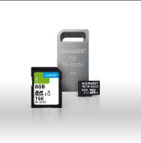  Image Source: Swissbit  Technical security equipment (TSE) to provide tamper-proof recordings of cash register data. The connection is made through a USB, SD or microSD interface. The TSE is available as solutions for stand-alone devices or for LANs. | 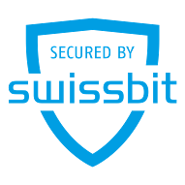  Image Source: Swissbit  At it-sa, Swissbit will showcase its hardware-based security solutions to protect data and devices.

About Swissbit
Swissbit AG is the only independent manufacturer of storage and security solutions for demanding applications in the Internet of Things (IoT) in Europe. Swissbit combines its unique competences in storage products, cutting-edge security solutions with its expertise in advanced packaging to store and protect data reliably in industrial, NetCom, automotive, medical and finance applications. The company develops and manufactures industrial-grade storage and security products “Made in Germany” with long-term availability, high reliability and custom optimization. Swissbit’s storage range includes SSDs with PCIe and SATA interface such as mSATA, Slim SATA, CFast™, M.2 and 2.5” as well as CompactFlash, USB flash drives, SD, micro SD memory cards and managed NAND BGAs. Security products are available in various application specific editions as USB flash drives, SD, and micro SD memory cards. Swissbit was founded in 2001 through a management buy-out of Siemens AG, and has offices in Switzerland, Germany, USA, Japan and Taiwan.

For further information, please visit www.swissbit.com

Contact:  Swissbit AG  Zeljko Angelkoski  Industriestrasse 4  9552 Bronschhofen  Switzerland  Tel: +49 172 6325706  Email: zeljko.angelkoski@swissbit.com  www.swissbit.com | Press Agency:  HighTech communications GmbH  Brigitte Basilio  Brunhamstrasse 21  81249 Munich  Germany  Tel: +49 89 500778-20  Fax: +49 89 500778-77  Email: b.basilio@htcm.de  www.htcm.de

