PRESS RELEASE

Swissbit extends application of TSE for networked POS systems
TSE Connector Software solution for LAN POS environments
Bronschhofen, Switzerland. 25 March 2020 – Swissbit was the first provider to offer an easy-to-integrate and cost-effective plug-in solution for tamper-proof recording of cash register data. Now the company has launched an extension software (SW) solution for LAN networks: The certified Swissbit TSE (BSI TR-03153-standard Technical Security Device) now serves to secure networked POS systems without the need for hardware modifications of individual cash registers. These can be cash registers, PC-based systems, or even handheld devices. The Swissbit TSE LAN Connector SW supports POS solution vendors to comply with regulations that came into force on 1 January 2020 in Germany for example. The SDK for simple integration is available through distributors Gastro-MIS, Jarltech and Partner Tech and licensed per retail location.
As with the standalone version, the heart of the fiscal solution is a durable, real industrial flash memory with a digital signing certificate according to TR-03145 and the Common Criteria-certified security modules BSI-PP-SMAERS and BSI-PP-CSP. The LAN Connector SW solution requires USB TSE modules to be plugged into a "master"-POS or an in-store POS server. For each USB-TSE, the TSE LAN Connector SW supports up to five POS systems simultaneously. Thus, in principle, an unlimited number of POS systems per retail location can easily be rendered compliant by one Connector SW leveraging already certified Swissbit USB-TSEs. For manufacturers of cash registers, Swissbit offers convenient software development kits for Windows, Linux and Android to set up cash registers ready for use of either locally or network connected TSE modules.
"Retailers in Germany have to comply at the very latest by the end of September 2020 with new fiscal regulations, so the short remaining time has to be used efficiently. With Swissbit's TSE LAN Connector SW retailers can now quickly retrofit their networked cash registerss. Those POS solution providers who require a networking solution, can benefit from the easy to integrate LAN Connector SW" explains Hubertus Grobbel, Vice President Security Solutions at Swissbit. "The design of our TSE LAN Connector SW for POS vendors offers ease of use, scalability, efficiency, performance and most of all compliant usage of our certified TSEs."

Easy to integrate and cost-effective
Swissbit's plug-in TSE uses standard storage interfaces and is thus perfectly positioned to retrofit legacy cash register systems. With the LAN integration SW, all devices within entire locations can be converted without hardware intervention or expensive license costs. In addition to a secure fiscal memory, which stores the automatically signed transactions, Swissbit TSEs also provide freely available user memory to cash register systems. Secure export of fiscal data is enabled by a harmonized digital interface. Swissbit will shortly be the first provider to offer an integrated interface to DATEV and Telekom Security’s fiscalization platform in the Swissbit SDK.

Available images
The following images are available for download in printable format at: http://www.htcm.de/kk/swissbit
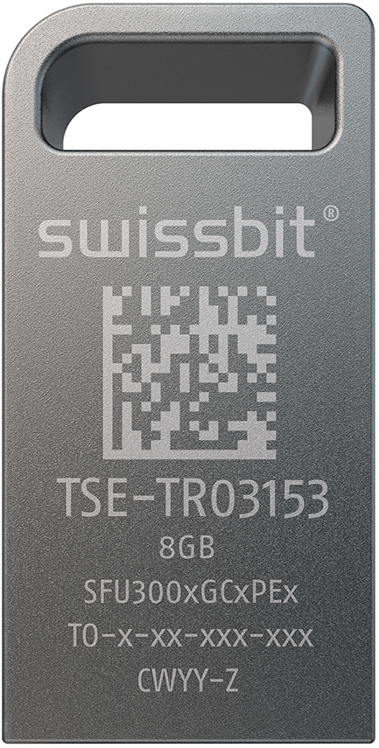  Image Source: Swissbit  Usage of Swissbit's fiscal TSE solution now extends to networked POS systems. | 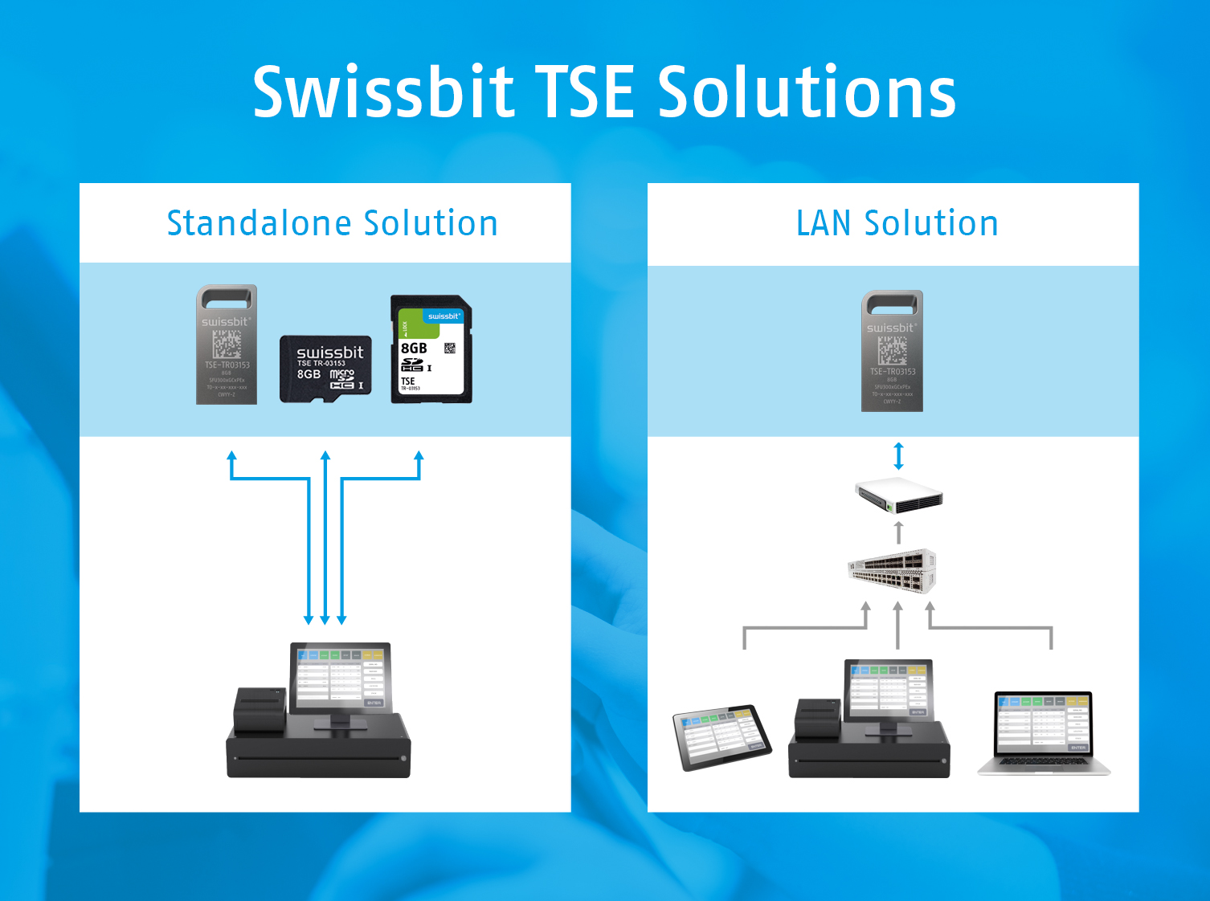  Image Source: Swissbit  Swissbit TSE as standalone and LAN-Connector SW Solution.

About Swissbit
Swissbit AG is the only independent European manufacturer of storage and embedded IoT solutions for demanding applications. Swissbit combines its unique competences in storage and embedded IoT technology with its expertise in advanced packaging to store and protect data reliably in industrial, NetCom, automotive, medical and finance applications as well as across the Internet of Things (IoT). The company develops and manufactures industrial-grade storage and security products “Made in Germany” with long-term availability, high reliability and custom optimization. Swissbit’s storage range includes SSDs with PCIe and SATA interface such as mSATA, Slim SATA, CFast™, M.2 and 2.5” as well as CompactFlash, USB flash drives, SD, micro SD memory cards and managed NAND BGAs. Security products for embedded IoT applications are available in various application specific editions as USB flash drives, SD, and micro SD memory cards. Swissbit was founded in 2001 through a management buy-out of Siemens AG, and has offices in Switzerland, Germany, USA, Japan and Taiwan.
For further information, please visit www.swissbit.com

Regional Headquarters North and South America:
Swissbit NA Inc.
238 Littelton Rd #202b
Westford, MA 01886
USA
Tel: +1 978-490-3252
Email: sales@swissbitna.com
www.swissbit.com
Contact Headquarters:  Swissbit AG  Zeljko Angelkoski  Industriestrasse 4  9552 Bronschhofen  Switzerland  Tel: +49 172 6325706  Email: zeljko.angelkoski@swissbit.com  www.swissbit.com | Press Agency:  miXim Ltd.  Kim Sauer (Mr)  Tel: +44 7906 019 022  Email: kim@miXimPR.com

