PRESS RELEASE

Swissbit e.MMC EM-20 with improved firmware
Precise lifetime forecasts of real industrial e.MMC
Bronschhofen (Switzerland). March 31, 2020 – Swissbit AG gives its proven e.MMC memory modules a firmware update. The robust and durable e.MMC 5.0 for industrial applications now features permanent lifetime monitoring. The new firmware allows very precise testing and extrapolation of aging behavior, based on the conditions of different applications. This enables reliable prediction of the lifetime of flash memory in critical applications and minimizes failures.
Swissbit offers the e.MMC 5.0, available in capacities from 4Gb to 64Gb, as a freely configurable MLC version EM-20 and as a preconfigured pSLC memory EM-26. The managed NAND modules for the industrial temperature range from -40°C to 85°C are perfect as boot data carriers as well as for write-intensive applications. As components that are permanently soldered via BGA, they cannot be replaced – therefore the prediction of the service life of an e.MMC is essential in helping to define the scope of an application.
Two major firmware improvements
The new firmware for EM-20 and EM-26 provides a very accurate counter for target, average and maximum block erases in the MLC and pSLC regions, as well as for the number of spare blocks on each chip. It also provides access via the Extended CSD Register, which is implemented as the default procedure for each e.MMC host driver. Due to this innovation, it is possible to compare the average deletion counter with the target deletion counter after a short test phase, and to then extrapolate the results reliably. Access via the Extended CSD Register has been chosen to provide a completely standard access path, unlike implementations that use vendor-specific access patterns.
For long-lasting solutions
Although the e.MMC Standard supports a basic lifetime control, it shows the percentage wear of the memory only in a coarse resolution. For reliable extrapolations within the scope of the Standard, the test time is several weeks. The lifetime forecast for a specific application profile is significantly faster and more precise thanks to the new Swissbit firmware. This makes it easier to select the capacity that is needed for the life of the application.

“We are constantly investing in the improvement of our products in order to be able to offer our customers reliable storage and embedded IoT solutions,” explains Roger Griesemer, General Manager Memory Solutions at Swissbit. “The new firmware is a big step towards effectively managing the service life of our e.MMC modules.”

Available images
The following images are available for download in printable format at: http://www.htcm.de/kk/swissbit
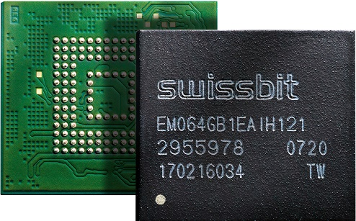
Image Source: Swissbit
Swissbit EM-20 e.MMC with FW 2.0

About Swissbit
Swissbit AG is the only independent European manufacturer of storage and embedded IoT solutions for demanding applications. Swissbit combines its unique competences in storage and embedded IoT technology with its expertise in advanced packaging to store and protect data reliably in industrial, NetCom, automotive, medical and finance applications as well as across the Internet of Things (IoT). The company develops and manufactures industrial-grade storage and security products “Made in Germany” with long-term availability, high reliability and custom optimization. Swissbit’s storage range includes SSDs with PCIe and SATA interface such as mSATA, Slim SATA, CFast™, M.2 and 2.5” as well as CompactFlash, USB flash drives, SD, micro SD memory cards and managed NAND BGAs. Security products for embedded IoT applications are available in various application specific editions as USB flash drives, SD, and micro SD memory cards. Swissbit was founded in 2001 through a management buy-out of Siemens AG, and has offices in Switzerland, Germany, USA, Japan and Taiwan.
For further information, please visit www.swissbit.com

Contact:  Swissbit AG  Zeljko Angelkoski  Industriestrasse 4  9552 Bronschhofen  Switzerland  Tel: +49 172 6325706  Email: zeljko.angelkoski@swissbit.com  www.swissbit.com | Press Agency:  HighTech communications GmbH  Brigitte Basilio  Brunhamstrasse 21  81249 Munich  Germany  Tel: +49 89 500778-20  Fax: +49 89 500778-77  Email: b.basilio@htcm.de  www.htcm.de

