
PRESS RELEASE

Swissbit joins virtual FMS 2020: Store and protect data reliably
Virtual Conference & Expo,
November 10–12, 2020
Industrial-quality memory and security products for demanding IoT applications
Bronschhofen, Switzerland. November 10, 2020 – This year it’s the world wide web instead of California for Flash Memory Summit (FMS) 2020 , which will be taking place as a virtual conference & expo from November 10 to 12, 2020. On booth #308, Swissbit will present robust memory solutions for demanding applications as well as data carriers with integrated security functions for embedded IoT applications.
At FMS 2020, Swissbit’s Embedded IoT Solutions division will showcase its hardware-based security solutions designed to protect data and devices in Internet of Things (IoT) applications.
By using familiar form factors and common flash memory media interfaces, it is possible with systems-in-package to provide M2M communication participants with forgery-proof identities, carry out data-encryption and equip embedded systems with secure boot media. Developers can test this with Swissbit’s secure boot solution for Raspberry Pi.
Endurance with 3D-NAND
With its range of data storage products, Swissbit proves that durable and reliable storage media for industrial applications are possible even based on 3D-NAND. Under the product name X-75, SATA 6 Gb/s SSDs for the industrial temperature range from -40 to +85 °C are available as 2.5-inch SSDs in the variants M.2 2280, 2242 as well as mSATA and SlimSATA. X-75 SSDs are optimized for highly consistent performance and long lifetime.
The ability to tolerate fluctuating temperatures between read and write operations across a wide temperature range is a key feature of industrial memory products such as the SD and microSD memory cards from the S-50 and S-56 series. These offer highest reliability for demanding applications such as data recorders and industrial PCs.
With its N-20m2, Swissbit offers a robust and powerful SSD featuring low power consumption and quad PCIe-3.1 interface. It is available in standard 2242 and 2280 dimensions as well as the smaller M.2 2230 form factor. This memory module is the ideal boot medium for small embedded systems and routers.
The latest e.MMC EM-30 is another product in compact BGA format. Capacities from 16 to 256 GB are available and, thanks to 3D-NAND, it is significantly more cost-effective than previous 2D-NAND products. Applications range from embedded systems, POS/POI terminals, routers and switches and EM-30 is particularly suited for factory automation, solutions for the Internet of Things (IoT) and medical technology applications.

Available images
The following images are available for download in printable format at: http://www.htcm.de/kk/swissbit
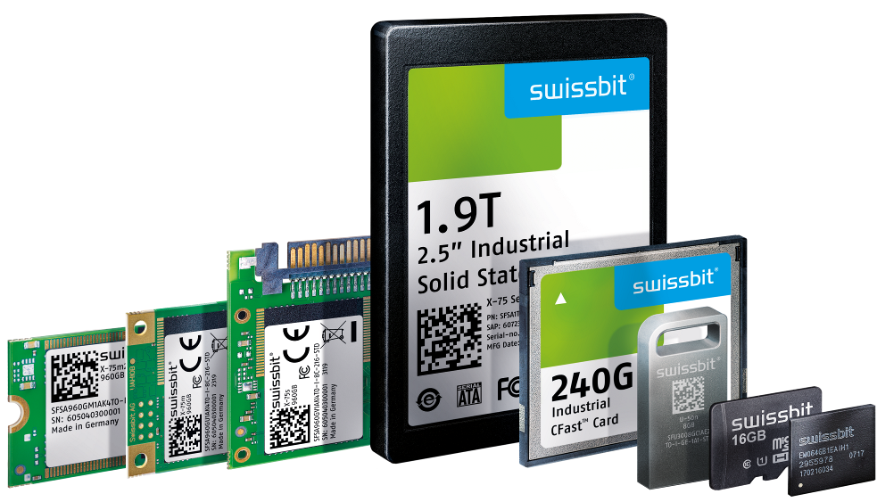  Image Source: Swissbit  Swissbit presents reliable, industrial-quality storage and security products at the virtual FMS 2020 conference & expo. | 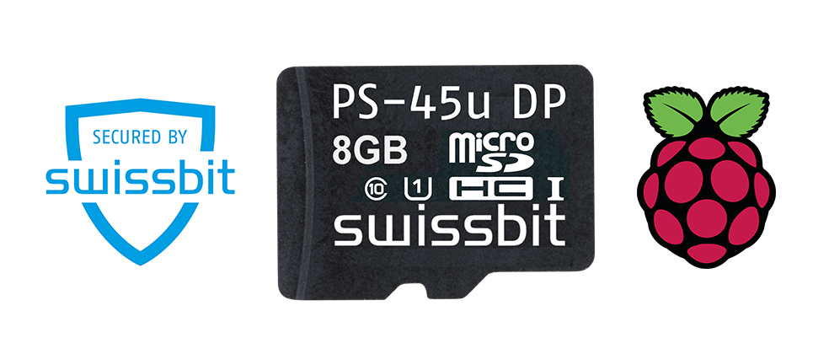  Image Source: Swissbit  The Swissbit Secure Boot Solution for Raspberry Pi includes a PS-45u-DP microSD card "Raspberry Edition" and a Software Development Kit.

About Swissbit
Swissbit AG is the only independent European manufacturer of storage and embedded IoT solutions for demanding applications. Swissbit combines its unique competences in storage and embedded IoT technology with its advanced packaging knowhow. This expertise allows our customers to reliably store and protect data in critical industrial, NetCom, automotive, medical and finance applications as well as across the Internet of Things (IoT).
Swissbit develops and manufactures industrial-grade storage and security products “Made in Germany” with high reliability, long-term availability, and custom optimization.
Swissbit’s storage range includes SSDs with PCIe and SATA interface such as mSATA, Slim SATA, CFast™, M.2 and 2.5” as well as CompactFlash, USB flash drives, SD Memory Cards, micro SD Memory Cards and managed NAND BGAs like e.MMC. Security products are available in various application specific editions as USB flash drives, SD Memory Cards, and micro SD Memory Cards.
Swissbit was founded in 2001 and has offices in Switzerland, Germany, USA, Japan and Taiwan.
For further information, please visit www.swissbit.com

Regional Headquarters:
Swissbit Germany AG
Bitterfelder Strasse 22
12681 Berlin
Germany
Tel: +49 30 936 954 0
Email: info@swissbit.com
www.swissbit.com
Headquarters:
Swissbit AG
Industriestrasse 4
9552 Bronschhofen
Switzerland
Tel: +41 71 913 03 03
Email: info@swissbit.com
www.swissbit.com
Contact:  Swissbit AG  Zeljko Angelkoski  Industriestrasse 4  9552 Bronschhofen  Switzerland  Tel: +49 172 6325706  Email: zeljko.angelkoski@swissbit.com  www.swissbit.com | Press Agency:  HighTech communications GmbH  Brigitte Basilio  Brunhamstrasse 21  81249 Munich  Germany  Tel: +49 89 500778-20  Fax: +49 89 500778-77  Email: b.basilio@htcm.de  www.htcm.de

