PRESS RELEASE
Swissbit Introduces Secure Boot Solution
Universal security solution for
Raspberry Pi
Bronschhofen, Switzerland. May 19, 2020 – Swissbit has launched a solution for the encryption and access protection of data on a Raspberry Pi to secure the boot image and the boot process. Swissbit Secure Boot Solution for Raspberry Pi consists of a PS-45u-DP-microSD card ‘Raspberry Edition’ and a software development kit. This ensures protection of the Raspberry Pi bootloader, to encrypt boot & application code (for the protection of licenses), proprietary know-how and intellectual property or to provide write-protection. The Swissbit Secure Boot Solution for Raspberry Pi can be obtained via Mouser, Farnell or Digi-Key.
The Raspberry Pi’s low-cost and widely used hardware can contain valuable and protectable data and functions. Swissbit now offers an easy-to-implement safety system based on a long-lasting flash memory suitable for industrial applications. This way, hardware-based security functions can be implemented independently of the CPU and with high flexibility – even retrospectively. The PS-45u-DP-microSD card ‘Raspberry Edition’ encrypts the data and allows access only via a flexible configurable authentication function, which unlocks further access to the data carrier in the pre-boot phase. The number of permitted invalid access attempts can be configured.
Users can implement security policies in three different ways: via PIN input, via the USB authentication dongle Swissbit USB-Stick PU-50n DP ‘Raspberry Edition’, or via a Net-Policy-Server. In addition, the microSD card can be coupled to the CPU and hence to the specific hardware (pairing).
“Devices are becoming smarter, but also more vulnerable,” explains Hubertus Grobbel, Vice President Security Solutions at Swissbit. “Users as well as manufacturers need to take greater security considerations into account when operating networked devices. At Swissbit, we offer a unique hardware-based solution for the protection of data and devices – it’s completely modular, flexible and easy to retrofit.”
The Swissbit Secure Boot Solution is suitable for Raspberry Pi 2 and 3B+. With its encryption and security functions, the flexible Swissbit solution protects against unauthorized data access, code manipulation and IP violations in applications, and ensures the system integrity of Raspberry Pi devices. It is available online through Mouser Electronics, Farnell and Digi-Key Electronics.

Available images
The following images are available for download in printable format at: http://www.htcm.de/kk/swissbit
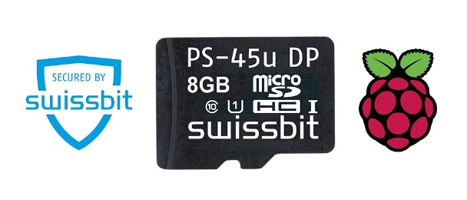
Image Source: Swissbit
Swissbit’s Secure Boot Solution for Raspberry Pi includes a PS-45u-DP-microSD card ‘Raspberry Edition’ and a software development kit.

About Swissbit
Swissbit AG is the only independent European manufacturer of storage and embedded IoT solutions for demanding applications. Swissbit combines its unique competences in storage and embedded IoT technology with its advanced packaging know how. This expertise allows our customers to reliably store and protect data in industrial, NetCom, automotive, medical and finance applications as well as across the Internet of Things (IoT).
Swissbit develops and manufactures real industrial storage and security products “Made in Germany” with long-term availability, high reliability and custom optimization.
Swissbit’s storage range includes SSDs with PCIe and SATA interface such as mSATA, Slim SATA, CFast™, M.2 and 2.5” as well as CompactFlash, USB flash drives, SD, micro SD memory cards and managed NAND BGAs. Security products for embedded IoT applications are available in various application specific editions as USB flash drives, SD, and micro SD memory cards. Swissbit was founded in 2001 and has offices in Switzerland, Germany, USA, Japan and Taiwan.
For further information, please visit www.swissbit.com

Contact:  Swissbit AG  Zeljko Angelkoski  Industriestrasse 4  9552 Bronschhofen  Switzerland  Tel: +49 172 6325706  Email: zeljko.angelkoski@swissbit.com  www.swissbit.com | Press Agency:  HighTech communications GmbH  Brigitte Basilio  Brunhamstrasse 21  81249 Munich  Germany  Tel: +49 89 500778-20  Fax: +49 89 500778-77  Email: b.basilio@htcm.de  www.htcm.de

