PRESS RELEASE
Swissbit Flash Memory for Critical Medical Applications
Immediate and long-term availability for medical technology manufacturers
Bronschhofen, Switzerland. April 23, 2020 – In the fight against the coronavirus pandemic, manufacturers of medical technology are increasing their production capacity. The critical data storage modules they require can be obtained from Swissbit. Medical device customers can continue to be sure of reliable supply by the company, which produces its memory solutions in Germany. The complete range of robust storage media used in medical technology, such as SD, microSD or compact flash cards for handheld devices or 2.5" and M.2 SSDs for medical imaging, is in stock and readily available.
Devices for medical treatment and diagnosis must not fail. Built-in memory modules must deliver the highest reliability against power failure, shock, vibration, moisture, or radiation, for example. Consequently, component qualification for medical systems is a complex and thorough process. That is why Swissbit is giving medical technology manufacturers the highest priority at this time, insulating them against potential production and supply-chain bottlenecks that can be caused by short-term increases in demand.
“There is currently great demand for storage products for critical medical devices. Our own production facility in Berlin for memory products “Made in Germany”, enables us to ensure uninterrupted, quick and reliable supply to medical technology manufacturers,” explains Roger Griesemer, General Manager Memory Solutions at Swissbit AG.
For its medical technology memory modules, Swissbit guarantees long-term availability with fixed BOM and offers expert advice on the selection of application-specific memory solutions. Whether applications primarily access memory as read, serial or block-write, Swissbit offers a full range of SSDs and memory cards specifically optimized for the demands of the medical sector.

Available images
The following images are available for download in printable format at: http://www.htcm.de/kk/swissbit

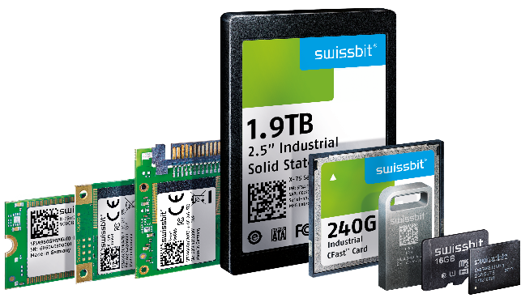
Image Source: Swissbit
Swissbit offers a wide range of products for medical devices.

About Swissbit
Swissbit AG is the only independent European manufacturer of storage and embedded IoT solutions for demanding applications. Swissbit combines its unique competences in storage and embedded IoT technology with its expertise in advanced packaging to store and protect data reliably in industrial, NetCom, automotive, medical and finance applications as well as across the Internet of Things (IoT). The company develops and manufactures industrial-grade storage and security products “Made in Germany” with long-term availability, high reliability and custom optimization. Swissbit’s storage range includes SSDs with PCIe and SATA interface such as mSATA, Slim SATA, CFast™, M.2 and 2.5” as well as CompactFlash, USB flash drives, SD, micro SD memory cards and managed NAND BGAs. Security products for embedded IoT applications are available in various application specific editions as USB flash drives, SD, and micro SD memory cards. Swissbit was founded in 2001 through a management buy-out of Siemens AG, and has offices in Switzerland, Germany, USA, Japan and Taiwan.
For further information, please visit www.swissbit.com

Contact:  Swissbit AG  Zeljko Angelkoski  Industriestrasse 4  9552 Bronschhofen  Switzerland  Tel: +49 172 6325706  Email: zeljko.angelkoski@swissbit.com  www.swissbit.com | Press Agency:  HighTech communications GmbH  Brigitte Basilio  Brunhamstrasse 21  81249 Munich  Germany  Tel: +49 89 500778-20  Fax: +49 89 500778-77  Email: b.basilio@htcm.de  www.htcm.de

