PRESS RELEASE
Swissbit EM-30: Industrial grade 3D-NAND e.MMC-5.1 BGA
Robust, reliable and cost-efficient storage device for embedded applications
Bronschhofen, Switzerland. 29 September 2020 – Swissbit extends its range of miniaturized storage solutions with the launch of its EM-30 device with an e.MMC-5.1 standard interface. The BGA package combines a modern controller with industrial grade 3D-NAND and firmware that supports the most demanding applications. Available in capacities from 16 to 256GB, EM-30 offers significant cost savings over former 2D-NAND solutions. Possible applications range from embedded systems, POS / POI terminals, factory automation, routers, and switches to solutions for the Internet of Things (IoT) and medical systems.
The EM-30 product series complies with e.MMC-5.1 specifications and is fully downward compatible. Thanks to established standards, integration is very easy. With a temperature range of -40 to +85°C, the product family is ideally suited for the most important embedded applications. With sequential data rates of up to 300 MB/s for read and 230 MB/s for write as well as 39 K IOPS and 41 K IOPS for read and write random access, EM-30 delivers the performance of SATA SSDs, but with significantly smaller size requirements and costs.
Data refresh and reliability
Similar to large SSDs, the EM-30 firmware supports automatic background data refresh of read-only areas that for instance occur with boot media. This feature coupled with strong error correction, ensures that data availability is always highly reliable, even if the data has not been accessed under prolonged periods of exposure to high temperatures.
A further special feature is the increased protection against data corruption in the event of sudden power loss, which not only occurs in regions with an unstable power supply, but also typically when handling medical devices or embedded systems.
Future proof solution
„The new e.MMC series is positioned to address the growing demands of embedded systems and their new chipsets, which typically require ultra-small, vibration-proof form factors with ever-increasing data-storage capacities. Extended Lifetime Monitoring support combined with potential in-field firmware updates without data loss and typical Swissbit longevity makes the new EM-30 series a future proof solution for our customers”, explains Roger Griesemer, General Manager Memory Solutions at Swissbit AG.
Predictable service life
The BGA component comes in an 11.5x13mm, 153 ball housing with 0.5mm pitch or optionally in a 100 ball, 1mm pitch BGA. For soldered-down components, knowing the expected service life under real conditions is important. EM-30 devices offer the option to access detailed information about the consumption of the write cycles and internal resources via standard access to the e.MMC registers without the need for special access methods or drivers. This feature goes far beyond the e.MMC standard and allows a reliable prediction of the service life in the field.
Flexible configuration
EM-30 devices can be partitioned by the user into several TLC and pSLC (enhanced reliable) segments to optimally separate read-only areas from partitions that are frequently written to. If the maximum possible endurance of the NAND is required, Swissbit offers an EM-36 variant preconfigured to 100% pSLC. These types are available in capacities between 5 and 80 GB.

Available images
The following images are available for download in printable format at: http://www.htcm.de/kk/swissbit
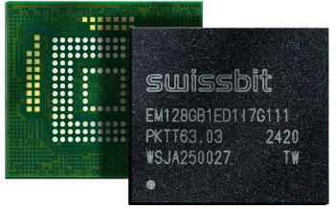  Image Source: Swissbit  Beyond the standard:  Swissbit EM-30 e.MMC-5.1 | 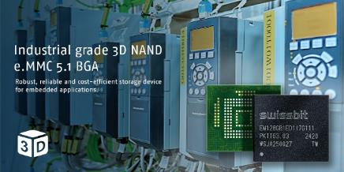  Image Source: Swissbit  Swissbit‘s memory solution EM-30 with e.MMC-5.1 is suitable for embedded systems applications, for example.

About Swissbit
Swissbit AG is the only independent European manufacturer of storage and embedded IoT solutions for demanding applications. Swissbit combines its unique competences in storage and embedded IoT technology with its advanced packaging knowhow. This expertise allows our customers to reliably store and protect data in critical industrial, NetCom, automotive, medical and finance applications as well as across the Internet of Things (IoT).
Swissbit develops and manufactures industrial-grade storage and security products “Made in Germany” with high reliability, long-term availability, and custom optimization.
Swissbit’s storage range includes SSDs with PCIe and SATA interface such as mSATA, Slim SATA, CFast™, M.2 and 2.5” as well as CompactFlash, USB flash drives, SD Memory Cards, micro SD Memory Cards and managed NAND BGAs like e.MMC. Security products are available in various application specific editions as USB flash drives, SD Memory Cards, and micro SD Memory Cards.
Swissbit was founded in 2001 and has offices in Switzerland, Germany, USA, Japan and Taiwan.
For further information, please visit www.swissbit.com

Contact:  Swissbit AG  Zeljko Angelkoski  Industriestrasse 4  9552 Bronschhofen  Switzerland  Tel: +49 172 6325706  Email: zeljko.angelkoski@swissbit.com  www.swissbit.com | Press Agency:  HighTech communications GmbH  Brigitte Basilio  Brunhamstrasse 21  81249 Munich  Germany  Tel: +49 89 500778-20  Fax: +49 89 500778-77  Email: b.basilio@htcm.de  www.htcm.de

