PRESS RELEASE

Swissbit announces long-term availability for SD and CompactFlash cards S-250 and C-350
Guaranteed: another seven years for memory cards aimed at legacy systems.
Bronschhofen, Switzerland. November 24, 2020 – Swissbit announces that it has extended the availability of its SLC-based SD memory cards, microSD memory cards and CompactFlash™ cards. The new product series S-250(u) and C-350 deploy the same product architecture as the previous S-200(u) and C-300 products. The new models replace these industrial memory products, which were introduced in 2008, and extend their availability well beyond 2027. Since the new products feature identical interfaces, controllers and NAND flash technologies, qualification of the new series can be carried out without risk and with minimal effort. This facilitates continued use in embedded control units that have already been in operation for a long time in automation, rail and avionics systems.
With the new S-250(u) and C-350 cards, Swissbit has extended the long-term availability of its robust and durable storage media to a total of almost 20 years. While NAND flash products usually have a short availability due to relatively rapid innovation cycles, Swissbit meets the critical requirements of industrial embedded systems with long life cycles through these special products. The S-250-SD and S-250u-microSD memory cards are SLC-based memory products that comply with the SD standard and support the SPI mode. The capacities range from 512MB to 2GB. The cards are specified for an industrial temperature range of -40°C to +85°C, offer a long operational life with data retention of up to ten years, and feature a robust design with an increased gold layer on the contacts. The cards are manufactured in Swissbit’s own factory in Berlin, Germany using a chip-on-board process.
New memory for legacy systems
The C-350 CompactFlash cards are available in capacities from 32MB to 256MB and support the same temperature range and functions. Historically, the CompactFlash form factor was the preferred solution for demanding industrial applications requiring easy replacement and reliable protection when used in harsh environments. Although the industry has since migrated to more modern form factors such as SD and CFast for new developments, Swissbit remains committed to supplying proven memory cards formats with long-term availability.

Industrial applications: more than just extended temperature ranges
Robust and durable memory products are predominantly used in applications that have long life cycles. Here, long-term availability is a primary requirement. “Swissbit addresses industrial applications in two different ways,” explains Roger Griesemer, General Manager Memory Solutions at Swissbit AG. “On the one hand, we support the demand for state-of-the-art technology with large capacities and high performance at low total cost. On the other hand, we know that there are many legacy systems that still need support and will remain in the field for another decade. Swissbit serves both markets with passion, commitment and the optimum products.”

Available images
The following images are available for download in printable format at: http://www.htcm.de/kk/swissbit
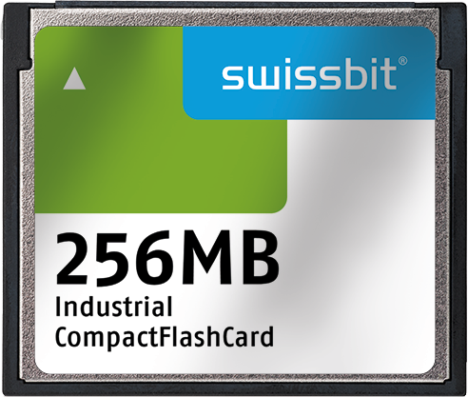  Image Source: Swissbit  C-350 CompactFlash cards – continue to be in demand for industrial applications. Swissbit ensures long-term availability. | 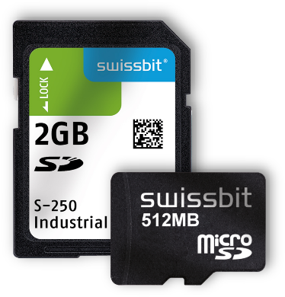  Image Source: Swissbit  SLC NAND-based SD cards for industrial applications.

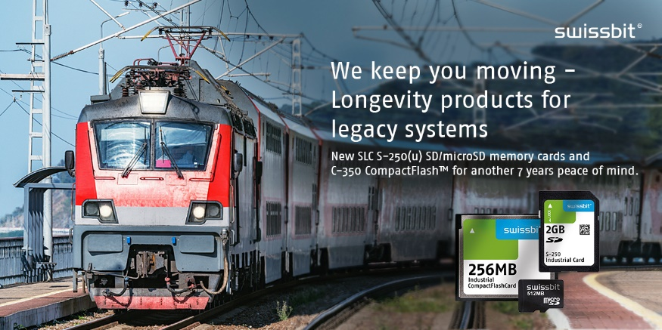
Image Source: Swissbit
Swissbit provides storage media for legacy systems, for example for transportation applications.

About Swissbit
Swissbit AG is the only independent European manufacturer of storage and embedded IoT solutions for demanding applications. Swissbit combines its unique competences in storage and embedded IoT technology with its advanced packaging knowhow. This expertise allows our customers to reliably store and protect data in critical industrial, NetCom, automotive, medical and finance applications as well as across the Internet of Things (IoT).
Swissbit develops and manufactures industrial-grade storage and security products “Made in Germany” with high reliability, long-term availability, and custom optimization.
Swissbit’s storage range includes SSDs with PCIe and SATA interface such as mSATA, Slim SATA, CFast™, M.2 and 2.5” as well as CompactFlash, USB flash drives, SD Memory Cards, micro SD Memory Cards and managed NAND BGAs like e.MMC. Security products are available in various application specific editions as USB flash drives, SD Memory Cards, and micro SD Memory Cards.
Swissbit was founded in 2001 and has offices in Switzerland, Germany, USA, Japan and Taiwan.
For further information, please visit www.swissbit.com

Regional Headquarters:
Swissbit Germany AG
Bitterfelder Strasse 22
12681 Berlin
Germany
Tel: +49 30 936 954 0
Email: info@swissbit.com
www.swissbit.com
Headquarters:
Swissbit AG
Industriestrasse 4
9552 Bronschhofen
Switzerland
Tel: +41 71 913 03 03
Email: info@swissbit.com
www.swissbit.com

Contact:  Swissbit AG  Zeljko Angelkoski  Industriestrasse 4  9552 Bronschhofen  Switzerland  Tel: +49 172 6325706  Email: zeljko.angelkoski@swissbit.com  www.swissbit.com | Press Agency:  HighTech communications GmbH  Brigitte Basilio  Brunhamstrasse 21  81249 Munich  Germany  Tel: +49 89 500778-20  Fax: +49 89 500778-77  Email: b.basilio@htcm.de  www.htcm.de

