PRESS RELEASE

Swissbit launches CFast™ memory card F-800 for industrial high-end applications
Extremely robust with SLC-NAND technology for durable applications
Bronschhofen, Switzerland. December 01, 2020 – In response to the rising demand for robust boot drives and removable data storage in the proven CFast™ form factor, Swissbit has launched its latest F-800 product series. Featuring high-quality SLC-NAND flash memory chips and the very latest controller firmware, F-800 offers maximum performance, durability, and reliability as memory for embedded systems and industrial applications. This includes high temperature tolerance and protection against data loss in case of power failure.
CFast™ has become a popular storage solution for embedded systems in industrial automation and motion control, POS/POI terminals, industrial PCs, transportation and medical technology thanks to the combination of SATA protocol and a CompactFlash form factor of 36.4×42.8×3.6mm. "With the latest DRAM-less controller architecture, autonomous data care management and intelligent diagnostic extensions for predictive maintenance as well as guaranteed long-term availability, Swissbit F-800 is the perfect removable storage medium for demanding and durable industrial applications", explains Roger Griesemer, General Manager Memory Solutions at Swissbit AG.
The F-800 series is available in various capacities from 2 to 64 GB and is characterized by low power consumption and low heat generation. Sophisticated firmware functions for active and passive data maintenance and the protection against data loss in the event of power failure ensure reliable data retention. Through the provision of detailed lifetime information, long maintenance cycles can be easily scheduled. F-800 is specified for an operating temperature range from -40 to +85 °C.
Playing it safe thanks to the controller and firmware
The combination of a DRAM-less flash memory controller and powerful, robust SLC-NAND flash makes Swissbit F-800 exceptionally reliable from the outset. Firmware features provide additional security: Background Media Refresh, end-to-end data path protection, SRAM ECC, Subpage-based Flash Translation Layer (FTL) and optional security features such as AES-128/256 encryption and TCG Opal. The unique performance of the CFast™ memory card, especially by low densities, opens up even greater application opportunities: sequential data rates of up to 320 MB/s in read and 168 MB/s in write mode.
For use in less harsh environments, Swissbit F-800 is available in a version that specifies an operating temperature range of 0 to +70 °C. The interface complies with SATA III 6 Gb/s and is backward compatible with SATA II and SATA I.

Available images
The following images are available for download in printable format at: http://www.htcm.de/kk/swissbit
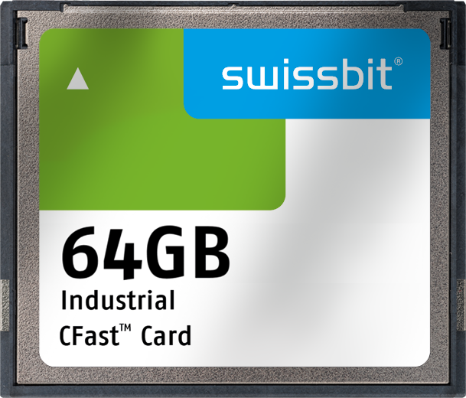  Image Source: Swissbit  With SLC-NAND technology, the CFast™ memory card F-800 is extremely robust and the perfect removable storage medium for demanding and durable applications. |  Image Source: Swissbit  CFast™ memory card F-800 from Swissbit for high-end industrial applications.

About Swissbit
Swissbit AG is the only independent European manufacturer of storage and embedded IoT solutions for demanding applications. Swissbit combines its unique competences in storage and embedded IoT technology with its advanced packaging knowhow. This expertise allows our customers to reliably store and protect data in critical industrial, NetCom, automotive, medical and finance applications as well as across the Internet of Things (IoT).
Swissbit develops and manufactures industrial-grade storage and security products “Made in Germany” with high reliability, long-term availability, and custom optimization.
Swissbit’s storage range includes SSDs with PCIe and SATA interface such as mSATA, Slim SATA, CFast™, M.2 and 2.5” as well as CompactFlash, USB flash drives, SD Memory Cards, micro SD Memory Cards and managed NAND BGAs like e.MMC. Security products are available in various application specific editions as USB flash drives, SD Memory Cards, and micro SD Memory Cards.
Swissbit was founded in 2001 and has offices in Switzerland, Germany, USA, Japan and Taiwan.
For further information, please visit www.swissbit.com

Regional Headquarters:
Swissbit Germany AG
Bitterfelder Strasse 22
12681 Berlin
Germany
Tel: +49 30 936 954 0
Email: info@swissbit.com
www.swissbit.com
Headquarters:
Swissbit AG
Industriestrasse 4
9552 Bronschhofen
Switzerland
Tel: +41 71 913 03 03
Email: info@swissbit.com
www.swissbit.com
Contact:  Swissbit AG  Zeljko Angelkoski  Industriestrasse 4  9552 Bronschhofen  Switzerland  Tel: +49 172 6325706  Email: zeljko.angelkoski@swissbit.com  www.swissbit.com | Press Agency:  HighTech communications GmbH  Brigitte Basilio  Brunhamstrasse 21  81249 Munich  Germany  Tel: +49 89 500778-20  Fax: +49 89 500778-77  Email: b.basilio@htcm.de  www.htcm.de

