Racing sports promote development of electric powertrains and e-Mobility: Würth Elektronik eiSos is new innovation partner of ABT Sportsline in the Formula E

Nuremberg/Waldenburg, Germany, July 7, 2014 – Würth Elektronik eiSos GmbH & Co. KG, German manufacturer of electronic and electromechanical components, is a new partner and sponsor of the Formula E Racing Team of ABT Sportsline. The CEOs of Würth Elektronik eiSos, Oliver Konz and Thomas Schrott, as well as Hans-Jürgen Abt, managing director of ABT Sportsline GmbH, signed an official agreement at the Norisring in Nuremberg on July 29, 2014. The Kemptener racing team is the only German team that will drive in the recently established FIA Formula E Championship in the 2014/2015 season; it will compete in ten races for the Formula E Championship of the electric racing cars. The opening race will start in Peking on September 13, 2014. In Europe, the Formula E circus will make its appearance for the first time on May 9, 2015 at the famous city course in the Principality of Monaco. Other races will take place in Malaysia, Uruguay, Argentina, the U.S. and England. The home contest for the ABT Sportsline team will be the race on May 30, 2015 in Berlin. Würth Elektronik eiSos expects that in addition to increasing brand awareness, its involvement in Formula E will provide an important stimulus for the technological development of components for electric drives and e-Mobility.

"Racing in the past was important for vehicle development, and it still is today. Innovations from racing cars later benefit vehicles produced in series. We are convinced: the new Formula E will promote the technical development of battery technology, materials, electric motors and components. Interest in the new racing series is huge. Exciting tournaments in many metropolitan areas of the world will demonstrate the economic potential and appeal of modern electric cars," say Oliver Konz and Thomas Schrott, CEOs at Würth Elektronik eiSos, in explaining the company's involvement in the new racing series. "For us as a developer and manufacturer of electronic and electromechanical components, Formula E not only offers a fabulous advertising platform, but we also gain first-hand experience in developing the future e-Mobility market and in introducing our innovative products even at this early stage." Alexander Gerfer, CTO, and Oliver Opitz, Division Managers of Strategic Product Development (both at Würth Elektronik eiSos), add that Würth Elektronik eiSos has been engaged in highly-efficient and low-loss component solutions for many years. This includes low-loss inductors and transformers, as well as high-performance connectors and high-capacity, short-term memories that can be used, for example, in battery charging technology.

Hans-Jürgen Abt, managing director at ABT Sportsline GmbH, remarked at the signing of the agreement: "Würth and ABT Sportsline have had a successful partnership with each other for many years both in racing and day-to-day business. So I am especially pleased that we are now continuing our collaboration with Elektronik eiSos as we enter the future of motor sports. Formula E is a big adventure for drivers, teams and sponsors. It's nice to experience this adventure with another reliable partner at our side. The innovative spirit of Würth Elektronik eiSos fits perfectly with our team."

High-performance eBolides
In the first season in 2014/2015, a total of ten Formula E teams in identical racing cars will go to the starting line using drives and transmissions from the high-tech forges of McLaren. Even racing cars in this season will have a boost mode for passing maneuvers in excess of 200 kW (270 horsepower) when they hit the road.

The companies will integrate their own developments into the vehicles at future Formula E championships. In the medium term, they will then participate in competitions with their very own Formula E racing cars.

Further information is available online at:
Würth Elektronik eiSos www.we-online.de
ABT Sportsline GmbH www.abt-sportsline.de
FIA Formula E Championship www.fiaformulae.com

Available images
The following printable images can be downloaded at: http://www.htcm.de/kk/wuerth
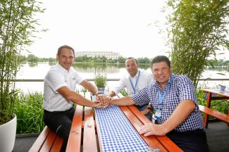  Picture source: ABT Sportsline GmbH  Symbolic handshake for a successful collaboration at the DTM race on the Norisring in Nuremberg: Hans-Jürgen Abt (managing director of ABT Sportsline GmbH), Thomas Schrott and Oliver Konz (CEOs of the Würth Elektronik eiSos Group) (left to right) | 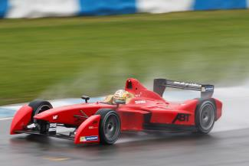  Picture source: ABT Sportsline GmbH  Formula E racing car from ABT Sportsline
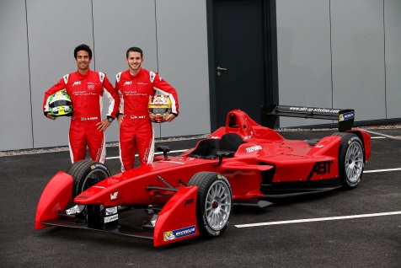  Picture source: ABT Sportsline GmbH  Formula E drivers from ABT Sportsline: Lucas di Grassi (left) and Daniel Abt | 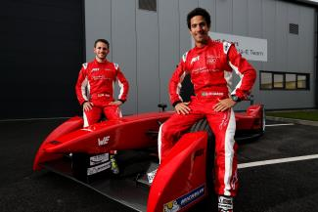  Picture source: ABT Sportsline GmbH  Formula E drivers from ABT Sportsline: Daniel Abt (left) and Lucas di Grassi

About Abt Sportsline GmbH:

ABT Sportsline is a worldwide leading customizer of vehicles for the Volkswagen Group and a successful motor sports team. A family company founded in 1896, it is now being managed by family members in the fourth generation. With more than 170 employees in Kempten (in the southern German region of Allgäu), 130 partners in Germany, and partners in 50 countries, ABT Sportsline is well established both nationally and internationally. Over the last six decades another focus of the company has been motor sports. ABT Sportsline has won victories and titles in all speedway categories and with its five titles is one of the most successful teams in the recent history of the DTM, the international touring car racing series.

About Würth Elektronik eiSos GmbH & Co. KG:

Würth Elektronik eiSos GmbH & Co. KG is a manufacturer of electronic and electromechanical components for the electronics industry. The company is part of the Würth Group, the global market leader for fastener technology. It employs 5,000 people and generated sales of 335 million Euros in 2013. Würth Elektronik eiSos is active with direct sales in 50 countries worldwide.

Manufacturing facilities in Europe, Asia and North America ensure the delivery of the growing customer basis. The product range covers EMC components, inductors, RF inductors and LTCC components, transformers, components for circuit protection, power modules, LEDs, connectors, switches, power elements in press-fit technology and assembly technique.

Würth Elektronik eiSos is one of Europe's largest manufacturers of passive components.

Würth Elektronik: more than you expect!

