Würth Elektronik eiSos continues to grow: Groundbreaking ceremony for logistics center
Waldenburg, Germany, 28 October 2014 – With a festive groundbreaking ceremony, the electronic component manufacturer Würth Elektronik eiSos GmbH & Co. KG yesterday commenced construction work on its new warehouse and logistics complex at the Waldenburg (Germany) site. The 25 million euro investment in expansion will be concluded by the middle of next year. The construction project is primarily driven by the company's strong growth. At the same time the company is expanding its service offering with the building work. This will mean that instead of 10,000 at present, there will be capacity to deliver over 30,000 products from stock in the future. Subpackaging units and samples will then be sent on their way in a largely automated process. With this and many other value-added services, Würth Elektronik eiSos is consistently simplifying and accelerating logistics processes for its customers.
Fully automated small parts warehouse
The new facilities consist of two building segments. In the three-storey function building, incoming and outgoing goods will be accommodated with a total of 10 loading ramps. The second segment consists of a fully automated small parts warehouse. In the first expansion phase, this so-called shuttle warehouse will comprise six aisles with around 85,000 racking slots on 32 levels.
Following inauguration of the Technology Center in 2012, the logistics expansion is the second new building project within a short time. Both projects reflect the component manufacturer's strong growth and demonstrate how the Waldenburg company is investing in developing its service leadership in the industry.

Available images
The following printable images can be downloaded at: http://www.htcm.de/kk/wuerth
Groundbreaking ceremony for logistics expansion at Würth Elektronik eiSos in Waldenburg
F.l.t.r.: Robert Friedmann, Chairman of the Central Managing Board of the Würth Group; Lorenz Kraft, Kraft + Kraft Architekten; Jürgen Klohe, Member of the Executive Board of the Würth Group ; Oliver Konz, CEO Würth Elektronik eiSos Group; Thomas Schrott, CEO Würth Elektronik eiSos Group; Christian Freiherr von Stetten, Member of the Bundestag, CDU; Joachim Schaaf, Association Chairman of the Administration Union of the Industrial Park Hohenlohe & Mayor of Kupferzell; Eckhart Rist, Ed. Züblin AG
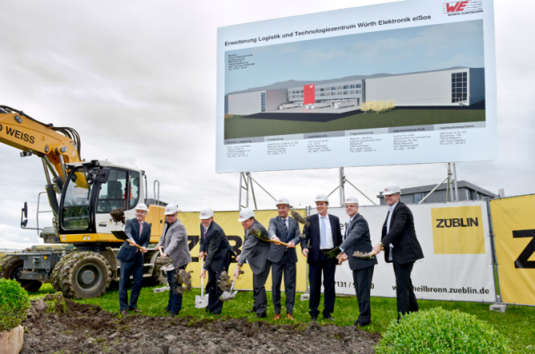
Picture source: Würth Elektronik eiSos
About Würth Elektronik eiSos

Würth Elektronik eiSos GmbH & Co. KG is a manufacturer of electronic and electromechanical components for the electronics industry. The company is part of the Würth Group, the global market leader for fastener technology. It employs 6,000 people and generated sales of 335 million Euros in 2013. Würth Elektronik eiSos is active with direct sales in 50 countries worldwide.

Manufacturing facilities in Europe, Asia and North America ensure the delivery of the growing customer basis. The product range covers EMC components, inductors, RF inductors and LTCC components, transformers, components for circuit protection, power modules, LEDs, connectors, switches, power elements in press-fit technology and assembly technique.

Würth Elektronik eiSos is one of Europe's largest manufacturers of passive components.

Würth Elektronik: more than you expect!

