Würth Elektronik eiSos presents SMD air coils for high-frequency applications: high Q-factor, high rated current, high frequencies

Waldenburg, Germany, 24 February 2015
High-frequency applications, especially in the area of radio technology, require air coils with a particularly high Q-factor. Specifically adapted to the current market requirements for this area of applications, Würth Elektronik eiSos is now expanding its portfolio of WE-CAIR air coils by the new design types 1322 and 1340. These new types are one-third flatter than the current types of this series of products. The new 1320 type in the WE-CAIR series has a 20% higher rated current with the conventional ceramic coils in the 0805 chip format. Its high Q-factor remains stable even in the high MHz range, thus enabling these extremely flat air coils to be used over a broad spectrum of frequencies. Thanks to the air coil, the inductance can be kept constant all the way into the GHz range, meaning that these new air coils are predestined for use in radio-engineering applications. A compact design combined with a high Q-factor and a high rated current enables use in HF front-ends of all kinds and for the adjustment of the impedance of antennas for diverse frequency bands. Samples are available free of charge on request. All products are available from stocks.

For further information please go to www.we-online.de

Available image material
The following image material is available in the internet for downloading: http://www.htcm.de/kk/wuerth
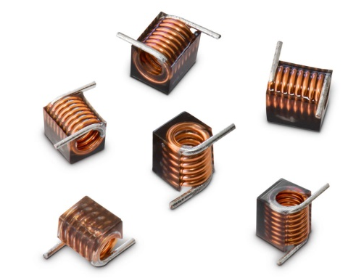

Image source: Würth Elektronik eiSos
New SMD air coils for high-frequency applications by Würth Elektronik eiSos

About Würth Elektronik eiSos GmbH & Co. KG

Würth Elektronik eiSos GmbH & Co. KG is a manufacturer of electronic and electromechanical components for the electronics industry. The company is part of the Würth Group, the global market leader for fastener technology. It employs 6,000 people and generated sales of almost 400 million Euros in 2014. Würth Elektronik eiSos is active in 50 countries worldwide.

Manufacturing facilities in Europe, Asia and North America ensure delivery to a customer base that is growing worldwide. The product range covers EMC components, inductors, transformers, HF components, varistors, capacitors, power modules, LEDs, connectors, power elements, switches and assembly technology.

Würth Elektronik eiSos is one of Europe's largest manufacturers of passive components.

Würth Elektronik: more than you expect!

