Würth Elektronik offers practical search functions for EMC: Finding the right metrology lab

Waldenburg, Germany, 2 July 2015

On its homepage we-online.de/messlabore, Würth Elektronik offers a service for electronics manufacturers as well as EMC laboratories. Using a directory of more than 400 laboratories worldwide, manufacturers can search for the right partners for EMC tests and certifications. A selection page makes it easy to search among different criteria and areas of specialization. For test labs the directory provides a way to establish contact with new customers using the frequently-visited homepage of Würth Elektronik at no cost.

From CE to cars
By using the EMC laboratory directory of Würth Elektronik, electronics manufacturers can search for service providers with whom they can consult on EMC, CE or FCC seals of approval related to their development or manufacturing issues. When they enter their information, the service providers, notified agencies and accredited laboratories indicate what kinds of EMC tests they offer, e.g. emission and interference immunity, whether they carry out CE-related tests, and if they perform measurements on site at the company's own location. The directory can also be used to run searches for laboratories that perform network analyses or environmental simulations. Particular areas of focus within the industry can also be entered to narrow down the selection, e.g. specializations in telecommunications or demands of the automotive industry, aviation, astronautics, or medical technology.

More information at www.we-online.de

Available image material
The following image material is available in the internet for downloading: http://www.htcm.de/kk/wuerth
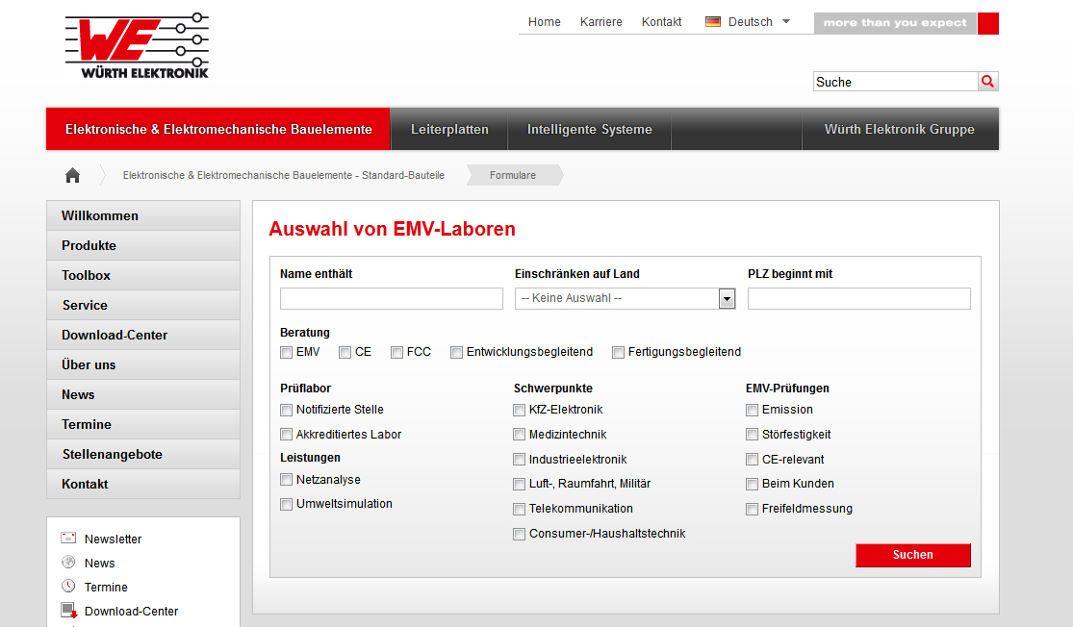

Image source: Würth Elektronik eiSos
Manufacturers and specialized metering service providers can come together when they use the EMC laboratory directory on the Würth Elektronik homepage.

About Würth Elektronik eiSos GmbH & Co. KG

Würth Elektronik eiSos GmbH & Co. KG is a manufacturer of electronic and electromechanical components for the electronics industry. The company is part of the Würth Group, the global market leader for fastener technology. It employs 6,100 people and generated sales of almost 400 million Euros in 2014. Würth Elektronik eiSos is active in 50 countries worldwide.

Manufacturing facilities in Europe, Asia and North America ensure delivery to a customer base that is growing worldwide. The product range covers EMC components, inductors, transformers, HF components, varistors, capacitors, power modules, LEDs, connectors, power elements, switches and assembly technology.

Würth Elektronik eiSos is one of Europe's largest manufacturers of passive components.

Würth Elektronik: more than you expect!

