Würth Elektronik eiSos brings you the latest:
Wireless Power Consortium (WPC) expands standard

Waldenburg, Germany, 23 April 2015

The WPC announced the addition of the 15-W and "multi-device charging" options to the Qi standard. Draft versions of the specs were released to its members.
http://www.wirelesspowerconsortium.com/data/downloadables/1/3/6/2/technology-milestones-for-fast-charging-and-resonant-multi-device-charging-with-spatial-freedom.pdf

Würth Elektronik eiSos, as Full Member of the WPC, welcomes and supports these activities.

All WPCC transmitter coils from Würth Elektronik already meet the new medium-power requirements of the specs. Würth Elektronik thus offers its customers solutions with a guaranteed future. The efficiency that can be achieved with WE Wireless Power Coils is over 88 %. With a temperature range of -20 °C to +105 °C, Würth Elektronik also offers a solution for a broad spectrum of applications. All WPCC coils from Würth Elektronik have very low R_{DC} and due to their high quality they are ideally suited for use in professional applications.

The comprehensive coil program of 14 transmitter and 12 receiver coils supports customers in selecting just the right coil for their device. Würth Elektronik also offers expertise in creating customized coil solutions.
Würth Elektronik is committed to the WPC's wireless power technology and actively contributes its expertise to the work of standardization.
As usual with Würth Elektronik, all wireless power coils are available ex warehouse.

More information at www.we-online.de

Available picture material
The following picture material is printable and available for downloading at: http://www.htcm.de/kk/wuerth
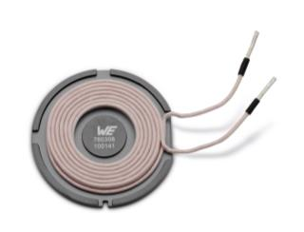  Image source: Würth Elektronik eiSos  WPCC Transmitter coil (760308100141/ø50) from Würth Elektronik eiSos | 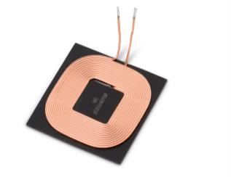  Image source: Würth Elektronik eiSos  WPCC Transmitter coil (760308103207/4040) from Würth Elektronik eiSos

About Würth Elektronik eiSos GmbH & Co. KG

Würth Elektronik eiSos GmbH & Co. KG is a manufacturer of electronic and electromechanical components for the electronics industry. The company is part of the Würth Group, the global market leader for fastener technology. It employs 6,100 people and generated sales of almost 400 million Euros in 2014. Würth Elektronik eiSos is active in 50 countries worldwide.

Manufacturing facilities in Europe, Asia and North America ensure delivery to a customer base that is growing worldwide. The product range covers EMC components, inductors, transformers, HF components, varistors, capacitors, power modules, LEDs, connectors, power elements, switches and assembly technology.

Würth Elektronik eiSos is one of Europe's largest manufacturers of passive components.

Würth Elektronik: more than you expect!

