Würth Elektronik eiSos is expanding its seminar program: Practice-oriented know-how on electromechanics

Waldenburg, Germany, 27 May 2015

Würth Elektronik eiSos is expanding its program of free seminars. In addition to popular events on EMC and power design, new seminars are now being offered in the area of electromechanics – if desired, also as customized in-house training at customer sites.

In the seminars the speakers deepen the knowledge of electronics developers and technicians in order to improve selection and use of Würth Elektronik eiSos components in applications. Topics on electromechanics will be taught such as the HF behavior of standard circuit board connectors, connector contacts and surfaces, high-current circuit technology of circuit board connectors by means of press-fit technology, and the basics of crimping technology. The free seminars look not only at technological aspects but also discuss cost-benefit aspects for manufacturing and application.

Seminar program and registration at www.we-online.de/seminare

More information at www.we-online.de

Available picture material
The following picture material is printable and available for downloading at: http://www.htcm.de/kk/wuerth
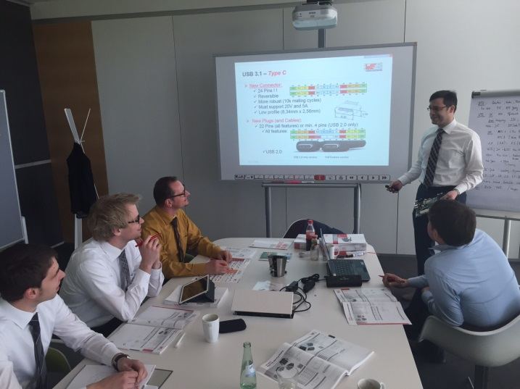
Picture source: Würth Elektronik eiSos
In the future Würth Elektronik eiSos will also be offering seminars related to electromechanics.

About Würth Elektronik eiSos GmbH & Co. KG

Würth Elektronik eiSos GmbH & Co. KG is a manufacturer of electronic and electromechanical components for the electronics industry. The company is part of the Würth Group, the global market leader for fastener technology. It employs 6,100 people and generated sales of almost 400 million Euros in 2014. Würth Elektronik eiSos is active in 50 countries worldwide.

Manufacturing facilities in Europe, Asia and North America ensure delivery to a customer base that is growing worldwide. The product range covers EMC components, inductors, transformers, HF components, varistors, capacitors, power modules, LEDs, connectors, power elements, switches and assembly technology.

Würth Elektronik eiSos is one of Europe's largest manufacturers of passive components.

Würth Elektronik: more than you expect!

