PCIM Europe Trade Fair:
Würth Elektronik eiSos with extensive line of new components

Waldenburg, Germany, 28 April 2015

Würth Elektronik eiSos GmbH & Co. KG, leading manufacturer of electronic and electromechanical components, will be represented at the PCIM Europe 2015 (19-21 May 2015). The company will underscore its significance as an innovative manufacturer of components in Hall 7 at booth 219 of the Nuremberg Trade Fair. In addition to a large number of new components of very different types, the company will also introduce its new complete catalogue, "Passive Components 2015/2016" at the PCIM.

Smallest storage choke and USB with EMC
One of the trade fair premiers at our booth: The smallest storage choke in the world will be introduced; it is called the WE-MAPI and is 1.6 x 1.6 x 1.0 mm. WE-MAPI features outstandingly high saturation currents and low resistance. Also new: the WE-EPLE. The USB 2.0 type A jack is the first USB 2.0 jack with fully integrated EMC filter and ESD protection. The new component is pin-compatible with most existing THT USB 2.0 jacks and an efficient shortcut for a successful EMC test.

Expanded line of capacitors
A significantly expanded line of capacitors will attract lots of fair visitors, e.g. radio interference suppression capacitors for network filtering as X and Y capacitor.

The WE-XHMI and WE-FAMI are highlights in the area of high-current inductors. WE-XHMI is a molded high-current inductor with flat-wire contact. Compared with previous storage chokes the new series features 50% less DC resistance. WE-FAMI is a THT high-current inductor made of combined core materials. Due to its ideal material composition the new WE-FAMI series has 60% more saturation current than comparable series.

Combined core materials
Combined materials are also the secret for success of current-compensated common-mode chokes: the component has a double core made of manganese-zinc and nickel-zinc. Its insertion loss affects a broader frequency range than a single NiZn or MnZn core. This current-compensated common-mode choke is designed for network applications with a broadband interference spectrum in EMC, network or common-mode filters, especially in power electronics and motor suppression.

Connector service
At the PCIM Würth Elektronik eiSos will also be informing visitors about a new service with the name "WE Plus": if requested, customized connectors will now be delivered ex warehouse. The products also include numerous new components such as terminal blocks in the wire protection and tensioning clamp system.

Live demonstrations
For the release of the new Infineon XMC Digital Power Explorer Kit there will be two live demonstrations daily at the PCIM booth of Würth Elektronik eiSos. At 10:30 am and 1:30 pm detailed product information will be available and insights into functionality will be shared with fair visitors.

More information at www.we-online.de

Available picture material
The following picture material is printable and available for downloading at: http://www.htcm.de/kk/wuerth
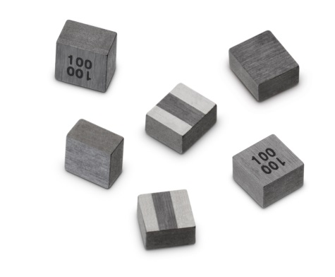
Picture source: Würth Elektronik eiSos
New WE-MAPI designs from Würth Elektronik eiSos

About Würth Elektronik eiSos GmbH & Co. KG

Würth Elektronik eiSos GmbH & Co. KG is a manufacturer of electronic and electromechanical components for the electronics industry. The company is part of the Würth Group, the global market leader for fastener technology. It employs 6,100 people and generated sales of almost 400 million Euros in 2014. Würth Elektronik eiSos is active in 50 countries worldwide.

Manufacturing facilities in Europe, Asia and North America ensure delivery to a customer base that is growing worldwide. The product range covers EMC components, inductors, transformers, HF components, varistors, capacitors, power modules, LEDs, connectors, power elements, switches and assembly technology.

Würth Elektronik eiSos is one of Europe's largest manufacturers of passive components.

Würth Elektronik: more than you expect!

