Würth Elektronik joins Diversity Charter:
Diversity as opportunity

Niedernhall, Germany, 19 August 2015

At the Third German Diversity Day on 9 June 2015 in Heilbronn, the Würth Elektronik Group joined the Diversity Charter, together with 38 other companies and institutions in the Heilbronn-Franconia region. The signing took place in the presence of Baden-Württemberg's Integration Minister Bilkay Öney in the Heilbronn Innovations Factory. The number of supporters of this business initiative, founded in 2006 to promote diversity in companies and institutions, rose to 2,100 as a result. The initiative promotes the recognition, appreciation and integration of diversity in business culture in Germany. The organizations thus demonstrate their intention of creating a work environment that is free of prejudice. The Diversity Charter is a fundamental affirmation of the economic benefits of diversity, and of tolerance and fairness in the workplace. All employees should be valued – without regard to their gender, nationality, ethnic background, religion or ideology, disability, age, sexual orientation and identity.

More information at www.we-online.com

Available image material
The following image material is available in the internet for downloading: http://www.htcm.de/kk/wuerth
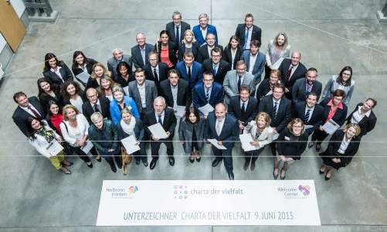  Image source: WHF GmbH  Signers of the Diversity Charter in the Heilbronn Innovation Factory on 9 June 2015 | 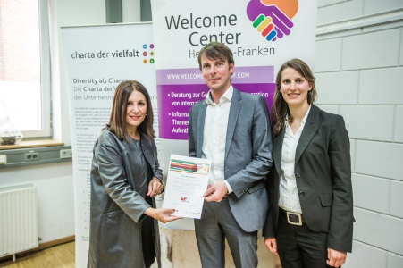  Image source: WHF GmbH  Presentation of the certificate: Bilkay Öney, Integration Minister of the state of Baden-Württemberg; Mathias Kalmbach, Marketing director at Würth Elektronik eiSos GmbH & Co. KG; and Mirjam Hermann, Human Resources, Würth Elektronik eiSos GmbH & Co. KG (left to right).

About the Würth Elektronik Group of Companies

The Würth Elektronik Group, with its headquarters in Niedernhall (Hohenlohe), employs more than 7,400 people worldwide and generated sales of € 527 million in 2014.
With its 16 production sites across the globe, Würth Elektronik is one of the most successful companies in the Würth Group.
Würth Elektronik is active internationally with three divisions in various markets:

- Electronic and electromechanical components (headquarters: Waldenburg)
Würth Elektronik eiSos (electronic and electromechanical components) is one of the largest European manufacturers of electronic and electromechanical components. Its worldwide sales network with 500 technical sales staff is unique in the electronics market. The manufacturer offers its customers excellent design-in support on-site. Production plants in Germany, Czech Republic, Bulgaria, the U.S., Mexico, Taiwan and China guarantee ready availability in all markets. All catalog products are available ex warehouse, and samples are free of charge.

- Circuit boards (headquarters: Niedernhall)
As one of the leading circuit board manufacturers in Germany, Würth Elektronik CBT (Circuit Board Technology) is specialized in prototypes and small and medium-size order quantities. Electronics developers find one-stop shopping for all the common and many innovative board technologies and even system solutions – in addition to consultations with competent specialists.

- Intelligent systems (headquarters: Niedernhall-Waldzimmern)
As specialist for the development and production of system solutions in press-fit technology, e.g. central electrical systems, Würth Elektronik ICS (Intelligent Connecting Systems) is a development partner for many manufacturers of commercial vehicles. Professional project management is offered to support business partners from product idea to series production.

