Würth Elektronik eiSos intensifies its Formula E sponsoring activities:
Engagement for the future e-mobility market

Waldenburg (Germany), 29 July 2015

The car race in London marked the end of the first season of the 2014/2015 FIA Formula E racing series for electric-powered racing cars. The “Audi Sport ABT Formula E” team proudly sponsored by Würth Elektronik eiSos took a phenomenal third place in the overall team ranking. Pilot Lucas di Grassi had been leading the field right up to the eighth lap in the Berlin race, and Daniel Abt ended the season in the eleventh slot.

After the successful start of the racing season, which comprised eleven races in ten cities on all continents of the world, Würth Elektronik eiSos prolonged its sponsoring agreement with the “Audi Sport ABT Formula E” team for a further three years. The preparations for the coming season are already under the sign of the long-term technology partnership that is being strived for, since in future Formula E teams will be able to pursue their own developments in the areas of engines, transmission systems, and engine software. Applications in racing cars count as the acid test for electronic concepts and systems. Its engagement in the Formula E sector will give Würth Elektronik eiSos valuable input for the future development of electronic components – for example in the areas of heat management and energy efficiency.

Technology partnership
“We enthusiastically shared the thrills and spills and the successes of our teams. We’re very proud to be involved in this sporting segment of e-mobility from the very outset,” say Oliver Konz and Thomas Schrott, CEOs of Würth Elektronik eiSos, in describing the company’s engagement in the new racing series. “For us in our role as developers and suppliers of electronic and electromechanical components, the Formula E series is not only a fantastic advertising platform – we’re also gaining valuable first-hand experience that will help us develop innovative electronic components for the future market of e-mobility and to launch them early on.”

For more information please go to
www.we-speed-up-the-future.com

Available images
The following images can be downloaded from the Internet in printable quality: http://www.htcm.de/kk/wuerth

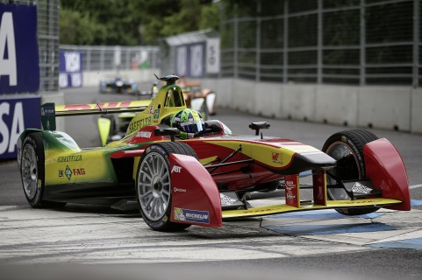  Image source: ABT Sportsline GmbH  An ABT Sportsline team’s Formula E racing car | 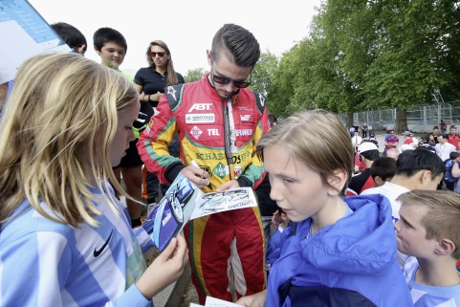  Image source: ABT Sportsline GmbH  Daniel Abt giving autographs

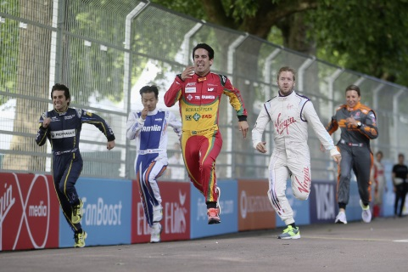

Image source: ABT Sportsline GmbH
Lucas di Grassi (centre) with his Formula E colleagues right before the final race in Battersea Park, London.

About Würth Elektronik eiSos GmbH & Co. KG

Würth Elektronik eiSos GmbH & Co. KG is a manufacturer of electronic and electromechanical components for the electronics industry. The company is part of the Würth Group, the global market leader for fastener technology. It employs 6,100 people and generated sales of almost 400 million Euros in 2014. Würth Elektronik eiSos is active in 50 countries worldwide.

Manufacturing facilities in Europe, Asia and North America ensure delivery to a customer base that is growing worldwide. The product range covers EMC components, inductors, transformers, HF components, varistors, capacitors, power modules, LEDs, connectors, power elements, switches and assembly technology.

Würth Elektronik eiSos is one of Europe's largest manufacturers of passive components.

Würth Elektronik: more than you expect!

