Würth Elektronik eiSos publishes the RED EXPERT online design tool:
the world's most precise AC loss calculation

Waldenburg, Germany, 6 August 2015

With RED EXPERT, Würth Elektronik eiSos has published a new online tool with which developers can simulate the power inductors from Würth Elektronik. With just a few clicks, the power inductors are selected and the complete AC losses calculated. The special feature: RED EXPERT enables the world's most precise loss calculation, because it is not based on the known Steinmetz models with sinusoidal excitation, but rather is derived and validated from measurements of the power inductors in a switching controller set-up.

The losses determined with RED EXPERT are based on current and voltage waveforms typical in applications. Besides the core and winding losses, they also include the losses arising from the specific geometries of the inductance, such as the air gap.

Particular highlights of the RED EXPERT AC loss model are the range of duty cycles supported from 10 to 90 percent and the switching frequency range of 50 kHz to 5 MHz. This gives the RED EXPERT AC loss model a previously unattained precision.

RED EXPERT is freely available in German, English, Spanish, Japanese, Russian and Chinese at
www.we-online.com/redexpert.

Further info at www.we-online.com

Available image material
The following image material is available in the internet for downloading: http://www.htcm.de/kk/wuerth
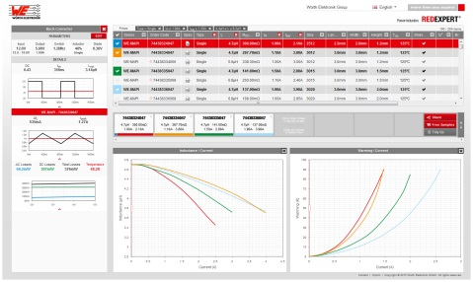  Image source: Würth Elektronik eiSos  Modern User Interface of RED EXPERT | 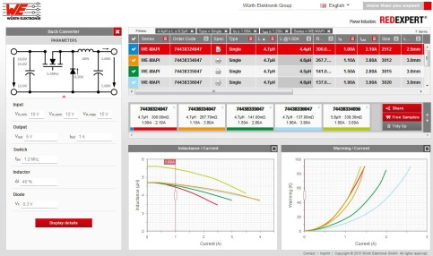  Image source: Würth Elektronik eiSos  Simulation of an inductor for a buck converter

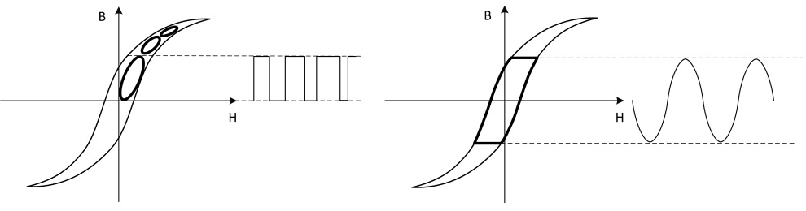
Image source: Würth Elektronik eiSos
Point of Operation vs. Usual Large Signal Approach

About Würth Elektronik eiSos GmbH & Co. KG

Würth Elektronik eiSos GmbH & Co. KG is a manufacturer of electronic and electromechanical components for the electronics industry. The company is part of the Würth Group, the global market leader for fastener technology. It employs 6,100 people and generated sales of almost 400 million Euros in 2014. Würth Elektronik eiSos is active in 50 countries worldwide.

Manufacturing facilities in Europe, Asia and North America ensure delivery to a customer base that is growing worldwide. The product range covers EMC components, inductors, transformers, HF components, varistors, capacitors, power modules, LEDs, connectors, power elements, switches and assembly technology.

Würth Elektronik eiSos is one of Europe's largest manufacturers of passive components.

Würth Elektronik: more than you expect!

