Würth Elektronik eiSos expands its series of terminal block push-on connectors:
new products and additional contact-space pitches

Waldenburg, Germany, 16 September 2015

Würth Elektronik eiSos is expanding its range of terminal block push-on connectors in the WR-TBL series, based on the wire-protection principle, with a number of new products. A total of eight new series now complement the already available product portfolio – both in the classic 5.00 mm pitch as well as in the form of new push-on connectors in the contact-space pitches 7.5 and 10 mm. The terminal blocks are all UL/cULus- and VDE-listed. They feature a current-carrying capacity of up to 24 A/750 V_{AC} and are suited for applications involving operating temperatures between -30 and +120 °C.

The terminal blocks, some of which can be modularly connected in series, support a broad spectrum of cable cross-sections from AWG30 (0.05 mm²) up to a maximum of AWG12 (3.31 mm²).

All products are directly available from stock; free-of-charge samples of the new WR-TBL products can be sent out on request.

For further information please visit www.we-online.de

Available images
The following images can be downloaded from the Internet in printable quality: http://www.htcm.de/kk/wuerth
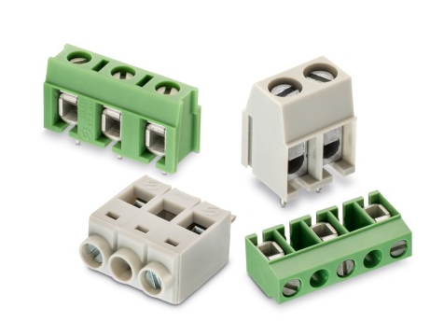

Image source: Würth Elektronik eiSos
Terminal block push-on connectors of the WR-TBL series based on the wire-protection principle

About Würth Elektronik eiSos GmbH & Co. KG

Würth Elektronik eiSos GmbH & Co. KG is a manufacturer of electronic and electromechanical components for the electronics industry. The company is part of the Würth Group, the global market leader for fastener technology. It employs 6,100 people and generated sales of almost 400 million Euros in 2014. Würth Elektronik eiSos is active in 50 countries worldwide.

Manufacturing facilities in Europe, Asia and North America ensure delivery to a customer base that is growing worldwide. The product range covers EMC components, inductors, transformers, HF components, varistors, capacitors, power modules, LEDs, connectors, power elements, switches and assembly technology.

Würth Elektronik eiSos is one of Europe's largest manufacturers of passive components.

Würth Elektronik: more than you expect!

