Terminal blocks in many different versions:
Würth Elektronik eiSos with new models of "rising cage clamps" in the WR-TBL series

Waldenburg, Germany, 23 September 2015

Würth Elektronik eiSos is immediately adding 26 new series to its product portfolio of connectors based on cage clamps. New models have pitches of 3.50, 3.81, 5.00, 5.08, 7.50, 7.62 and 10.16 mm. There are also new pitches available in 6.35, 9.52 and 10.00 mm. The terminal blocks offer various cable outlets: in horizontal, vertical and with a 45° angles.
The terminal blocks of the WR-TBL series, based on cage clamps, are UL/cULus and VDE listed, suitable for operating temperatures of -30 °C to +120 °C, and have conductivity of up to 32 A/750 V_{AC}.

Partially stackable as modules, the terminal blocks support a broad spectrum of cable cross-sections from AWG30 (0.05 mm²) up to a maximum of AWG10 (5.26 mm²).
All products are available ex-stock. Free samples of the new WR-TBL versions are available now - free of charge.

More information at www.we-online.com

Available images
The following images can be downloaded from the Internet in printable quality: http://www.htcm.de/kk/wuerth/
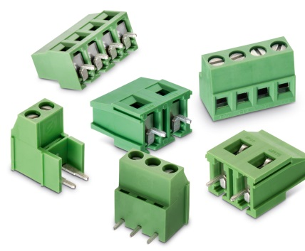

Image source: Würth Elektronik eiSos
Terminal block connector of the WR-TBL series based on cage tension

About Würth Elektronik eiSos GmbH & Co. KG

Würth Elektronik eiSos GmbH & Co. KG is a manufacturer of electronic and electromechanical components for the electronics industry. The company is part of the Würth Group, the global market leader for fastener technology. It employs 6,100 people and generated sales of almost 400 million Euros in 2014. Würth Elektronik eiSos is active in 50 countries worldwide.

Manufacturing facilities in Europe, Asia and North America ensure delivery to a customer base that is growing worldwide. The product range covers EMC components, inductors, transformers, HF components, varistors, capacitors, power modules, LEDs, connectors, power elements, switches and assembly technology.

Würth Elektronik eiSos is one of Europe's largest manufacturers of passive components.

Würth Elektronik: more than you expect!

