Würth Elektronik eiSos makes additions to its WR-TBL series:
Stable connectors with screwless terminal blocks

Waldenburg, Germany, 30 September 2015

Würth Elektronik eiSos is adding three series to the screwless terminal blocks of its successful WR-TBL series and including two new pitches of 5.08 mm and 7.50 mm. A spring mechanism makes the connectors screwless; they also offer an option of a horizontal or 45⁰ cable outlet and 2 to 12 pins. Other versions are available upon request.

The terminal blocks of the WR-TBL series are UL/cULus and VDE listed, suitable for operating temperatures of -30 °C to +120 °C and have conductivity of up to 10 A/750 V_{AC}.

Thanks to two connection pins per contact, the terminal blocks are mechanically stable on the circuit board. They are suitable for a broad spectrum of cable cross-sections, from AWG30 (0.05 mm²) up to a maximum of AWG16 (1.31 mm²). All products are available ex-stock. Free samples of the new terminal blocks are available free of charge with immediate effect.

More information at www.we-online.com

Available picture material
The following picture material is printable and available for downloading at: http://www.htcm.de/kk/wuerth
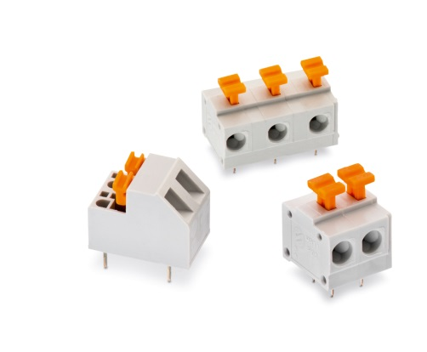

Image source: Würth Elektronik eiSos
Screwlos terminal block connectors of the WR-TBL series

About Würth Elektronik eiSos GmbH & Co. KG

Würth Elektronik eiSos GmbH & Co. KG is a manufacturer of electronic and electromechanical components for the electronics industry. The company is part of the Würth Group, the global market leader for fastener technology. It employs 6,100 people and generated sales of almost 400 million Euros in 2014. Würth Elektronik eiSos is active in 50 countries worldwide.

Manufacturing facilities in Europe, Asia and North America ensure delivery to a customer base that is growing worldwide. The product range covers EMC components, inductors, transformers, HF components, varistors, capacitors, power modules, LEDs, connectors, power elements, switches and assembly technology.

Würth Elektronik eiSos is one of Europe's largest manufacturers of passive components.

Würth Elektronik: more than you expect!

