Wurth Electronics Midcom offers SHDSL Evaluation Kit featuring SOCRATESTM chipset

Watertown, USA, 18 November 2015

In partnership with Teleconnect GmbH, Wurth Electronics Midcom is announcing the availability of the SOCRATESTM Evaluation Kit for SHDSL Ethernet First Mile (EFM) Modems, featuring Lantiq’s SOCRATESTM SHDSL chipset. This demonstration kit provides the ability to test the capabilities of Lantiq’s SOCRATESTM in single-pair SHDSL applications.

The SOCRATESTM Evaluation Board can be used as an EFM modem, an SHDSL EFM module, or a Plug-and-Play Ethernet Extender. This versatile board contains five DIP switches to allow customers to evaluate the SOCRATESTM chipset in multiple modes. Twenty different bitrates, including auto mode, are available for selection. The SOCRATESTM family supports up to 60Mbps throughput over 4 copper wires, using four-pair bonding. Customers using SOCRATESTM in the field have achieved data rates up to 15Mbps per copper pair, or reach beyond 15Kilometers (9.3miles). This kit allows customers to test the SOCRATESTM chipset in a wide variety of new SHDSL applications in telecom, industrial and smart city markets.

“The SHDSL transformer has been customized to be compact (17.7 x 13.4 x 12.7 mm height) and provides very good total harmonic distortion. These transformers meet UL and IEC standards, have a low leakage inductance (less than 35uH) and offers excellent longitudinal balance,” said Swaroop Vaidyanath, Product Marketing Engineer at Wurth Electronics Midcom.

SOCRATESTM is the most innovative SHDSL chipset in the market, with the low power consumption (650mW per line), a small footprint (AFE-DFE-LD in one chip), the best throughput and excellent crosstalk cancellation. This kit provides customers the opportunity to evaluate and incorporate SHDSL into products.

For more information on the SOCRATESTM Evaluation Kit, visit www.we-online.com/socratesdemo
Magnetics: Wurth Electronics Midcom
www.we-online.com/midcom
Design services: Teleconnect GmbH www.teleconnect.de

Available images
The following images can be downloaded from the Internet in printable quality: http://www.htcm.de/kk/wuerth
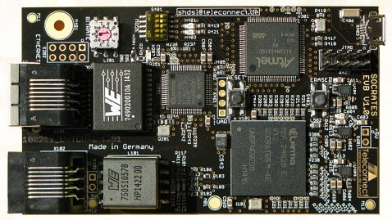

Image source: Wurth Elektronik Midcom
SHDSL Evaluation Kit featuring SOCRATESTM chipset

About Wurth Electronics Midcom, Inc.

Wurth Electronics Midcom is a global leader in the design and manufacture of custom magnetics. A standard line of magnetics is offered, including inductors, ferrites, chokes, and EMI shielding materials. Recently, the electromechanical and interconnect line was added to the product offering, which includes Board-to-Board, Wire-to-Board, Terminal Blocks, and Input/Output Communication.

Customers in Asia, Europe and the Americas are supported through a local direct technical sales network, regional design and applications engineers and manufacturing based in the People’s Republic of China.

Our standard lines and custom-made transformers are used around the world in LED lighting, smart grid and utility metering, industrial controls, telecom (CPE and CO), home automation, and home appliances.
Wurth Electronics Midcom offers all catalog products in stock. Free samples are offered to customers on connectors and both catalog and custom magnetics.

