Würth Elektronik eiSos and Formula E Sponsoring:
The second season allows in-house innovations

Waldenburg, Germany, 7 October 2015

The second season of Formula E begins with the first heat on 24 October 2015 in Peking. Team ABT Schaeffler Audi Sport (previously Audi Sport Abt Formula E Team), which is supported by Würth Elektronik eiSos, will be there too. The coming season is exciting not only as a sporting event, but also from a technological point of view: for the first time in Formula E, motors, gears and motor software can be built by different manufacturers. This means that sponsoring is headed toward the long-term objective of creating technological partnerships in which the company can provide valuable input for developing electronic components for eMobility – for example, for energy efficiency and thermal management.
"As developers and manufacturers of electronic and electro-mechanical components, eMobility for us is an important future market," explain Oliver Konz and Thomas Schrott, CEOs of Würth Elektronik eiSos, their involvement in the new racing series. "Formula E is both an image campaign for eMobility and a test environment for improving technologies under extreme conditions."

Powertrain released
FIA has recognized Team ABT Schaeffler Audi Sport with its technology partners as a manufacturer. Standard-specification cars were driven during the first season, but this time, Daniel Abt and Lucas di Grassi will be driving the "ABT Schaeffler FE01." Its core element is the "ABT Schaeffler MGU 01" electric motor. It has better torque and efficiency than its predecessor.

More information at www.we-online.com

Available images
The following images can be downloaded from the Internet in printable quality: http://www.htcm.de/kk/wuerth
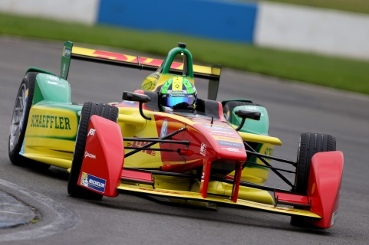  '  Image source: ABT Schaeffler Audi Sport  Formula E racing car "ABT Schaeffler FE01" shows its new design and technical improvements. | 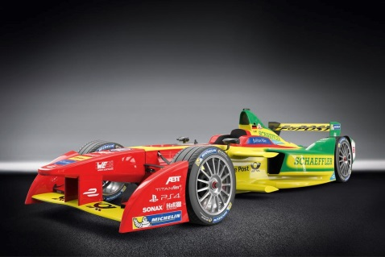  Image source ABT Schaeffler Audi Sport  New Formula E racing car "ABT Schaeffler FE01"

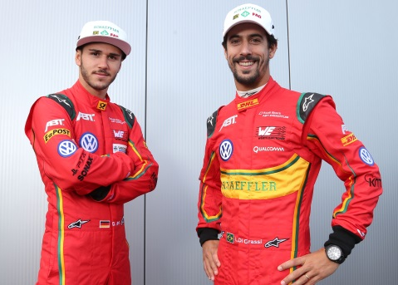

Image source: ABT Schaeffler Audi Sport
The Formula E drivers of ABT Schaeffler Audi Sport: Daniel Abt (l.) and Lucas di Grassi (r.)

About Würth Elektronik eiSos GmbH & Co. KG

Würth Elektronik eiSos GmbH & Co. KG is a manufacturer of electronic and electromechanical components for the electronics industry. The company is part of the Würth Group, the global market leader for fastener technology. It employs 6,100 people and generated sales of almost 400 million Euros in 2014. Würth Elektronik eiSos is active in 50 countries worldwide.

Manufacturing facilities in Europe, Asia and North America ensure delivery to a customer base that is growing worldwide. The product range covers EMC components, inductors, transformers, HF components, varistors, capacitors, power modules, LEDs, connectors, power elements, switches and assembly technology.

Würth Elektronik eiSos is one of Europe's largest manufacturers of passive components.

Würth Elektronik: more than you expect!

