Würth Elektronik eiSos opens Competence Center Berlin:
Vibrant research environment

Waldenburg, Germany, 27 October 2015

Würth Elektronik eiSos GmbH & Co. KG opened its new Competence Center Berlin on 23 October 2015, marking a further milestone of the company’s expansion strategy. The Competence Center Berlin will primarily be a hub for hard- and software engineers designing and programming applications for new components, and supporting customers with product integration or application developments. Students will also be given opportunities to contribute their innovative ideas to the organization.

Adlershof Technology Park
The 640 m² site in Adlershof Technology Park was chosen with foresight as the location of the new Würth Elektronik eiSos office. Berlin’s governing mayor Michael Müller embraced the company’s decision to settle in the capital: “A warm welcome to Würth Elektronik eiSos and all its staff. The investment of such an innovative player in Berlin proves that our city has successfully established itself as an attractive high-tech location. Adlershof offers Würth Elektronik eiSos numerous partner companies, skilled professionals, and potential from our universities. The Würth Elektronik eiSos subsidiary here is an example of our successful economic development policy and confirms that we are doing a good job”. Adlershof Technology Park is already home to ten independent research institutes, six Humboldt University institutes, and almost 1000 companies. The impressive number of electrical engineering firms and high-tech start ups, on the one hand, and academic institutes, on the other, was a key factor for the electronics and electromechanical components manufacturer. Berlin-Adlershof is already a dynamic technology hub with a huge potential of skilled professionals to support the further development of the subsidiary.

“With Würth Elektronik eiSos we have brought a real electronics industry giant to Berlin. We are delighted that the company was attracted to the German capital with its unique academic landscape and vibrant digital scene. Würth will be able to use these assets in its Competence Center and can create high-quality jobs and opportunities in the area,” says Dr. Stefan Franzke, spokesman of Berlin Partners for Industry and Technology.

Oliver Konz, Managing Director at Würth Elektronik eiSos explains: “Research and development are the supporting pillars of success for a technology company such as ours. This location in the direct vicinity of independent and university-related research institutes is ideal for cooperations”. Thomas Schrott, also Managing Director at Würth Elektronik eiSos, adds: “What’s more, we are convinced that the setting will attract young engineers to our company”.

34 jobs have already been created at the new Berlin site; a total of 100 new jobs are planned for the medium term. The Competence Center Berlin currently accommodates the offices for the software developers and a customer area for events and seminars. Initial projects will focus on the development of software and complete systems relating to wireless energy transmission.

Address:
Würth Elektronik eiSos GmbH & Co. KG
Volmerstrasse 10
12489 Berlin-Adlershof
Germany

For more information, please visit www.we-online.com

Available images
The following images can be downloaded from the Internet in printable quality: http://www.htcm.de/kk/wuerth
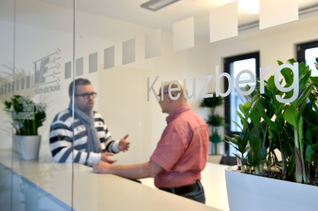  Image source: Würth Elektronik eiSos  The Competence Center Berlin is also open for customers | 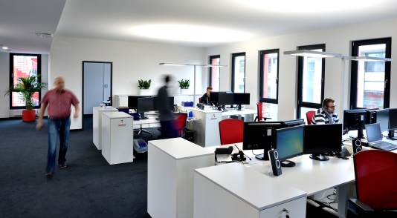  Image source: Würth Elektronik eiSos  Offices for the first 34 Würth Elektronik eiSos employees in Berlin have already been completed

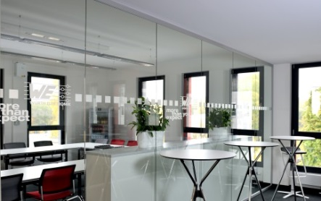
Image source: Würth Elektronik eiSos
Meeting and training rooms are also available in the new Würth Elektronik eiSos branch office in Berlin

About Würth Elektronik eiSos GmbH & Co. KG

Würth Elektronik eiSos GmbH & Co. KG is a manufacturer of electronic and electromechanical components for the electronics industry. The company is part of the Würth Group, the global market leader for fastener technology. It employs 6,100 people and generated sales of almost 400 million Euros in 2014. Würth Elektronik eiSos is active in 50 countries worldwide.

Manufacturing facilities in Europe, Asia and North America ensure delivery to a customer base that is growing worldwide. The product range covers EMC components, inductors, transformers, HF components, varistors, capacitors, power modules, LEDs, connectors, power elements, switches and assembly technology.

Würth Elektronik eiSos is one of Europe's largest manufacturers of passive components.

Würth Elektronik: more than you expect!

