Würth Elektronik eiSos at the SPS IPC Drives 2015 Trade Fair:
New passive and electromechanical components

Waldenburg, Germany, 5 November 2015

Würth Elektronik eiSos GmbH & Co. KG, manufacturer of electronic and electromechanical components for the electronics industry, will have an exhibit at the SPS IPC Drives 2015 Trade Fair in Nuremberg, Germany. The company will be focusing this time on its new connector products at booth 10.0-601 from 24-26 November 2015. In addition to its new product catalogue, "Passive Components 2016," the almost 1,000-page catalogue "Electromechanical Components 2016" will thus also be introduced. This catalogue contains the product groups for connectors, switches, keys, fuse holders, connection technology and power elements in press-fit technology.

Hitting the ground running with USB 3.1
10 Gb/s instead of 5 Gb/s, and up to 20-V power supply – the new USB-3.1 standard is an important step forward in development that will open up lots of new applications. Würth Elektronik eiSos now has the needed connectors, jacks and cables in stock. The catalogue contains the USB-3.1 products that, as always, are available as free samples, under WR-COM USB 3.1 Superspeed+.

Form factor and operation
Sophisticated space-saving designs and easy assembly are features that make electromechanical components from Würth Elektronik eiSos consistently stand out. New products highlighted at the trade fair include WR-LECO, an SMD Board-to-Board connector for LED stripe PCBs. Extremely flat, with a total height of only 2.45 mm, the white plastic casing was optimized to allow for minimal shading. The FPC series added the WR-FPC, a new connector with Back Lock locking. The WR-TBL, a new terminal block, is also extremely practical; its cut-clamp technology makes cable stripping unnecessary.

EMC and energy transmission
In the area of passive components, Würth Elektronik eiSos again demonstrates its leading role in EMC products; multilayer SMD ferrites are among products of this kind in the exhibition. As a member of the Wireless Power Consortium, Würth Elektronik eiSos is responding to the increased significance of wireless energy transmission. The stimulus to the market comes here from consumer electronics and the booming business in wearables, but the possible applications are much more broadly based. At the trade fair Würth Elektronik will provide information about its wide variety of receiver and sender coils and their use.

More information at www.we-online.de

Available images
The following images can be downloaded from the Internet in printable quality: http://www.htcm.de/kk/wuerth
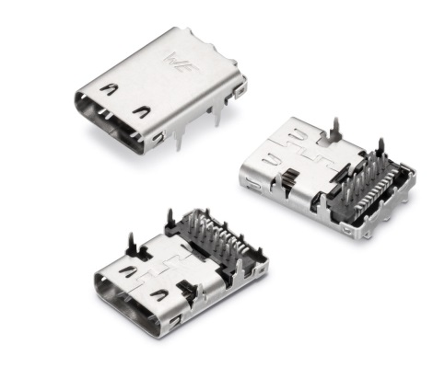

Image source: Würth Elektronik eiSos
USB 3.1. Connector type C

About Würth Elektronik eiSos GmbH & Co. KG

Würth Elektronik eiSos GmbH & Co. KG is a manufacturer of electronic and electromechanical components for the electronics industry. The company is part of the Würth Group, the global market leader for fastener technology. It employs 6,100 people and generated sales of almost 400 million Euros in 2014. Würth Elektronik eiSos is active in 50 countries worldwide.

Manufacturing facilities in Europe, Asia and North America ensure delivery to a customer base that is growing worldwide. The product range covers EMC components, inductors, transformers, HF components, varistors, capacitors, power modules, LEDs, connectors, power elements, switches, assembly technology and fuse holders.

Würth Elektronik eiSos is one of Europe's largest manufacturers of passive components.

Würth Elektronik: more than you expect!

