Würth Elektronik Honored in the Netherlands:
National Business Success Award 2015 "De Success Factor"

Waldenburg, Germany, 13 November 2015

Würth Elektronik eiSos congratulates the colleagues of Würth Elektronik Nederland B.V. on receiving the National Business Success Award:

Würth Elektronik Nederland B.V. has been rewarded by the “The National Business Success Award Institute” as branch winner 2015 in the category “Electro technical components branch”.

The jury cited the company's service quality, its outstanding logistics with high level of availability, short delivery times and free samples. Representatives of the award winner also make appearances on the RTL television show "De Success Factor" (https://youtu.be/YTlOeU87zE8).

Success factors
The jury highlighted several success factors. For example, Würth Elektronik eiSos has all of its components in stock and can make quick deliveries to its Dutch customers from the logistics centers in Germany and France. A particular advantage are the free samples that can be sent to customers within one to two days. Customers are also not required to purchase minimum order quantities from Würth Elektronik. "In addition," as Robert Zwaan, head of the Executive Nomination Committee, pointed out, "no other company has such extensive customer contacts at its disposal."

More information at www.we-online.com

Available images
The following images can be downloaded from the Internet in printable quality: http://www.htcm.de/kk/wuerth
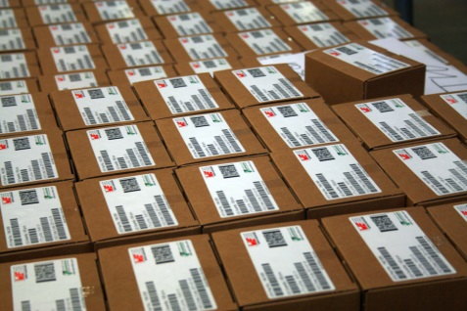  Image source: Würth Elektronik eiSos  The jury cited the company's service quality, its outstanding logistics with high level of availability, short delivery times and free samples. | 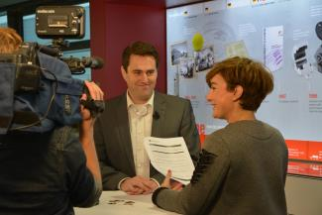  Image source: Würth Elektronik eiSos  Niels Braams, Managing Director Würth Electronics Nederland B.V., interviewed by the team of RTL television show "De Success Factor".

About Würth Elektronik eiSos GmbH & Co. KG

Würth Elektronik eiSos GmbH & Co. KG is a manufacturer of electronic and electromechanical components for the electronics industry. The company is part of the Würth Group, the global market leader for fastener technology. It employs 6,100 people and generated sales of almost 400 million Euros in 2014. Würth Elektronik eiSos is active in 50 countries worldwide.

Manufacturing facilities in Europe, Asia and North America ensure delivery to a customer base that is growing worldwide. The product range covers EMC components, inductors, transformers, HF components, varistors, capacitors, power modules, LEDs, connectors, power elements, switches, assembly technology and fuse holders.

Würth Elektronik eiSos is one of Europe's largest manufacturers of passive components.

Würth Elektronik: more than you expect!

