Würth Elektronik eiSos presents expanded assortment in the electromechanics catalogue:
connectors, switches, power elements

Waldenburg, Germany, 8 December 2015

The new "Electromechanical Components 2016" catalogue is almost 1,000 pages long and can now be ordered from Würth Elektronik eiSos. This standard work of connection technology includes the product groups of connectors, switches, keys, fuse holders, connection technology and power elements in press-fit technology.

Highlights of the new catalogue
The product family of terminal blocks has become much larger, for example in insulation displacement contact technology (IDC) and reversed-gender types, available in the grid spacings 3.81 and 5.08 mm. One example of a new item in the board-to-board area is an SMD connection for contacting LED strip PCBs with 1.50 mm grid spacing. The communications range is expanded to include the new USB 3.1 Superspeed+ standard. Jack types A and C and wires are available. Short-type modules were also added to the USB 2.0 standard. The family of ZIF connectors has expanded by adding a back-lock version in the 0.5 mm grid with a design height of only 1 mm.
Two new wire-to-board versions with 2.54 mm grid are available for contacting wires on the PCB: the Autocom series as IDC type as well as the Intercom as crimp version for single litz wires with matching male connectors. The new UHS-II standard for SD 4.0 memory cards has produced a new card holder, which is likewise available as a standard product. New fuse holders and miniature key switches have also been developed.

All products are available ex warehouse. Free samples and lab assortments with free refills are also available.

More information at www.we-online.de

Available images
The following images can be downloaded from the Internet in printable quality: http://www.htcm.de/kk/wuerth
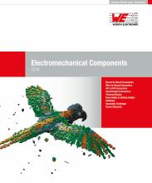  Image source:  Würth Elektronik eiSos  New catalog of Würth Elektronik eiSos "Electromechanical Components 2016" | 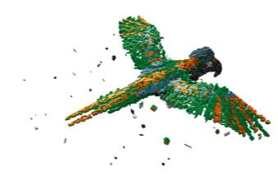  Image source:  Würth Elektronik eiSos  The cover of the new catalogue shows a parrot made out of electromechanical components.

About Würth Elektronik eiSos GmbH & Co. KG

Würth Elektronik eiSos GmbH & Co. KG is a manufacturer of electronic and electromechanical components for the electronics industry. The company is part of the Würth Group, the global market leader for fastener technology. It employs 6,100 people and generated sales of almost 400 million Euros in 2014. Würth Elektronik eiSos is active in 50 countries worldwide.

Manufacturing facilities in Europe, Asia and North America ensure delivery to a customer base that is growing worldwide. The product range covers EMC components, inductors, transformers, HF components, varistors, capacitors, power modules, LEDs, connectors, power elements, switches, assembly technology and fuse holders.

Würth Elektronik eiSos is one of Europe's largest manufacturers of passive components.

Würth Elektronik: more than you expect!

