PRESS RELEASE

Würth Elektronik eiSos presents connectors for LED boards
Discrete board-to-board connectors
Waldenburg (Germany), 3 March 2016 – The use of LED strip PCB’s is popular in the efficient production of electrical lighting solutions. Würth Elektronik eiSos is now introducing a completely new series of connectors for connecting LED strip PCB’s: WR-LECO is available with two, three, four or five poles and is attractive due to its very flat design, only 2.45 mm high. The grid spacing is 1.5 mm. The SMD board-to-board connector for LED applications is made of white plastic to minimize shading. Locking allows the connector to create excellent holding forces.
The electrical paramaters of the WR-LECO allow for a maximum current of 1 A and a operating voltage up to 150 V AC. The operating temperature is -25 °C to + 85 °C.
All products are available ex warehouse. Samples of the new connectors are now available free of charge.

Available images
The following images can be downloaded from the Internet in printable quality: http://www.htcm.de/kk/wuerth
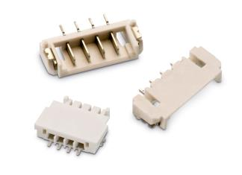

Image source: Würth Elektronik eiSos
SMD board-to-board connector for LED applications: WR-LECO

About Würth Elektronik eiSos GmbH & Co. KG

Würth Elektronik eiSos GmbH & Co. KG is a manufacturer of electronic and electromechanical components for the electronics industry. The company is part of the Würth Group, the global market leader for fastener technology. It employs 6,100 people and generated sales of almost 475 million Euros in 2015. Würth Elektronik eiSos is active in 50 countries worldwide.
Manufacturing facilities in Europe, Asia and North America ensure delivery to a customer base that is growing worldwide. The product range covers EMC components, inductors, transformers, HF components, varistors, capacitors, power modules, LEDs, connectors, power elements, switches, assembly technology and fuse holders.
Würth Elektronik eiSos is one of Europe's largest manufacturers of passive components.
Würth Elektronik: more than you expect!
Further information at www.we-online.com

Further information:  Würth Elektronik eiSos GmbH & Co. KG  Sarah Hurst  Max-Eyth-Strasse 1  74638 Waldenburg  Germany  Phone: +49 7942 945-5186  E-mail: sarah.hurst@we-online.de  www.we-online.de | Press contact:  HighTech communications GmbH  Brigitte Basilio  Grasserstrasse 1c  80339 Munich  Germany  Phone: +49 89 500778-20  Fax: +49 89 500778-77  E-mail: b.basilio@htcm.de  www.htcm.de

