PRESS RELEASE

Würth Elektronik eiSos expands its family of FPC connectors
Effortless fixation of flexible circuit boards
Waldenburg (Germany), 4 May 2016 – There are many interesting applications for flexible printed circuits and flat-flex cables, but there’s one problem they all have in common: FFCs and FPCs need a reliable connector base. Würth Elektronik eiSos has now extended its family of WR-FPC products by a back-lock dual-contact ZIF plug-in connector.
The simple-to-use and tool-free locking concept ensures strong holding forces. Only 1 mm thick, the extremely flat plug-in connector has contacts on its top and bottom surfaces for even more flexibility in the use of flexible printed circuits and flat-flex cables.
The spacing pitch is 0.5 mm, and the connector is supplied in all standard pole numbers from 6 to 28, including a 17-pole version. The plug-in connector has a maximum ampacity of 0.5 A and is capable of withstanding voltages of up to 50 V alternating current. It can be operated at temperatures ranging from -40°C to +105°C.
All products are directly available from stock. Free-of-charge samples of the new plug-in connectors are available on request with immediate effect.

Available images
The following images can be downloaded from the Internet in printable quality: http://www.htcm.de/kk/wuerth
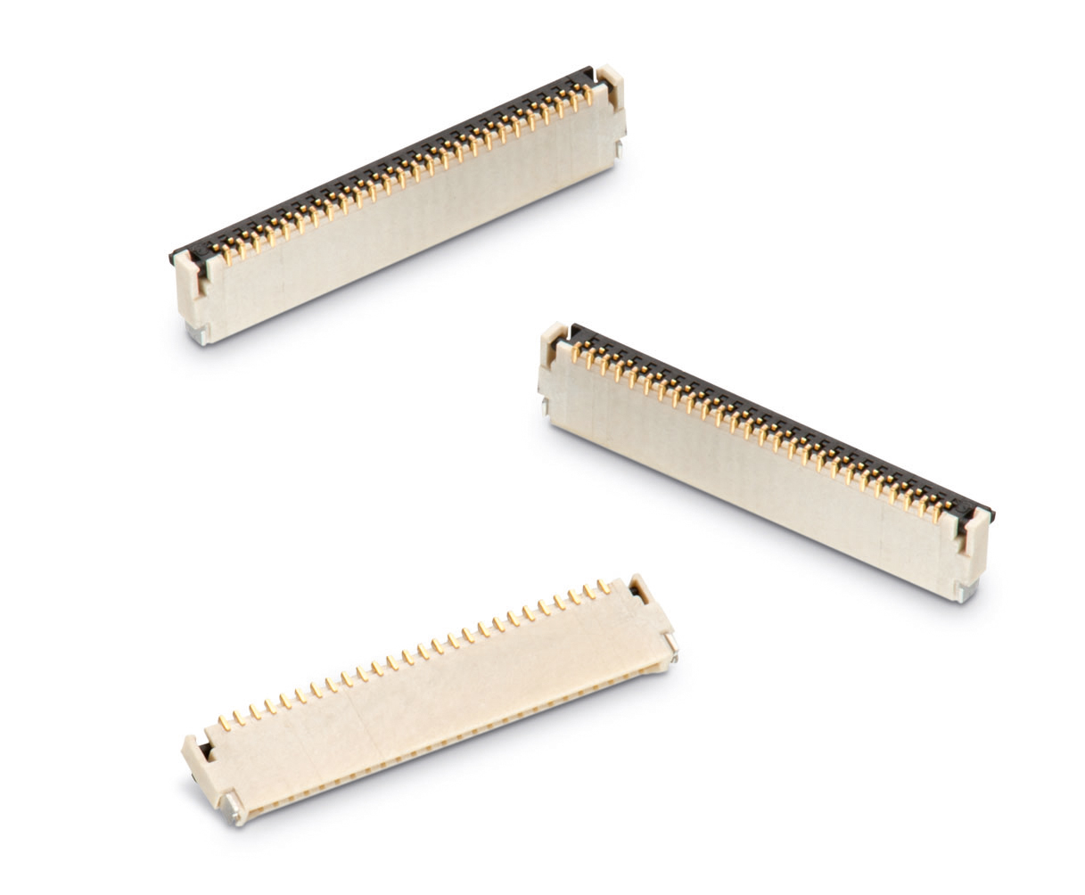
Image source: Würth Elektronik eiSos
WR-FPC: Back-lock dual-contact ZIF plug-in connectors

About Würth Elektronik eiSos GmbH & Co. KG

Würth Elektronik eiSos GmbH & Co. KG is a manufacturer of electronic and electromechanical components for the electronics industry. The company is part of the Würth Group, the global market leader for fastener technology. It employs 6,100 people and generated sales of almost 475 million Euros in 2015. Würth Elektronik eiSos is active in 50 countries worldwide.
Manufacturing facilities in Europe, Asia and North America ensure delivery to a customer base that is growing worldwide. The product range covers EMC components, inductors, transformers, HF components, varistors, capacitors, power modules, LEDs, connectors, power elements, switches, assembly technology and fuse holders.
Würth Elektronik eiSos is one of Europe's largest manufacturers of passive components.
Würth Elektronik: more than you expect!
Further information at www.we-online.com

Further information:  Würth Elektronik eiSos GmbH & Co. KG  Sarah Hurst  Max-Eyth-Strasse 1  74638 Waldenburg  Germany  Phone: +49 7942 945-5186  E-mail: sarah.hurst@we-online.de  www.we-online.de | Press contact:  HighTech communications GmbH  Brigitte Basilio  Grasserstrasse 1c  80339 Munich  Germany  Phone: +49 89 500778-20  Fax: +49 89 500778-77  E-mail: b.basilio@htcm.de  www.htcm.de

