PRESS RELEASE

Würth Elektronik eiSos expands its WR-TBL terminal block product family
Wire-stripping is a thing of the past
Waldenburg (Germany), 11 May 2016 – Würth Elektronik eiSos is launching a series of new terminal blocks. The special feature: thanks to the insulation-displacement technique employed in the WR-TBL terminal blocks, the cables no longer need be stripped.
The terminal blocks are supplied in the 3.81 mm and 5.08 mm spacing pitches, both with and without flanging. According to the cULus method, maximum ampacity is 5 A/300 V_{AC} for the 3.81 mm version and 7 A/300 V_{AC} for the 5.08 mm version. Available cable cross-sections: 3.81 mm: 22-20 AWG (0.326–0.518 mm²), 5.08 mm: 22-18 AWG (0.626–0.823 mm²).
All products are directly available from stock. Free-of-charge samples of the new terminal blocks are available on request with immediate effect.

Available images
The following images can be downloaded from the Internet in printable quality: http://www.htcm.de/kk/wuerth
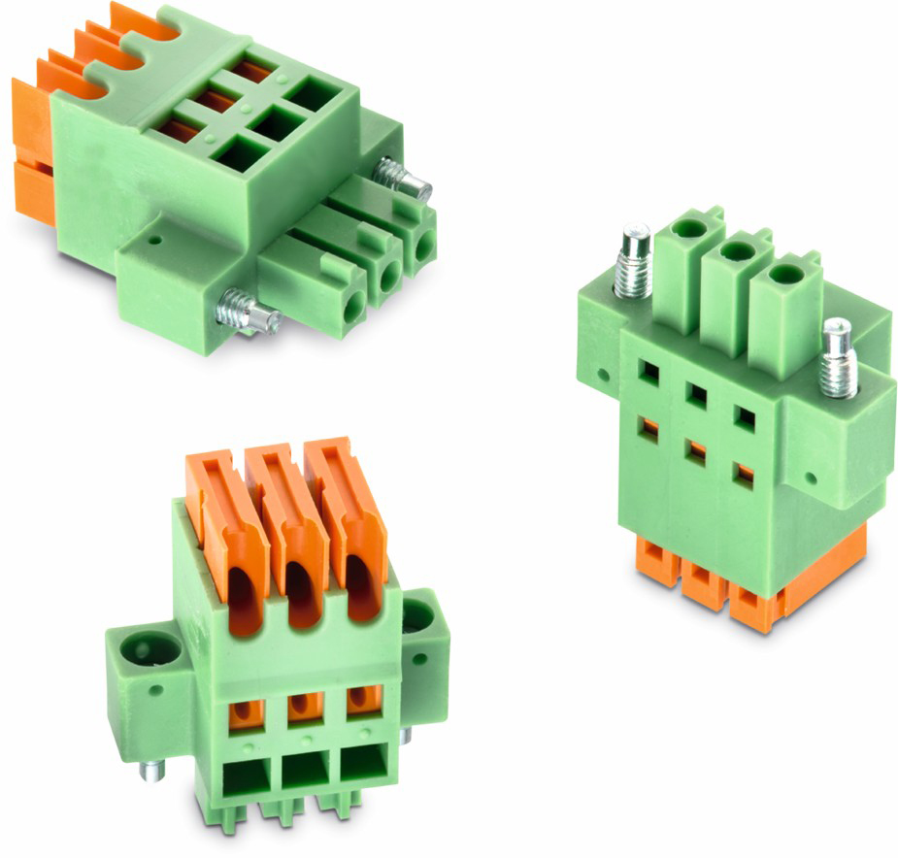
Image source: Würth Elektronik eiSos
WR-TBL – Terminal blocks insulation-displacement technology

About Würth Elektronik eiSos GmbH & Co. KG

Würth Elektronik eiSos GmbH & Co. KG is a manufacturer of electronic and electromechanical components for the electronics industry. The company is part of the Würth Group, the global market leader for fastener technology. It employs 6,100 people and generated sales of almost 475 million Euros in 2015. Würth Elektronik eiSos is active in 50 countries worldwide.
Manufacturing facilities in Europe, Asia and North America ensure delivery to a customer base that is growing worldwide. The product range covers EMC components, inductors, transformers, HF components, varistors, capacitors, power modules, LEDs, connectors, power elements, switches, assembly technology and fuse holders.
Würth Elektronik eiSos is one of Europe's largest manufacturers of passive components.
Würth Elektronik: more than you expect!
Further information at www.we-online.com

Further information:  Würth Elektronik eiSos GmbH & Co. KG  Sarah Hurst  Max-Eyth-Strasse 1  74638 Waldenburg  Germany  Phone: +49 7942 945-5186  E-mail: sarah.hurst@we-online.de  www.we-online.de | Press contact:  HighTech communications GmbH  Brigitte Basilio  Grasserstrasse 1c  80339 Munich  Germany  Phone: +49 89 500778-20  Fax: +49 89 500778-77  E-mail: b.basilio@htcm.de  www.htcm.de

