Würth Elektronik iBE aquires Büchele Group:

Thyrnau/Esslingen (Germany), February 1, 2016

Würth Elektronik iBE GmbH, headquartered in Thyrnau near Passau (Germany), is part of the Würth Elektronik eiSos Group – a leading European manufacturer of passive and electromechanical. As a specialist for customized EMC components and inductors for automotive applications, Würth Elektronik iBE has been a preferred partner of the automobile industry for over 30 years. With the merger, Würth Elektronik iBE further strengthens its position as a market and technology leader in the automotive sector. For the formerly family-run Büchele Group, this step opens up access to the internationally oriented distribution structure of Würth and the Würth Elektronik eiSos Group. Belonging to the Würth Group in the future will also mean even more extensive investment in technology and product development, thus creating security for customers, the company and its employees.

Setting its sights on global market and technology leadership
With the purchase, Würth Elektronik iBE aims to further expand its position as a market and technology leader in the field of electronic EMC components and inductors for automotive applications. The company has been a partner for automobile suppliers since 1982 and with its five production sites and two sales offices is now present on almost all the important markets. “Additional added value will be generated through the Büchele Group merger allowing us to accompany our customers from the very first product idea through to series production with even greater competence and efficiency”, the managing directors of Würth Elektronik iBE, Thorsten Jordan and Rainer Schätzl, explain. “By acquiring the Büchele Group, we combine the excellent manufacturing technologies of both companies, as well as automation and product expertise, unified with an unrivaled service and added value concept”, the managing directors continue.
The CEOs of the Würth Elektronik eiSos Group – Oliver Konz and Thomas Schrott – also gladly welcome the new member in their worldwide group of electronics companies, active in 50 countries with its own staff, operating 20 productions sites and generating sales of 475 million euros with 6,100 employees in 2015.

Further info at www.we-online.com

Available image material
The following picture ready for printing is available for downloading at: http://www.htcm.de/kk/wuerth
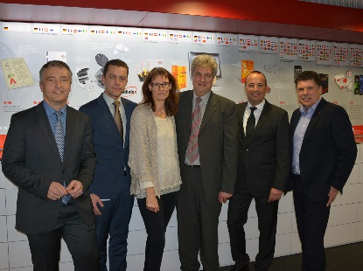

Picture source: Würth Elektronik iBE GmbH
(from left to right): Rainer Schätzl (Managing Director Würth Elektronik iBE GmbH), Thorsten Jordan (Managing Director Würth Elektronik iBE GmbH), Martina Kissling (Managing Director Büchele Group), Erwin Büchele (Managing Director Büchele Group), Thomas Schrott (CEO Würth Elektronik eiSos Group), Oliver Konz (CEO Würth Elektronik eiSos Group)

About the Büchele Group

The Büchele Group product portfolio encompasses customized rod core chokes, bent wire parts in various versions and SMD rod core chokes. The company was founded by Erwin Büchele senior in 1946 and initially manufactured and repaired electric motors. In 1967 the company passed over to Jürgen Büchele whereupon coils and chokes were manufactured. The company started its own machinery and plant engineering in 1984. Six years later the capacity for coil and choke production was expanded with the factory in Kladno (Czech Republic). In 1998 the present Managing Director Erwin Büchele junior and his sister Martina Kissling assumed management of the company.
The company employs 40 staff at its Esslingen (Germany) site and a further 120 at its subcontractor site in Kladno (Czech Republic).
Sales of 16.2 mil. Euros were generated in 2014.

About Würth Elektronik iBE GmbH

Würth Elektronik iBE GmbH is a manufacturer of customized rod core chokes for automotive applications. As part of the Würth Elektronik Group and a subsidiary of Würth Elektronik eiSos GmbH & Co. KG, Würth Elektronik iBE employs a staff of over 1,200 and produced over 675 million components in 2015 generating sales of 48 mil. Euros.

The company with its five production sites is represented on all the important markets and continents: Germany, Czech Republic, Bulgaria, Mexico and China. The product portfolio extends from customized rod core and special chokes to high current inductors, automotive ferrites and power inductors used in automobiles.

