PRESS RELEASE

Würth Elektronik eiSos presents updated Catalogue for Power Modules
Clear overview and easy selection
Waldenburg (Germany), 9 March 2016 – The new, expanded and improved Power Module Catalogue 2016 from Würth Elektronik eiSos is now available. Selecting the right step-down converters and LED drivers you need has become even more convenient. A selection tool depicts a clear overview of the various product groups, including pictograms to show all of their important functions at a glance. For the first time, the Power Module Catalogue also contains an overview of the available Application Notes.
Substitute for linear regulator
Technical highlights of the Power Module Catalogue are five new products: MagI³C-FDSM is a substitute for the widespread 78xx linear voltage controller. With input voltages of 7 to 28 V the non-synchronous step down regulator module offers set output voltages of 3.3 or 5 V at 1 A. The benefit: no external components are required for its operation (SIP-3 design).
Ideal for FPGA supply
MagI³C-VDRM (synchronous variable step down regulator module) with 2.95 to 6 V_{in} and 0.8 to 3.6 V_{out} is especially well suited for supplying processors and FPGAs that require a scalable output current (2 A/4 A/6 A) and a programmable switching frequency (BQFN-39 design).
The Würth Elektronik eiSos service is strong, as always: an application team offers customers a free design check. All components of the 60-page catalogue are available ex warehouse. Free samples, laboratory selections with free refills and evaluation boards are also provided.

Available images
The following images can be downloaded from the Internet in printable quality: http://www.htcm.de/kk/wuerth
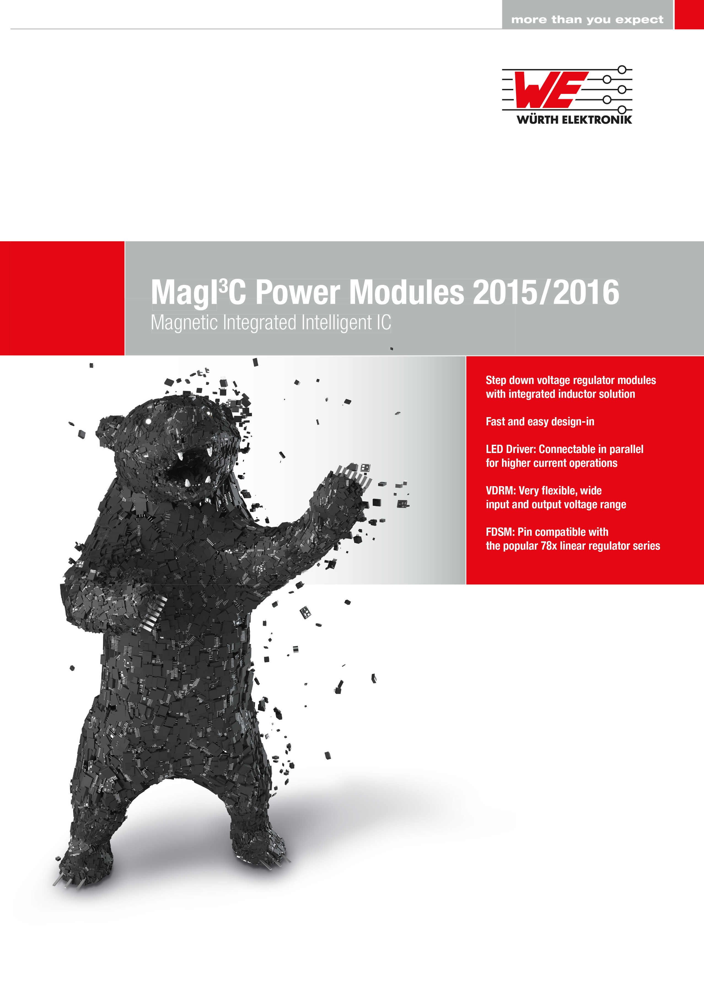  Image source: Würth Elektronik eiSos  New publication from Würth Elektronik eiSos: the "Power Module Catalogue 2016" |   Image source: Würth Elektronik eiSos  On the catalogue cover is a bear made of step-down converters and LED drivers.

About Würth Elektronik eiSos GmbH & Co. KG

Würth Elektronik eiSos GmbH & Co. KG is a manufacturer of electronic and electromechanical components for the electronics industry. The company is part of the Würth Group, the global market leader for fastener technology. It employs 6,100 people and generated sales of almost 475 million Euros in 2015. Würth Elektronik eiSos is active in 50 countries worldwide.
Manufacturing facilities in Europe, Asia and North America ensure delivery to a customer base that is growing worldwide. The product range covers EMC components, inductors, transformers, HF components, varistors, capacitors, power modules, LEDs, connectors, power elements, switches, assembly technology and fuse holders.
Würth Elektronik eiSos is one of Europe's largest manufacturers of passive components.
Würth Elektronik: more than you expect!
Further information at www.we-online.com

Further information:  Würth Elektronik eiSos GmbH & Co. KG  Sarah Hurst  Max-Eyth-Strasse 1  74638 Waldenburg  Germany  Phone: +49 7942 945-5186  E-mail: sarah.hurst@we-online.de  www.we-online.de | Press contact:  HighTech communications GmbH  Brigitte Basilio  Grasserstrasse 1c  80339 Munich  Germany  Phone: +49 89 500778-20  Fax: +49 89 500778-77  E-mail: b.basilio@htcm.de  www.htcm.de

