PRESS RELEASE

Würth Elektronik eiSos presents the WE-PMMI and WE-PMCI series
Compact SMD power inductors
Waldenburg (Germany), 23 June 2016 – Würth Elektronik eiSos supplements its portfolio of compact SMD power inductors with two new series: WE-PMMI and WE-PMCI. The two new power inductors are used, for example, in highly efficient DC/DC switching controllers with a low space requirement.
The WE-PMMI (Power Molded Multilayer Inductor) series is manufactured in the multilayer process. The RDC value is significantly reduced by pressing a double silver layer. Besides a high current loading capacity, the series available in 0806, 0805 LP and 0806 LP packages also has high saturation current values and, as a result of its low RDC, is suitable for efficient switching controllers with switching frequencies up to 20 MHz.
Very high saturation currents
The WE-PMCI (Power Molded Chip Inductor) is a compact pressed power inductor with wire winding, available in five package sizes and three types. The product series excels through its excellent “soft saturation behavior” and is also suitable for portable applications with switching frequencies up to more than 20 MHz.
Free samples are available on request and all products are always immediately available from stock.

Available images
The following images can be downloaded from the Internet in printable quality: http://www.htcm.de/kk/wuerth
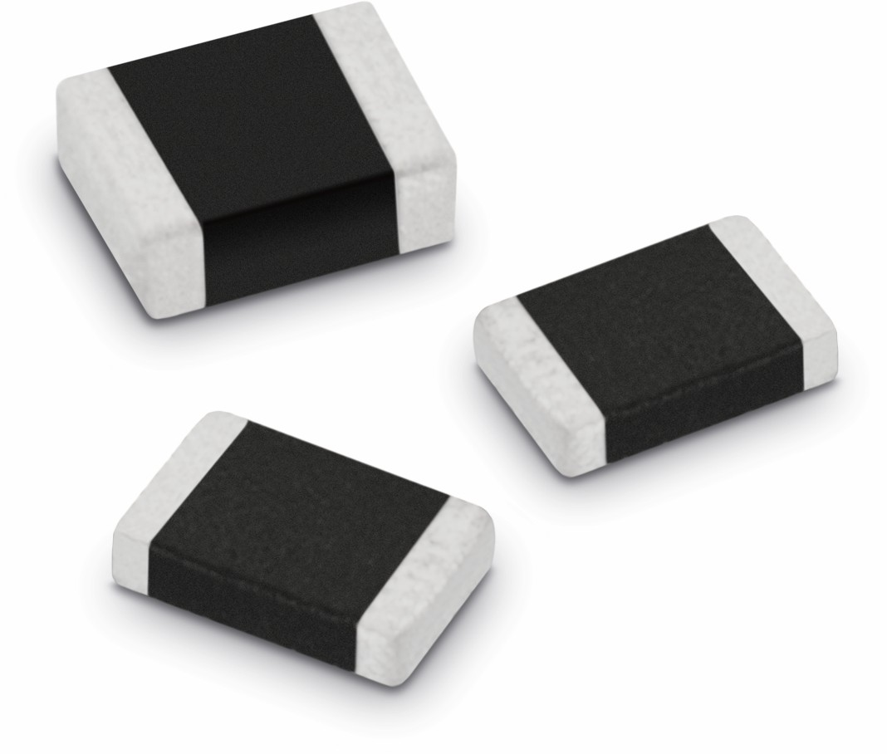
Image source: Würth Elektronik eiSos
WE-PMMI SMD power inductor product series

About Würth Elektronik eiSos GmbH & Co. KG

Würth Elektronik eiSos GmbH & Co. KG is a manufacturer of electronic and electromechanical components for the electronics industry. The company is part of the Würth Group, the global market leader for fastener technology. It employs 6,100 people and generated sales of almost 475 million Euros in 2015. Würth Elektronik eiSos is active in 50 countries worldwide.
Manufacturing facilities in Europe, Asia and North America ensure delivery to a customer base that is growing worldwide. The product range covers EMC components, inductors, transformers, HF components, varistors, capacitors, power modules, LEDs, connectors, power elements, switches, assembly technology and fuse holders.
Würth Elektronik eiSos is one of Europe's largest manufacturers of passive components.
Würth Elektronik: more than you expect!
Further information at www.we-online.com

Further information:  Würth Elektronik eiSos GmbH & Co. KG  Sarah Hurst  Max-Eyth-Strasse 1  74638 Waldenburg  Germany  Phone: +49 7942 945-5186  E-mail: sarah.hurst@we-online.de  www.we-online.de | Press contact:  HighTech communications GmbH  Brigitte Basilio  Grasserstrasse 1c  80339 Munich  Germany  Phone: +49 89 500778-20  Fax: +49 89 500778-77  E-mail: b.basilio@htcm.de  www.htcm.de

