New networking event in the electronics branch:
Würth Elektronik and Texas Instruments launch the INNOposium 2016 as a new event concept for decision-makers

Waldenburg, Germany, 11 February 2016
Which innovations are currently in the R&D pipeline of the electronics branch? How open must decision-makers in the electronics industry keep their minds for new technologies? And above all else: what is the role played by the “smart factory” in this connection? These and a host of similar questions were on the agenda of the very first Innovation Symposium in the Allianz Arena in Munich, Germany on 26 January, attended by more than 50 managers of German electronics companies.

This was an event the likes of which had not been seen before. “Our principle thought was to put on an event that offers a relaxed atmosphere for open discussion and exchange of opportunities and concepts,” says Thomas Schrott, CEO of Würth Elektronik eiSos, after the successful kick-off event. Marian Kost, Area Director Sales Central Europe South at Texas Instruments, also emphasized the networking character of the INNOposium: “Anyone wishing to keep pace with the trends and developments of the high-tech industry needs closely meshed networks and smoothly functioning partnerships.”

Speedfactory and Human-Centered Robotics
The inspiration for discussions and talking points at the kick-off event was given by two exciting, yet entirely different presentations dealing with the so-called “smart factory”. These provided the participants with insights into the broad variety of ways in which the smart factory idea can be driven forward and realized. Gerd Manz, VP Technology Innovation at adidas AG, presented the concept of the speed factory, an instrument that makes it possible to translate technological innovations into consumer products even more swiftly. An entirely new field of business that characterizes the smart factory in perfection is the area of Human-Centered Robotics. Prof. Ing. Sami Haddadin, CEO of the KBee AG company and director of the Institute of Control Engineering at the Leibniz University of Hannover, provided details on the rapid progress being made in this field, which counts as a major driving force behind the implementation of smart-factory concepts.

The venue for this year’s INNOposium was the Allianz Arena in Munich – an ideal setting, offering the participants of the event additional matter for discussion during a relatively technical tour of the famous sports stadium.

INNOposium 2017
The cornerstone for this new meeting point for the branch has now been laid. The forum of the INNOposium 2017 will be announced shortly on www.innoposium.de – this website provides all the information on the individual events and current posts in the INNOposium blog.

For further information please go to www.we-online.com

Available images
The following images can be downloaded from the Internet in printable quality: http://www.htcm.de/kk/wuerth
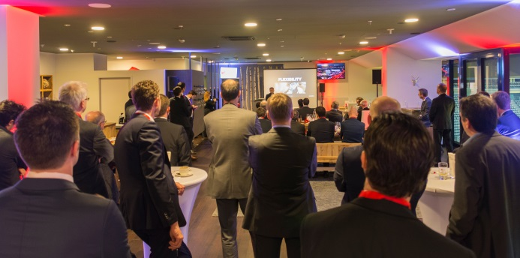

Image source: Würth Elektronik eiSos
The perfect place for the first innovation symposium: The Allianz Arena in Munich, Germany

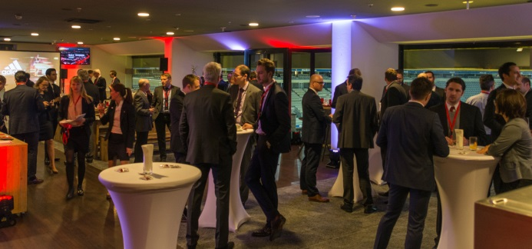

Image source: Würth Elektronik eiSos
Interresting discussions during INNOposium

About Würth Elektronik eiSos GmbH & Co. KG

Würth Elektronik eiSos GmbH & Co. KG is a manufacturer of electronic and electromechanical components for the electronics industry. The company is part of the Würth Group, the global market leader for fastener technology. It employs 6,100 people and generated sales of almost 475 million Euros in 2015. Würth Elektronik eiSos is active in 50 countries worldwide.

Manufacturing facilities in Europe, Asia and North America ensure delivery to a customer base that is growing worldwide. The product range covers EMC components, inductors, transformers, HF components, varistors, capacitors, power modules, LEDs, connectors, power elements, switches, assembly technology and fuse holders.

Würth Elektronik eiSos is one of Europe's largest manufacturers of passive components.

Würth Elektronik: more than you expect!

