MEDIA INFORMATION


Würth Elektronik eiSos at electronica 2016
Components and Services for Electronics of the Future
8–11 November 2016
Hall B6, booth 404
Hall B3, booth 539
Hall A4, booth 466
Waldenburg (Germany), 6 October 2016 – Würth Elektronik eiSos is appearing at electronica 2016 together with its subsidiaries Würth Elektronik iBE and Wurth Electronics Midcom (Hall B6 / booth 404). With a Formula E racing car and the motto “WE speed up the future“, the manufacturer of electronic and electromechanical components showcases its broad spectrum of products on twelve themed islands. Apart from the main booth in Hall B6, the Würth Elektronik eiSos Group is also represented by the companies Stelvio Kontek (Hall B3, booth 539) and Amber Wireless (Hall A4, booth 466).
On twelve Design & Solutions Islands, experts unveil innovative product and system solutions, reference designs and the REDEXPERT simulation software, with which engineers in electronic companies can quickly and easily find the suitable component for their application. The component selection assistant from the REDEXPERT tool is not only based on simulations, but also on extensive measurement series in typical applications and therefore delivers more accurate results.
Other themed islands are devoted to EMC and inductive automotive products from Würth Elektronik iBE, the custom capabilities of Wurth Electronics Midcom, electromechanical components, LED solutions and the themes of Internet of Things & Wireless Communication. Furthermore important future themes like E-Mobility, Wireless Power, Energy Harvesting, as well as Power Management Solutions will be presented.
Another highlight on the exhibition booth is a Formula E car and a racing simulator. An event talk takes place with the ABT Schaeffler Audi Sport Formula E Team with the drivers Daniel Abt and Lucas di Grassi on the occasion of the booth party on 9 November 2016 starting 6 pm.
Each day there will be brief talks on the booth in Hall B6 on component solutions, services, software tools and practice-oriented design-in tips.
Further info at www.we-online.com/e16

Available images
The following images can be downloaded from the Internet in printable quality: http://www.htcm.de/kk/wuerth
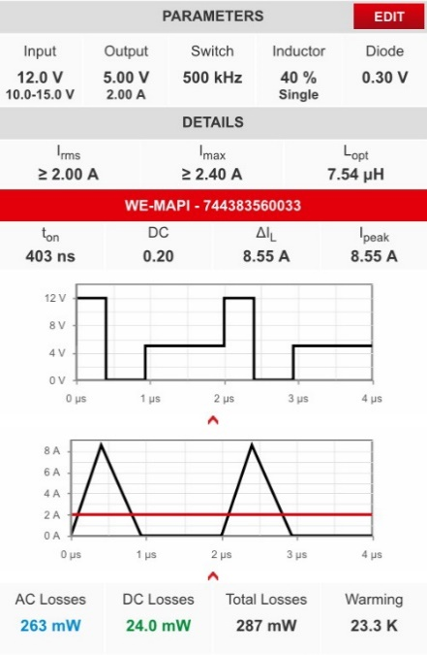  Image source:  Würth Elektronik eiSos  REDEXPERT simulation software: AC loss calculation in discontinuous conduction mode | 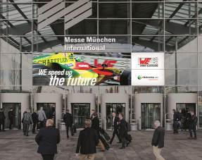  Image source:  Würth Elektronik eiSos  Würth Elektronik eiSos is appearing at electronica 2016 together with its subsidiaries Würth Elektronik iBE and Wurth Electronics Midcom – motto “WE speed up the future“

About Würth Elektronik eiSos GmbH & Co. KG

Würth Elektronik eiSos GmbH & Co. KG is a manufacturer of electronic and electromechanical components for the electronics industry. The company is part of the Würth Group, the global market leader for fastener technology. It employs 6,100 people and generated sales of almost 475 million Euros in 2015. Würth Elektronik eiSos is active in 50 countries worldwide.
Manufacturing facilities in Europe, Asia and North America ensure delivery to a customer base that is growing worldwide. The product range covers EMC components, inductors, transformers, HF components, varistors, capacitors, power modules, LEDs, connectors, power elements, switches, assembly technology and fuse holders.
Würth Elektronik eiSos is one of Europe's largest manufacturers of passive components.
Würth Elektronik: more than you expect!
Further information at www.we-online.com

Further information:  Würth Elektronik eiSos GmbH & Co. KG  Sarah Hurst  Max-Eyth-Strasse 1  74638 Waldenburg  Germany  Phone: +49 7942 945-5186  E-mail: sarah.hurst@we-online.de  www.we-online.de | Press contact:  HighTech communications GmbH  Brigitte Basilio  Grasserstrasse 1c  80339 Munich  Germany  Phone: +49 89 500778-20  Fax: +49 89 500778-77  E-mail: b.basilio@htcm.de  www.htcm.de

