PRESS RELEASE

Würth Elektronik eiSos upgrades the RED EXPERT online design tool
World's most precise AC loss calculation in Discontinuous Conduction Mode
Waldenburg (Germany), 7 April 2016 – With RED EXPERT from Würth Elektronik eiSos developers can simulate the power inductors from Würth Elektronik.
The losses determined with RED EXPERT are based on current and voltage waveforms typical in applications. Besides the core and winding losses, they also include the losses arising from the specific geometries of the inductance, such as the air gap.
With this upgrade the losses for buck and boost converters in discontinuous conduction mode can be accurately determined. Registered users even get the different losses of all the inductors clearly presented.
On top, this upgrade contains a new loss feature which has been added to calculate losses of any inductor irrespective of converter topology.
This AC loss model works very accurate for duty cycles from 0.1 to 0.9 and switching frequencies from 10 kHz to 10 MHz. The special feature: RED EXPERT enables the world's most precise loss calculation, with sinusoidal excitation, but rather is derived and validated from measurements of the power inductors in a switching controller set-up.
RED EXPERT is freely available in German, English, Spanish, Japanese, Russian and Chinese at www.we-online.com/redexpert.

Available images
The following images can be downloaded from the Internet in printable quality: http://www.htcm.de/kk/wuerth

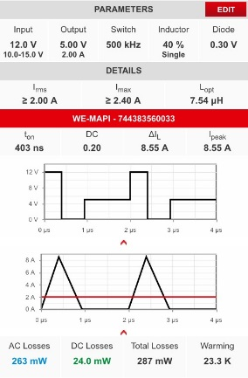  Image source: Würth Elektronik eiSos  AC loss determination in discontinuous conduction mode | 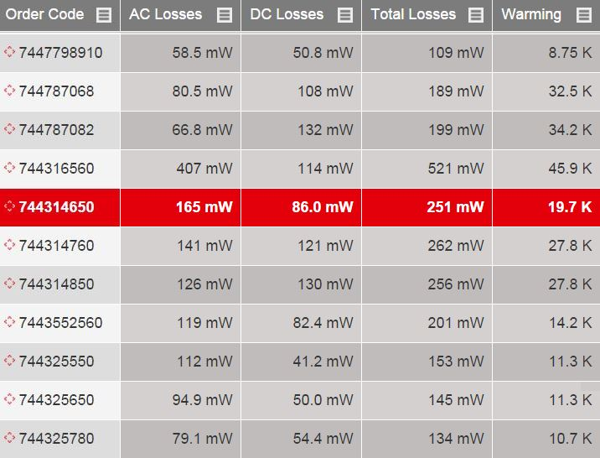  Image source: Würth Elektronik eiSos  Clearly presented AC and DC losses per inductor

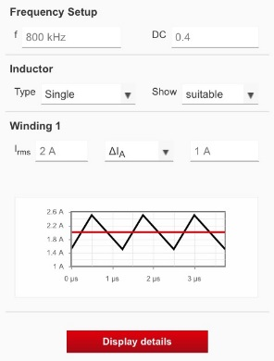
Image source: Würth Elektronik eiSos
Loss determination of any generic power converter

About Würth Elektronik eiSos GmbH & Co. KG

Würth Elektronik eiSos GmbH & Co. KG is a manufacturer of electronic and electromechanical components for the electronics industry. The company is part of the Würth Group, the global market leader for fastener technology. It employs 6,100 people and generated sales of almost 475 million Euros in 2015. Würth Elektronik eiSos is active in 50 countries worldwide.
Manufacturing facilities in Europe, Asia and North America ensure delivery to a customer base that is growing worldwide. The product range covers EMC components, inductors, transformers, HF components, varistors, capacitors, power modules, LEDs, connectors, power elements, switches, assembly technology and fuse holders.
Würth Elektronik eiSos is one of Europe's largest manufacturers of passive components.
Würth Elektronik: more than you expect!
Further information at www.we-online.com

Further information:  Würth Elektronik eiSos GmbH & Co. KG  Sarah Hurst  Max-Eyth-Strasse 1  74638 Waldenburg  Germany  Phone: +49 7942 945-5186  E-mail: sarah.hurst@we-online.de  www.we-online.de | Press contact:  HighTech communications GmbH  Brigitte Basilio  Grasserstrasse 1c  80339 Munich  Germany  Phone: +49 89 500778-20  Fax: +49 89 500778-77  E-mail: b.basilio@htcm.de  www.htcm.de

