MEDIA INFORMATION

Formula E technology partnership between Würth Elektronik eiSos and ABT Schaeffler Audi Sport
Winner’s atmosphere included

Waldenburg, 25 May 2016 – On 21 May the Formula E race series, the first FIA event in the world for fully electronic high-performance racing cars, came to Berlin for a world championship race. Würth Elektronik eiSos, technology partner of the only German racing team, ABT Schaeffler Audi Sport, used the race as an opportunity for a major customer and partner event. 80 invited guests enjoyed an exciting experience, watching the race unfold directly before their eyes from the grandstand and the “Race Suite” – an exclusive location right at the edge of the racing circuit. On the racetrack in the centre of Berlin, the electrically powered Formula E racing cars showed everything that makes car racing such an attractive sport: from rapid acceleration all the way to thrilling box stops. At the end of the event, the Würth Elektronik eiSos team took their leave of their guests in an ideal winning mood: both pilots of the ABT Schaeffler Audi Sport team managed to win places on the podium. On the home racetrack, Daniel Abt and Lucas di Grassi took second and third place respectively, crossing the finish line behind the winner of the day, Sebastian Buemi.
The guests were personally welcomed by Prof. Dr. h. c. mult. Reinhold Würth, Chairman of the Supervisory Board of the Würth Group, and Rolf Bauer, Honorary Member of the Advisory Board of the Würth Group and one of Professor Würth’s closest companions. The idea behind the engagement of Würth Elektronik eiSos in Formula E: combining the thrill of motor racing with the fascination for technical innovation. Europe’s leading manufacturer of electrical and electromechanical components sees this new form of racing sport as an important platform for the further development of e-mobility. The company exploits its role as a technology partner to explore the demands made of components under the extreme conditions of motor sports and to use the results to develop solutions in the e-mobility sector.
Close-up insights into electro-racing
Professor Würth took plenty of time to talk with his guests. The team, the pilots, and partners and customers alike thoroughly enjoyed the opportunity offered by the event to meet the legendary entrepreneur in person. In addition, a number of new projects were unveiled to the guests from the electronics sector, including innovative energy harvesting products and the world’s most precise AC loss calculation model RED EXPERT. During the race itself, the grandstand offered the guests an excellent view over the entire circuit and the start and finish line. Everyone also had the chance to visit the pit lane and the garage of the Abt Schaeffler Audi Sport team for a unique close-up experience of top performance in the area of e-mobility.
In its technology partnership with ABT Sportsline, Würth Elektronik eiSos is also following innovative approaches in the area of digital communication. All important facts and figures in this field can be accessed on the English website http://www.we-speed-up-the-future.com. In addition, Würth Elektronik eiSos uses the blogging platform tumblr (http://we-online-eprixberlin.tumblr.com/) to present event-related company articles on the races, with a live twitter (http://www.we-online.de/twitter) for a minute-by-minute commentary on what is happening on the racetrack.

Available images
The following images can be downloaded from the Internet in printable quality: http://www.htcm.de/kk/wuerth
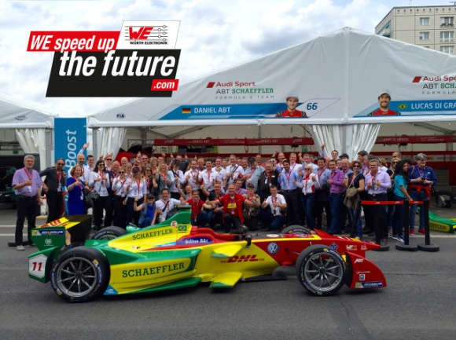  Image source: Würth Elektronik eiSos  Group picture, taken in the pit lane in front of the garage of the ABT Schaeffler Audi Sport team | 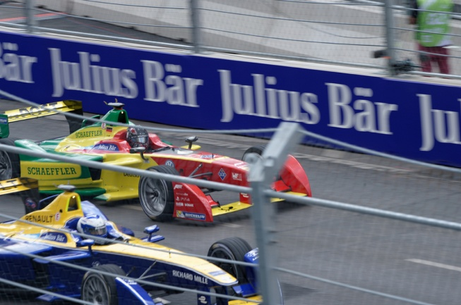  Image source: Würth Elektronik eiSos  ABT Schaeffler Audi Sport in full action

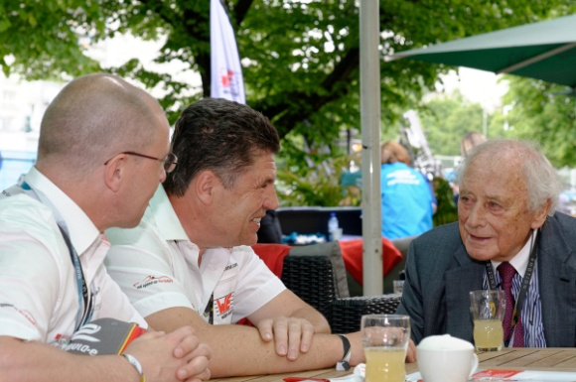  Image source: Würth Elektronik eiSos  Alexander Gerfer, CTO Würth Elektronik eiSos, Oliver Konz, CEO Würth Elektronik eiSos, and Prof. Dr. h. c. mult. Reinhold Würth, Chairman of the Supervisory Board of the Würth Group (from left) | 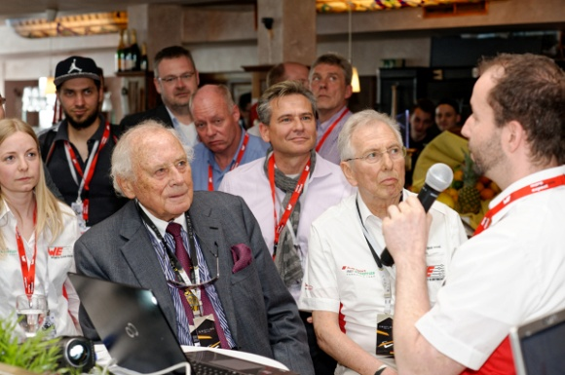  Image source: Würth Elektronik eiSos  Prof. Dr. h. c. mult. Reinhold Würth, Chairman of the Supervisory Board of the Würth Group, and Rolf Bauer, Honorary Member of the Advisory Board of the Würth Group, at the RED EXPERT product presentation in the Race Suite (from left)
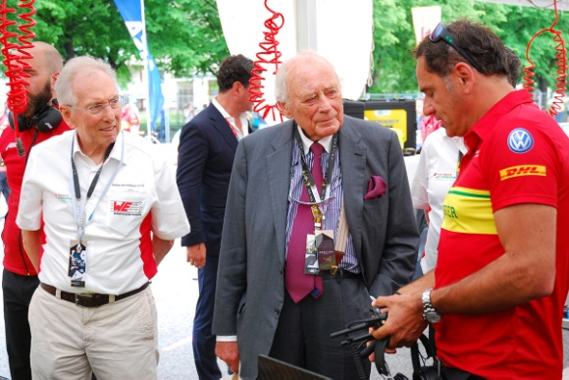
Image source: Würth Elektronik eiSos
Rolf Bauer, Honorary Member of the Advisory Board of the Würth Group, Prof. Dr. h. c. mult. Reinhold Würth, Chairman of the Supervisory Board of the Würth Group, and Hans-Jürgen Abt, CEO ABT Sportsline in a talk in the pit lane (from left)

Über Würth Elektronik eiSos GmbH & Co. KG

Die Würth Elektronik eiSos GmbH & Co. KG ist Hersteller von elektronischen und elektromechanischen Bauelementen für die Elektronikindustrie. Würth Elektronik eiSos ist Teil der Würth-Gruppe, dem Weltmarktführer für Montage- und Befestigungstechnik. Das Unternehmen beschäftigt über 6100 Mitarbeiter und hat im Jahr 2015 einen Umsatz von knapp 475 Millionen Euro erwirtschaftet. Das Unternehmen ist in 50 Ländern aktiv.
Fertigungsstandorte in Europa, Asien und Amerika, versorgen die weltweit wachsende Kundenzahl. Das Produktprogramm umfasst EMV-Komponenten, Induktivitäten, Übertrager, HF-Bauteile, Varistoren, Kondensatoren, Power Module, LEDs, Steckverbinder, Stromversorgungselemente, Schalter, Verbindungstechnik und Sicherungshalter.
Würth Elektronik eiSos ist einer der größten europäischen Hersteller von passiven Bauteilen.
Würth Elektronik: more than you expect!
Weitere Informationen unter www.we-online.de

Weitere Informationen:  Würth Elektronik eiSos GmbH & Co. KG  Sarah Hurst  Max-Eyth-Straße 1  74638 Waldenburg  Telefon: +49 7942 945-5186  E-Mail: sarah.hurst@we-online.de  www.we-online.de | Pressekontakt:  HighTech communications GmbH  Brigitte Basilio  Grasserstraße 1c  80339 München  Telefon: +49 89 500778-20  Telefax: +49 89 500778-77  E-Mail: b.basilio@htcm.de  www.htcm.de

