PRESS RELEASE

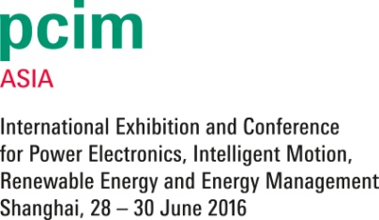
Würth Elektronik eiSos at the PCIM Asia 2016
Power modules and EMC solutions
Waldenburg (Germany), 16 June 2016 – Würth Elektronik eiSos is exhibiting at the PCIM Asia 2016 taking place from 28 thru 30 June 2016. In its presentation in the Shanghai World Expo Exhibition & Convention Center, the manufacturer will be focusing on power modules, for instance the step-down converters of the Magl³C product series, and on the topics of wireless power transfer and energy harvesting. Demoboards will be presented for all three focal topics. The exhibition will also host the presentation of the seminar “EMC Solutions Analysis and Theory Introduction” which has already proven to be a powerful crowd-puller at many other trade fairs in China.
Hall 4, Stand E24
Würth Elektronik eiSos is presenting its substantially expanded and improved Power Module Catalogue for 2016. This includes a number of special highlights, including for example the Magl³C-VDRM (synchronous variable step-down regulator module) with 2.95 to 6 V_{in} and 0.8 to 3.6 V_{out}, which is particularly suited for the power supply for processors and FPGAs that require a scaleable output current (2 A/4 A/6 A) and a programmable switching frequency (BQFN-39 design). Magl³C-FDSM replaces the standard 78xx linear voltage regulators. With input voltages ranging from 7 to 28 V, the non-synchronous step-down regulator module provides fixed output voltages of 3.3 or 5 V at 1 A. The advantage: no further external components are required for operation (SIP-3 design).
In the area of wireless power transfer, Würth Elektronik eiSos will be showing a comprehensive programme of coils and arrays. The company will also be presenting a variety of certified electrolyte, ceramic, and film capacitors from its EMC product range.
Record power inductor
The smallest product is the true star of the exhibition programme: the WE-MAPI is the world’s smallest series of shielded power inductors made of magnetic iron alloy. Their design enables a high current-carrying capacity and high saturation currents. A further highly interesting SMD component: in the WE-MPSB series of ferrites, the nominal current capacity is up to 55 percent higher than is the case with the comparable components that have been available so far. In addition, these ferrites are capable of briefly withstanding up to twenty times their specified rated current capacity.

Available images
The following images can be downloaded from the Internet in printable quality: http://www.htcm.de/kk/wuerth
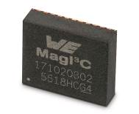  Image source: Würth Elektronik eiSos  At the PCIM Asia exhibition, Würth Elektronik eiSos will be presenting its new power modules, in particular the step-down converters of the Magl³C product range. | 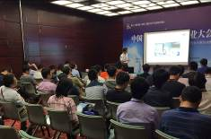 Image source: Würth Elektronik eiSos  At the PCIM Asia exhibition, Würth Elektronik eiSos will be offering an EMC seminar of the topic of EMC Solutions Analysis and Theory Introduction.

About Würth Elektronik eiSos GmbH & Co. KG

Würth Elektronik eiSos GmbH & Co. KG is a manufacturer of electronic and electromechanical components for the electronics industry. The company is part of the Würth Group, the global market leader for fastener technology. It employs 6,100 people and generated sales of almost 475 million Euros in 2015. Würth Elektronik eiSos is active in 50 countries worldwide.
Manufacturing facilities in Europe, Asia and North America ensure delivery to a customer base that is growing worldwide. The product range covers EMC components, inductors, transformers, HF components, varistors, capacitors, power modules, LEDs, connectors, power elements, switches, assembly technology and fuse holders.
Würth Elektronik eiSos is one of Europe's largest manufacturers of passive components.
Würth Elektronik: more than you expect!
Further information at www.we-online.com

Further information:  Würth Elektronik eiSos GmbH & Co. KG  Sarah Hurst  Max-Eyth-Strasse 1  74638 Waldenburg  Germany  Phone: +49 7942 945-5186  E-mail: sarah.hurst@we-online.de  www.we-online.de | Press contact:  HighTech communications GmbH  Brigitte Basilio  Grasserstrasse 1c  80339 Munich  Germany  Phone: +49 89 500778-20  Fax: +49 89 500778-77  E-mail: b.basilio@htcm.de  www.htcm.de

